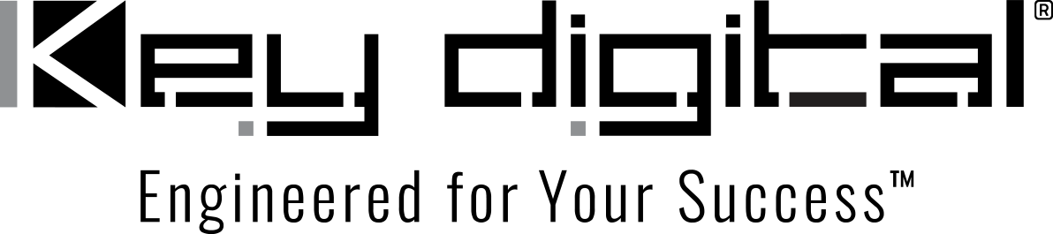

Contacts:

Key Digital

Masha Lakhter, COO

917.701.3238

masha@keydigital.com

Clyne Media, Inc.

Frank Wells, Senior Account Manager

615.585.0597

frank.wells@clynemedia.com

Key Digital’s combination of products and service give Trail Stop Tavern great visuals and ease-of-use

– Key Digital’s KD-IP822 encoders and decoders and ultra-high-speed cabling assure exceptional imaging, while the free Key Digital app provides seamless and reliable system control that’s a pleasure to use for the staff of this successful and stylish sports pub in Eagan, Minnesota –

MOUNT VERNON, NY, November 22, 2022 – The Trail Stop Tavern in Eagan, Minnesota, has been serving suburban Twin Cities burger connoisseurs and beer lovers since 2015 with a welcoming atmosphere and exceptional customer service. A dozen 65- and 85-inch video displays throughout the restaurant keep sports fans on top of every game. However, the older infrastructure behind the monitors left much to be desired: low-end splitters and outdated cabling made for both less-than-optimal image quality and a challenging operational situation, with as many as 15 different remotes needing to be wrangled by staff to control all of the displays and cable boxes. That all changed in October when Edina, MN-based AV systems designer and integrator Innovative Sales Solutions, Inc., installed solutions from Key Digital®, an award-winning developer and manufacturer of leading-edge digital video processing and AV signal distribution solutions.

Innovative Sales Solutions partnered with Key Digital to pinpoint the system components, which included eight KD-IP822ENC 4K UHD AV over IP Encoders (one per source), 11 KD-IP822DEC 4K UHD AV over IP Decoders (one per display or display group), KD-Pro8K 3- and 6-foot ultra-high-speed HDMI cables, and the KD-SMS16 Shelf Mounting System, allowing the integrator to deliver a ready-to-install infrastructure solution that immediately and vastly improved the video quality on the displays, much to the delight of sports-minded patrons. Along with the signal improvements, these solutions provide simplified, centralized control capabilities that, combined with the free companion Key Digital iOS KD-App iOS-based control system, make managing the displays and cable boxes easy for the Trail Stop staff (only iPad taps and swipes are needed to select sources and destinations, change channels, power displays, control volume, or to choose system-wide presets of common setups).

“They had really nice, big displays — it was the signal quality that was the problem, which is not something that many end users realize,” explains John Peterson, Vice President of Technology Sales at Innovative Sales Solutions. “The AV layout was also a challenge for them to manage — some of the cable boxes were up on high shelves that made them difficult to reach to change channels or reboot the boxes.”

Innovative Sales Solutions installer Chad Bonin replaced the archaic Trail Stop Tavern system with a new ergonomically efficient AV design, featuring six new cable TV source boxes and separate boxes for streaming content, as well as updating the entire cabling infrastructure with Cat-6 wiring. At the core of this solution were the Key Digital components. “It was a well-coordinated collaboration. Key Digital did all the configuration, including the network switch and wireless router. They labeled every part and it came to us tested and ready to install,” says Peterson. “The Key Digital App gave us a perfect control touchscreen without any programming required. Key Digital makes it very easy for the integrator and installer; they even added a numeric entry screen for direct channel selection to their GUI at our request. The restaurant is also ready to add new streaming sources, such as football on Amazon Prime on Thursday nights, as they become available.” The patrons of Trail Stop Tavern love what they’re seeing. “It’s amazing the quality of the image you can achieve when you use the right components, and the customers are noticing,” he says. “They can now easily have any channel they want on any display, all from the iPad.” The pub’s owners are demonstratively pleased and planning to launch another pub in January, says Peterson. “We’ll be part of that, and so will Key Digital.”

For more information:
Key Digital
KD-IP822 ENC and DEC AV over IP Encoders and Decoders
KD-App iOS-based control system
KD-Pro8K ultra high-speed HDMI cables
KD-SMS16 shelf mounting system

…ends 603 words

Photo File 1: TrailStop_panoramic.jpg
Photo Caption 1: Signal distribution and control of Trail Stop Tavern’s AV system is now unified via a modular Key Digital AV over IP infrastructure which provides major quality improvements along with simplified operation.

Photo File 2: TrailStop_KD-App.jpg
Photo Caption 2: Key Digital’s free KD-App gives Trail Stop Tavern total control of their entire AV system from an iPad, replacing 15 remotes.

Photo File 3: TrailStop_Encoder_Rack.jpg
Photo Caption 3: Cable boxes, streaming sources, Key Digital KD-IP822 Encoders and network switch are centrally located in a rack over the main bar.

Photo File 4: TrailStop_Bar.jpg
Photo Caption 4: Any video source can feed any monitor throughout Trail Stop Tavern.

About Key Digital:
Established in 1999, Key Digital® designs and engineers intuitive digital A/V connectivity and control solutions that embody excellence. Key Digital delivers reliable, superior-quality, easily-implemented, versatile, high-performance products for corporate, education, government, house-of-worship, bar & restaurant, digital signage and residential A/V applications.

Founded by innovator Mike Tsinberg, holder of over 40 digital video and HDTV patents, Key Digital designs and engineers its products in-house at its USA headquarters in Mount Vernon, New York. The result of meticulous research, development and testing, Key Digital products showcase the company’s extensive, unparalleled technical knowledge and expertise, as well as its market-driven approach, serving as a partner to consultants, designers, and system integration firms in the A/V industry. Key Digital works as its clients’ extended engineering team, developing customized solutions for specific applications. Key Digital is an lnfoComm, CEDIA, CES, and NAHB award-winning manufacturer.

Key Digital, Engineered For Your Success™

For more information, visit our webpage at www.keydigital.com.

Follow Key Digital on social media:

