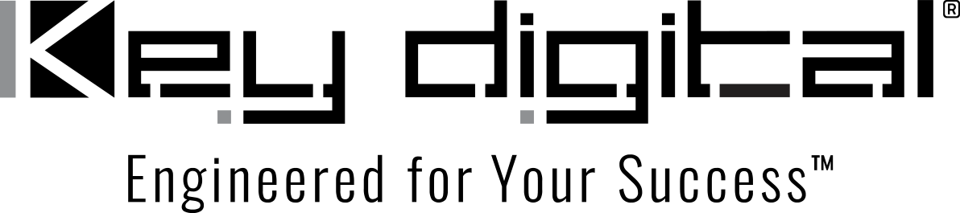

Contacts:

Key Digital

Masha Lakhter, COO

917.701.3238

masha@keydigital.com

Clyne Media, Inc.

Frank Wells, Senior Account Manager

615.585.0597

frank.wells@clynemedia.com

Key Digital® serves restaurants and bars great AV with a free side of control

— Scalable, modular, high performance and cost-effective AV over IP systems from Key Digital are the perfect order for restaurants and bars, with the added bonus of remarkably featured system control via the free KD-App —

MOUNT VERNON, NY, August 15, 2023 – The customer experience is paramount with AV systems deployed in restaurants and bars, with cost-effectiveness and ease of control running closely behind. Key Digital’s modular AV over IP systems are delivering the quality and cost-effectiveness required, and users are finding that the sophisticated yet intuitive iOS KD-App provides the control capabilities needed while amplifying the cost-effectiveness by being free to download and use.

At the Trail Stop Tavern in Eagan, Minnesota, a dozen 65- and 85-inch video displays throughout the restaurant keep sports fans on top of every game. “They had really nice, big displays – it was the signal quality that was the problem,” explains John Peterson, Vice President of Technology Sales at Edina, Minnesota-based systems designer and integrator Innovative Sales Solutions (ISS). “The AV layout was also a challenge for them to manage – some of the cable boxes were up on high shelves that made them difficult to reach to change channels or reboot the boxes.”

ISS installed a Key Digital 8 x 11 4k AV over IP system at Trail Stop that cleaned up the infrastructure and raised the quality of the video sources to match or exceed the capabilities of the existing televisions, with the free companion iOS KD-App iOS-based control system making managing the displays and cable boxes easy for the Trail Stop staff.

The Key Digital iOS KD-App is quite often all the control that’s needed to unlock the full potential of Key Digital hardware systems. “The ease of programming-free setup, intuitive use and comprehensiveness of the KD-App is praised by our customers,” says Key Digital’s Jonathon Ferry, VP of Product Education & Experience. “With KD-App, app-ready IP-enabled Key Digital products, including AV over IP network systems, are automatically detected when on a shared local area network.” Network scan and detect populates a pre-built GUI with Key Digital hardware and connected source and display/projector controls where applicable. The GUI provides immediate control of source selection, destination mapping and sophisticated multi-view and video wall display mode selection. Presets can be easily created for rapid system re-configuration. Custom naming of sources and displays along with thumbnail previews of sources and assigned content add to the intuitiveness of finger drag, swipe and tap system control. “Our customers are simply delighted to find that they get all that power absolutely free,” adds Ferry

“It was a well-coordinated collaboration,” says Peterson of the Trail Stop installation. “Key Digital did all the configuration, including the network switch and wireless router. They labeled every part, and it came to us tested and ready to install. The Key Digital App gave us a perfect control touchscreen without any programming required.”

Another example of satisfied Key Digital customers is Harold’s Chicken Shack – a Chicago institution since 1950 that expanded across the city and state then into Indiana, leading to locations in a half dozen additional states. The launch of Harold’s Chicken & Ice Bar in Atlanta-area Georgia created a model for new and renovated locations.

“Harold’s in Marietta was the first one that we did with the Key Digital AV over IP matrix,” says Zebadiah Henry, CEO and owner of Atlanta-based custom systems integrator INEX Systems & Designs who installed the 10 x 23 4K AV system. The system is controlled by the KD-App.

“Our AV over IP systems are modular,” says DeWayne Rains, VP of Sales for Key Digital, “making it easy to specify a system for any given application – you just need an encoder for each source and a decoder for each display, interconnected by a managed gigabit switch.” Control signals are distributed over IP alongside content, including control of consumer displays and cable boxes via IR extension, plus RS-232 and TCP/IP IP via Open API for easy two-way integration with other professional control systems. “Key Digital’s second-generation 4K AV over IP hardware has a lower cost than our earlier hardware, thanks to new chipsets and manufacturing efficiencies – a rare example of increased cost effectiveness without performance compromise,” adds Rains. “It’s not only signal distribution but integral features like RS-232 and IR ports, audio de-embedding with surround sound support and even the processing necessary for creating and controlling video walls are native to our systems.”

“Key Digital is priced right for all the features they give you,” says INEX’s Henry. Most importantly, he adds that at Harold’s, “It gives their patrons a great experience,” with some very practical benefits. “The system has brought a lot of new business because of the way they can show games and do themed events like fight nights,” says Henry, adding that “in any configuration, the audio for every television is completely in synch, with absolutely no latency. The staff and managers love it – any new staff member can easily learn how to access any source to any TV, and the managers can show them how on the iPad. Simple, easy, reliable, every time.”

Key Digital AV over IP system hardware ships from stock, preconfigured to client needs for turnkey installation. KD-App for iPad and iPhone, which has a built-in demo mode for experimentation and customer test drives, is available for free download from the Apple App Store.

Links
Key Digital
AV over IP solutions
KD-App
…ends 862 words

Photo File 1: TrailStop_KD-App.jpg
Photo Caption 1: Key Digital’s free KD-App gives Trail Stop Tavern total control of their entire AV over IP system from an iPad, replacing 15 remotes

Photo File 2: KeyDigital_Harolds.jpg
Photo Caption 2: Multi-screen viewing wall at Harold’s Chicken & Ice Bar in Marietta, Georgia, with the ability to individually assign a source to any display via a Key Digital AV over IP matrix under the control of the free iOS KD-App

About Key Digital:
Established in 1999, Key Digital® designs and engineers intuitive digital A/V connectivity and control solutions that embody excellence. Key Digital delivers reliable, superior-quality, easily-implemented, versatile, high-performance products for corporate, education, government, house-of-worship, bar & restaurant, digital signage and residential A/V applications.

Founded by innovator Mike Tsinberg, holder of over 40 digital video and HDTV patents, Key Digital designs and engineers its products in-house at its USA headquarters in Mount Vernon, New York. The result of meticulous research, development and testing, Key Digital products showcase the company’s extensive, unparalleled technical knowledge and expertise, as well as its market-driven approach, serving as a partner to consultants, designers, and system integration firms in the A/V industry. Key Digital works as its clients’ extended engineering team, developing customized solutions for specific applications. Key Digital is an lnfoComm, CEDIA, CES, and NAHB award-winning manufacturer.

Key Digital, Engineered For Your Success™

For more information, visit our webpage at www.keydigital.com.

Follow Key Digital on social media:

