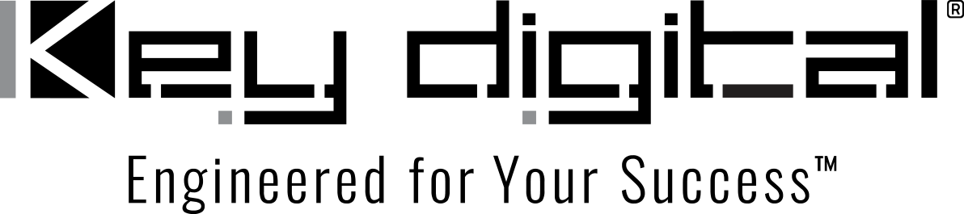

Contacts:

Key Digital

Masha Lakhter, COO

917.701.3238

masha@keydigital.com

Clyne Media, Inc.

Frank Wells, Senior Account Manager

615.585.0597

frank.wells@clynemedia.com

Key Digital components employed in major A/V conferencing system at the headquarters of Isuzu East Africa

– Key Digital Africa recently installed a corporate communication A/V conferencing system to facilitate virtual meetings around the campus of Isuzu East Africa. The system includes Key Digital AV over IP, KD-CAMUSB PTZ cameras and control products. –

MOUNT VERNON, NY, October 24, 2022 – Last year, Key Digital, an award-winning developer and manufacturer of leading-edge digital video processing and video signal distribution solutions, announced the formation of Key Digital Africa, a partnership with Magfre Enterprises Ltd, a Kenyan audio-visual specialist integrator and distributor. This partnership is dedicated to expansion of distribution and marketing of Key Digital products across the African continent, and it has been responsible for several successful system integrations since its formation.

A key example is the corporate communication A/V conferencing system installed at the headquarters of Isuzu East Africa in Nairobi, Kenya. The goal was to facilitate virtual meetings around the campus, accommodating on-site employees in two board rooms, production line members and employees working remotely.

The setup involves a combination of products from Key Digital and TOA Electronics. Specifically, the system includes the Key Digital KD-CAMUSB PTZ camera with automated camera tracking based on voice-tracking capabilities of TOA Electronics’ proprietary LENUBIO AM-CF1, which houses an eight-microphone array with active stereo speakers. Key Digital offers four configurations of its LeCAMbio Conferencing Systems, which mate the KD-CAMUSB with Key Digital controllers, switchers and AV over IP extenders to provide a range of integrated corporate conferencing solutions for small- to medium-sized rooms conference rooms.

By means of Key Digital’s Compass Control® Pro iOS-based control system, users are able to set up a call between the two board rooms and, with the click of a button on a tablet, add the production line. CEC functionality, managed by a KD-x4x1WUTx wall plate switcher provides seamless On/Off switching of the board room display screens. The displays on the production line are used for digital signage when not used for conferencing, and Key Digital KD-CX800 master controllers manage the displays’ switch to conferencing mode when activated. Audio on the production line side is de-embedded by a KD-DA2x8G distribution amplifier/switcher and directed to a TOA VX-3000 evacuation system.

David Kariuki, Magfre Enterprises Presale & Security Division Manager, stated, “We chose Key Digital products for the Isuzu East Africa project because of their ability to deliver a high level of control with nearly plug-and-play operation. Additionally, Key Digital offers an overwhelming amount of support from its technical team, which minimizes project implementation time. They are willing to go the extra mile to suit a particular project.”

For more information:
Key Digital

…ends 382 words

Photo File 1: IsuzuAfrica_Production1.jpg
Photo Caption 1: Isuzu East Africa production line employees participate in meetings and training facilitated by Key Digital conferencing solutions

Photo File 2: IsuzuAfrica_TrainingRoom.jpg
Photo Caption 2: Two board rooms at Isuzu East Africa can be used for remote meetings or internally tied together or to the production line

Photo File 3: IsuzuAfrica_Production2.jpg
Photo Caption 3: Isuzu East Africa production line employees participate in meetings and training facilitated by Key Digital conferencing solutions

About Key Digital:
Established in 1999, Key Digital® designs and engineers intuitive digital A/V connectivity and control solutions that embody excellence. Key Digital delivers reliable, superior-quality, easily-implemented, versatile, high-performance products for corporate, education, government, house-of-worship, bar & restaurant, digital signage and residential A/V applications.

Founded by innovator Mike Tsinberg, holder of over 40 digital video and HDTV patents, Key Digital designs and engineers its products in-house at its USA headquarters in Mount Vernon, New York. The result of meticulous research, development and testing, Key Digital products showcase the company’s extensive, unparalleled technical knowledge and expertise, as well as its market-driven approach, serving as a partner to consultants, designers, and system integration firms in the A/V industry. Key Digital works as its clients’ extended engineering team, developing customized solutions for specific applications. Key Digital is an lnfoComm, CEDIA, CES, and NAHB award-winning manufacturer.

Key Digital, Engineered For Your Success™

For more information, visit our webpage at www.keydigital.com

Follow Key Digital on social media:

