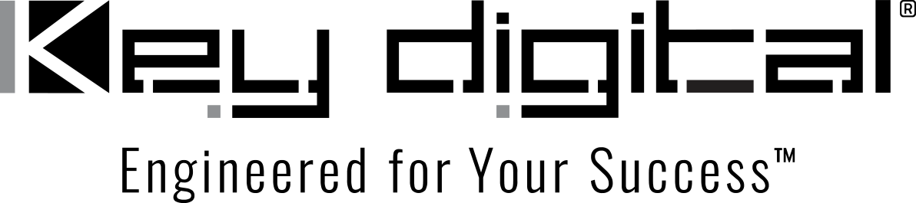

Contacts:

Key Digital

Masha Lakhter, COO

917.701.3238

masha@keydigital.com

Clyne Media, Inc.

Frank Wells, Senior Account Manager

615.585.0597

frank.wells@clynemedia.com

“Future AV Systems in 8K UHD” discussed in Key Digital webinar

– The latest episode of the Unlocking AV with Mike T webinar series discusses the impact of 8K video on the AV market, including content and connectivity –

MOUNT VERNON, NY, September 28, 2022 – The impact of the emergence of 8K video on both commercial and consumer markets and AV systems infrastructure is the topic of discussion in “Future AV Systems in 8K UHD,” the most recent episode of the Key Digital® monthly webinar series Unlocking AV with Mike T. Streaming Thursday, October 27, 2022 at noon EDT at facebook.com/KeyDigitalHQ, with replay available via keydigital.com, the episode will be hosted by Mike Tsinberg – Founder and CEO of Key Digital, as well as an award-winning pioneer in DVD and HDTV and holder of 40-plus patents. He is joined by industry insider Jason Knott, Chief Content Officer of CE Pro and Commercial Integrator magazines, and Leon Tsinberg, Business Development Manager at Key Digital.

“The industry went quickly from 1080P to 4K and is now driven to go to 8K in the same way,” says Mike Tsinberg. Leon Tsinberg prefaces his input by adding, “The emergence of 8K opens up a lot of opportunities, and we’re living in a more and more connected world with more and more screens.” The discussion, guided by questions from his readers shared by Knott, covers a broad sweep of 8K-related topics related to the implications of an 8K production and viewing environment.

The freewheeling conversation addresses the current penetration of 8K screens in both the commercial and residential markets, the state of 8K content – noting that display capabilities are currently leading content availability – and the need for large screens to appreciate the content. The progression of 8K production is discussed, from early 8K content creation in sports (effectively technology demonstrations) to the gaming market to adoption in movies and streaming content, and the impact and upward pressure on legacy content creators by independent 8K production for YouTube and other outlets given the availability of affordable 8K cameras.

Also discussed are best practices for 8K signal distribution, including the ability of HDMI 2.1 to carry 8K signals, cable-length limitations, optical options and AV over IP. When data compression is necessary within distribution schemes and potential processing latency penalties are also discussed, along with the impact of HDR10 and HDR10+ protocols and 120Hz refresh rates.

After its initial streaming, the presentation will join archived editions of Unlocking AV with Mike T on the Key Digital YouTube Channel (https://www.youtube.com/user/MashaKDS), along with archives of Key Digital’s two other monthly webinar events, Coffee with Key and Key Digital Live!

Learn more about Key Digital at keydigital.org.

…ends 401 words

Photo File 1: Unlocking-8K.jpg
Photo Caption 1: The impact of 8K video on both commercial and consumer markets and AV systems infrastructure is the topic of the Key Digital webinar “Future AV Systems in 8K UHD,” the most recent episode of the series Unlocking AV with Mike T, streaming Thursday, October 27, 2022 at noon EDT, hosted by Key Digital CEO Mike Tsinberg (top right) with guests Jason Knott (top left) and Leon Tsinberg.

Photo File 2: unlockingAV8K.jpg
Photo Caption 2: The impact of 8K video on both commercial and consumer markets and AV systems infrastructure is the topic of the Key Digital webinar “Future AV Systems in 8K UHD,” the most recent episode of the series Unlocking AV with Mike T, streaming Thursday, October 27, 2022 at noon EDT, hosted by Key Digital CEO Mike Tsinberg with guests Jason Knott and Leon Tsinberg.

About Key Digital:
Established in 1999, Key Digital® designs and engineers intuitive digital A/V connectivity and control solutions that embody excellence. Key Digital delivers reliable, superior-quality, easily-implemented, versatile, high-performance products for corporate, education, government, house-of-worship, bar & restaurant, digital signage and residential A/V applications.

Founded by innovator Mike Tsinberg, holder of over 40 digital video and HDTV patents, Key Digital designs and engineers its products in-house at its USA headquarters in Mount Vernon, New York. The result of meticulous research, development and testing, Key Digital products showcase the company’s extensive, unparalleled technical knowledge and expertise, as well as its market-driven approach, serving as a partner to consultants, designers, and system integration firms in the A/V industry. Key Digital works as its clients’ extended engineering team, developing customized solutions for specific applications. Key Digital is an lnfoComm, CEDIA, CES, and NAHB award-winning manufacturer.

Key Digital, Engineered For Your Success™

For more information, visit our webpage at www.keydigital.com

Follow Key Digital on social media:

