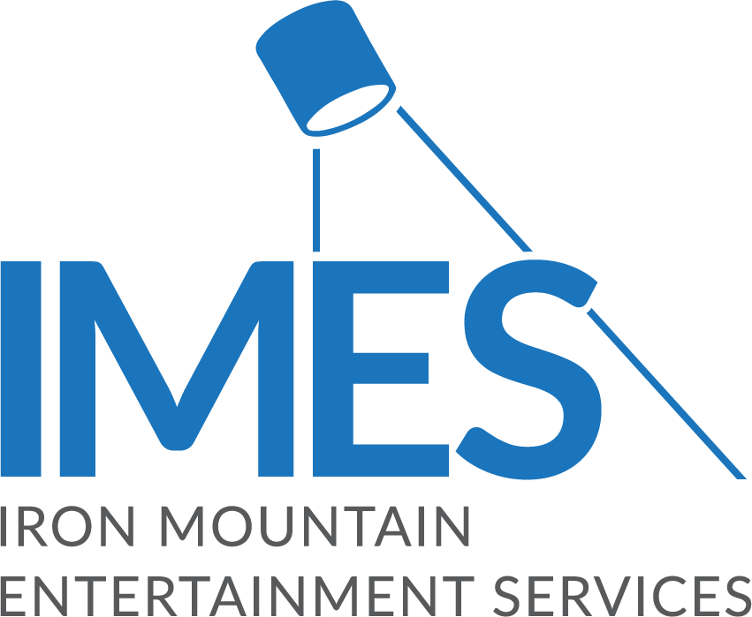

Iron Mountain Entertainment Services Offering Assistance to Those Affected by Middle Tennessee Tornadoes

— IMES is offering comprehensive relief services for artists, engineers and producers that were victims of the recent severe weather events in the Nashville area, to help preserve their archives and get their recording lives back to normal —

BOSTON, March 10, 2020 – The team at Iron Mountain Incorporated®’s Entertainment Services division (IMES), known as the industry’s entertainment content and asset preservation experts, is coordinating a comprehensive relief effort to help those affected by the recent tornadoes in Nashville and the rest of Middle Tennessee.

IMES is offering to conduct free appraisals of media assets, such as audio or video master recordings, that were damaged in the March 3rd tornadoes. If these appraisals are used for insurance purposes, once the claims have been processed, IMES can help coordinate and provide any remediation or restoration services necessary in its L.A. and New Jersey studio facilities. Additionally, IMES is offering free storage at its Nashville facility for up to 60 days for studio equipment, musical instruments, or media that have been displaced by the storms, while cleanup takes place.

Also, for anyone who has sustained damage to their fine art, IMES will work with its Crozier Fine Arts division to help access damage and offer advice on insurance claims, restoration, etc. The Crozier Fine Arts division is a storage, logistics and transportation firm for high-value paintings, photographs and other types of art belonging to individual collectors, galleries and art museums.

“Nashville is not only one of the most passionate music communities on the planet, but also it has the highest concentration of artists, engineers and producers in the world. The events of March 3rd affected the music community deeply,” stated Lance Podell, SVP and GM of Iron Mountain Entertainment Services. “Our goal is to help Nashville’s music community get back on its feet as quickly as possible, and we have a dedicated team of specialists on the ground to work with and advise those affected by this catastrophe in individualized ways.”

For further information, or to speak to someone about storage, restoration or insurance claims, please contact Brian Towle, IMES Sales Director, NA, and Global Head of Operations, brian.towle@ironmountain.com, (908) 251-7239.

To learn more about Iron Mountain Entertainment Services, please visit https://www.ironmountain.com/industries/entertainment.

About Iron Mountain Entertainment Services
Established to meet the needs of managing clients’ archives in music, film, television, academia, sports and entertainment, Iron Mountain Entertainment Services (IMES) provides physical and digital asset lifecycle management solutions with unmatched security and safety tailored to these market sectors. IMES operates purpose-built storage and studio facilities staffed with award-winning engineers in Los Angeles, Chicago, Nashville, Toronto, New York City, London, and Paris. Through IMES’s industry-leading best practices and expertise in inventory management and asset preservation, content creators and entertainers can rest assured that the value of their legacies is kept safe and remains accessible for future generations. Visit https://www.ironmountain.com/industries/entertainment for more information.

MEDIA CONTACTS:
Meg Travis / Iron Mountain Entertainment Services / 617-535-8366 / meg.travis@ironmountain.com
Robert Clyne / Clyne Media, Inc. / 615.662.1616 / robert@clynemedia.com
Lisa Roy / Rock & Roy / 310.463.1563 / lisaroyaudio@mac.com

# # #

