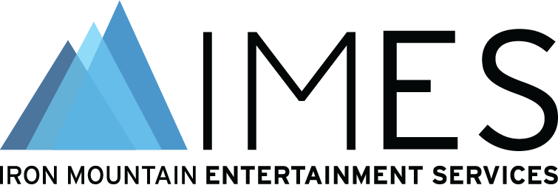

Iron Mountain Entertainment Services to hold TEC Tracks panel “Preserving and Future-Proofing Your Creative Content” at The NAMM Show on Friday, April 14, 2023

Anaheim, CA, April 4, 2023 – Iron Mountain Entertainment Services (IMES), known as the industry’s entertainment content and asset preservation experts, is hosting a TEC Tracks panel at the upcoming NAMM Show at the Anaheim Convention Center in Anaheim, CA. “Preserving and Future-Proofing Your Creative Content” will take place in the Audio Room (202A) from 10:00 to 10:50 a.m. PDT on Friday, April 14, 2023. The all-star panel includes George Massenburg (multi-GRAMMY® Award-winning producer, engineer, educator, inventor and designer), Chuck Ainlay (multi-GRAMMY, ACM, CMA, and TEC Award-winning producer/engineer) and Kelly Pribble (Director of Media Recovery Technology at IMES). Sarah Jones (noted industry journalist and committee member for the Recording Academy’s standards document Delivery Recommendations for Recorded Music Projects) will serve as moderator.

Whether your latest creative work was recorded on analog tape or digitally to a hard drive, preserving your recordings is paramount for future playback. Analog tape has its own problems, but we are moving into an age where basically every bit of information since the 1990s ultimately lives somewhere on hard drives. AND those hard drives will, inevitably, fail. What this means is there is a certain likelihood that some or all of our information will essentially evaporate and be lost forever. There is a real fear that we will encounter what is called a “digital black hole” of media from, say, the late 1990s through the early 2010s, when more creators became wiser and less careless about their backup regimen. This session will look at the practical and technical considerations for long-term archiving, various media storage methods, best practices and future catalog monetization.

Photo file: IMES_NAMM_panel_square_tall.JPG
Photo caption: Pictured L-R, top row: George Massenburg and Chuck Ainlay; bottom row: Kelly Pribble and Sarah Jones.

About Iron Mountain Entertainment Services
Iron Mountain Entertainment Services (IMES), the media and entertainment division of Iron Mountain Incorporated®, is the go-to physical and digital media archiving service for the media and entertainment industries. IMES partners with clients ranging from the broadcast, film, music and sports sectors to brand archives and individual artists' collections and estates, to protect and activate media archives to preserve our collective cultural heritage. A global leader in media preservation, restoration and archive management, IMES offers industry-leading archive, storage, chain-of-custody processes and physical and digital content preservation solutions to ensure the complete protection of some of the world’s most treasured and iconic assets. Visit https://www.imes.media for more information.

About Iron Mountain
Iron Mountain Incorporated (NYSE: IRM), founded in 1951, is the global leader for storage and information management services. Trusted by more than 225,000 organizations around the world, and with a real estate network of more than 90 million square feet across more than 1,480 facilities in over 50 countries, Iron Mountain stores and protects billions of valued assets, including critical business information, highly sensitive data, and cultural and historical artifacts. Providing solutions that include information management, digital transformation, secure storage, secure destruction, as well as data centers, cloud services and art storage and logistics, Iron Mountain helps customers lower cost and risk, comply with regulations, recover from disaster, and enable a digital way of working. Visit http://www.ironmountain.com for more information.

###

Media Contacts
Meg Travis / Iron Mountain Entertainment Services / 617-535-8366 / Margaret.Travis@ironmountain.com
Robert Clyne / Clyne Media, Inc. / 615.662.1616 / robert@clynemedia.com

