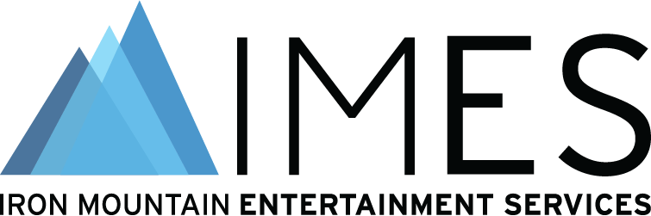

**Media alert for Wednesday, October 25**

Iron Mountain Entertainment Services to showcase latest technologies and ongoing innovations in “Transforming Your Audio Archive Management” at AES New York

IMES continues to promote best Archiving and Preservation practices including its groundbreaking Automated Media Image Capture System (AMICS) at AES New York 2023 Convention
October 10, 2023 – Iron Mountain Entertainment Services (IMES), the Media & Entertainment division of Iron Mountain Incorporated® (NYSE: IRM), has announced it will feature a panel discussion presentation on Wednesday, October 25 at 10:15am EDT in room 1E08 during the upcoming AES New York 2023 Convention, taking place October 25 – 27 at the Jacob Javits Center. Key panelists from IMES and Universal Music Group (UMG) will discuss ongoing Archiving and Preservation research and innovations in the panel “Transforming Your Audio Archive Management,” including the development and roll-out of IMES’s new Automated Media Image Capture System (AMICS). This state-of-the-art solution was designed to improve the accessibility and usability of large-scale audio archives, helping users understand and utilize their assets, all while backed by IMES’s world-class facilities and infrastructure. Using AMICS, clients now not only have access to a project/artists metadata, but also are able to view contextual information that might be written on the outside of a tape box or other storage medium that ultimately helps when researching what particular sources they want to use for a project.

Originally created to address the needs of Universal Music Group’s archive, and now in use with a variety of IMES clients, the newly developed AMICS technology enables the capture and processing of metadata for more than 2500 media assets in a single eight-hour shift, enabling IMES’s clients to perform inventory search, filter content, view workflow assignments and more with unprecedented ease and speed, transforming and lowering the total cost of media inventory management. Panelists will include Steve Hollencamp (Engineering Manager, IMES), Robert Koszela (Director of Studio Operations, IMES), and Nick Allen (Vice President of Asset and Archive Management, Universal Music Group). Meg Travis (Director of Global Marketing and Communications, IMES) will serve as moderator.

“We are excited to return to AES again this year to present our new AMICS technology and to showcase some of our accomplishments with clients such as Universal Music Group,” states Meg Travis. “As archive management continues to be of the utmost importance in preserving our audio heritage, continued research and development of technologies for preserving the physical assets used to document these recordings has yielded significant headway through the use of things like automated capture systems and cloud-based inventory accessibility.”

The panel “Transforming Your Audio Archive Management” will take place on Wednesday, October 25, at 10:15am EDT in room 1E08. Additionally, IMES will again co-host a presentation area on the exhibition floor with the Recording Academy® Producers & Engineers Wing® (booth 630/632).

Photo File 1: IMES_AESNY23_Panel.jpg
Photo Caption 1: Iron Mountain Entertainment Services will showcase its latest technologies and ongoing innovations, including the newly-implemented Automated Media Image Capture System (AMICS), in the panel discussion event “Transforming Your Audio Archive Management” on Wednesday, October 25 at 10:15am ET at the AES New York 2023 Convention. Shown clockwise from top left: Nick Allen (Vice President of Asset and Archive Management, Universal Music Group); Steve Hollencamp (Engineering Manager, IMES); Robert Koszela (Director of Studio Operations, IMES); and moderator Meg Travis (Director of Global Marketing and Communications, IMES).

Photo File 2: AMICS_Machine.jpg
Photo Caption 2: Iron Mountain Entertainment Services’ (IMES) Automated Media Image Capture System (AMICS) shown at the IMES facility in Boyers, PA.

PDF File: AMICS Automated Media Image Capture System.PDF

About Iron Mountain Entertainment Services
Iron Mountain Entertainment Services (IMES), the media and entertainment division of Iron Mountain Incorporated®, is the go-to physical and digital media archiving service for the media and entertainment industries. IMES partners with clients ranging from the broadcast, film, music and sports sectors to brand archives and individual artists' collections and estates, to protect and activate media archives to preserve our collective cultural heritage. A global leader in media preservation, restoration and archive management, IMES offers industry-leading archive, storage, chain-of-custody processes and physical and digital content preservation solutions to ensure the complete protection of some of the world’s most treasured and iconic assets. Visit http://www.ironmountain.com/entertainment for more information.
About Iron Mountain
Iron Mountain Incorporated (NYSE: IRM), founded in 1951, is the global leader for storage and information management services. Trusted by more than 225,000 organizations around the world, and with a real estate network of more than 90 million square feet across more than 1,480 facilities in over 50 countries, Iron Mountain stores and protects billions of valued assets, including critical business information, highly sensitive data, and cultural and historical artifacts. Providing solutions that include information management, digital transformation, secure storage, secure destruction, as well as data centers, cloud services and art storage and logistics, Iron Mountain helps customers lower cost and risk, comply with regulations, recover from disaster, and enable a digital way of working. Visit http://www.ironmountain.com for more information.
###

Media Contacts
Meg Travis / Iron Mountain Entertainment Services / 617-535-8366 /
Meg.Travis@ironmountain.com
Robert Clyne / Clyne Media, Inc. / 615.662.1616 / robert@clynemedia.com

