Revered supergroup The Immediate Family delivers a stellar set of timeless rock ‘n’ roll on their new studio album Skin In The Game, out on February 16, 2024

– Immediate Family documentary in theaters nationwide for a one-night-only event December 12, 2023, and available everywhere on December 15, 2023 –

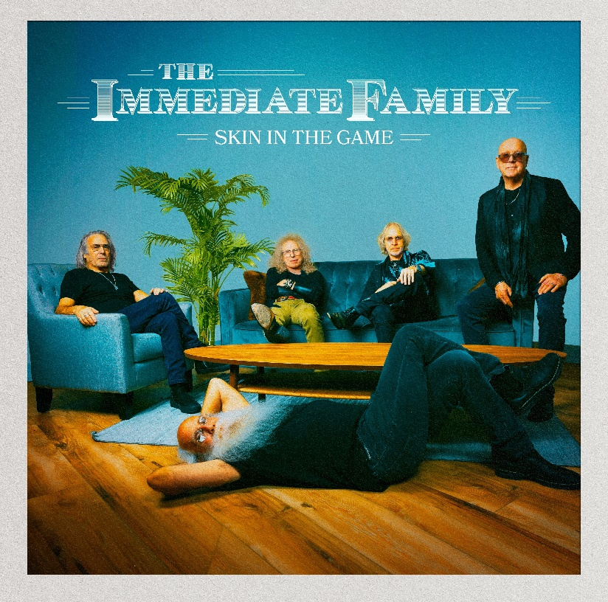
Download hi-res cover art – photo by Jay Gilbert/Chris Schmitt – Cover artwork by Brian Porizek

November 16, 2023 – The Immediate Family’s much-anticipated new studio album, Skin In The Game, will be released on February 16, 2024, via Quarto Valley Records. The legendary musicians’ second full-length studio album is a skillful combination of power and precision, fun and introspection, featuring soaring harmonies and a burst of R&B with the pure essence of rock and roll. Produced by the band themselves, Skin In The Game’s fourteen tracks showcase the remarkably versatile musical skills possessed by all five members of The Immediate Family: singer/songwriter/guitarists Danny Kortchmar, Waddy Wachtel, and Steve Postell, and one of the most renowned rhythm sections in rock history, Russ Kunkel and Leland Sklar.

Launching with the raucous opening track “Whole Lotta Rock and Roll,” the album’s thirteen original songs exuberantly careen from funky rockers such as “24/7/365,” “Confusion” and “Lost in the Shuffle” to gentler numbers, such as “Fragile Heart” and “Catch You on the Other Side.” On “Looking Away,” they effortlessly build the emotional drama by shifting from restrained acoustic guitars to a blast of electric guitar fury. Similarly, the band’s satiric edge can slide from the dark side on “Party at the Graveyard” to the lighter-hearted fun of “High Maintenance.” Sklar and Kunkel’s subtly profound ways of building and holding down a song’s foundation are present throughout Skin In The Game. The album’s title track begins with Kunkel’s drumbeat, complemented by Sklar’s sonorous bass. Together they bring a gravitas that supports the song’s message that life isn’t just about the money; you need to have heart, soul, pride, and be willing to risk everything – “skin in the game.”

The first single from Skin In The Game is its only cover tune: an arresting reimagining of Sparks’ “The Toughest Girl in Town.” The Immediate Family’s rendition, initially released in October of 2022, was hailed by Guitar Player Magazine as: “Injected with a shot of rock ‘n’ roll prowess, ‘The Toughest Girl in Town’ is transformed from eccentric synth-pop gem to ax-centric masterpiece.” Watch the video HERE. The second single, the title track “Skin In The Game,” will be released in January 2024.

The tight-knit quintet (Danny Kortchmar, Waddy Wachtel, Russ Kunkel, Leland Sklar and Steve Postell) initially rose to prominence working with some of rock’s biggest names, such as Keith Richards, Linda Ronstadt, James Taylor, Carole King, Jackson Browne, Stevie Nicks, Don Henley, Billy Joel, David Crosby and Joni Mitchell, to name a few – but now they have reinforced their own identity as The Immediate Family. “This band has such power. It’s almost like an embarrassment of riches,” states Wachtel. “We just knew we had all moved up to the next level in the group. It was such a great feeling, one that is the real reason all of us do what we do.” Leland Sklar adds, “The Immediate Family’s unrivaled musical chemistry comes from years of playing together. We all know each other backward and forward and can play to each other’s strengths in ways that other groups can’t always get to.”

The band’s unique, decades-long musical journey is the subject of the full-length documentary, Immediate Family, by acclaimed filmmaker Denny Tedesco (director of The Wrecking Crew). The film tracks the rise and collaborations of this group of legendary studio musicians Danny Kortchmar, Waddy Wachtel, Russ Kunkel, and Leland Sklar, through the 1970s and onward, spotlighting their prestigious partnerships and their indelible mark that helped define the sound of a generation. Immediate Family is a backstage tour of rock history, featuring intimate interviews with the band members, as well as memorable stories from some of music's most iconic performers including Carole King, James Taylor, Linda Ronstadt, Neil Young, Keith Richards, Don Henley, Stevie Nicks, David Crosby, Jackson Browne, Lyle Lovett and Phil Collins. Immediate Family will be released by Magnolia Pictures in theaters for special one-night screenings on December 12th and will be available everywhere on December 15th.

Watch the Official Trailer Now: https://www.immediatefamilyfilm.com/
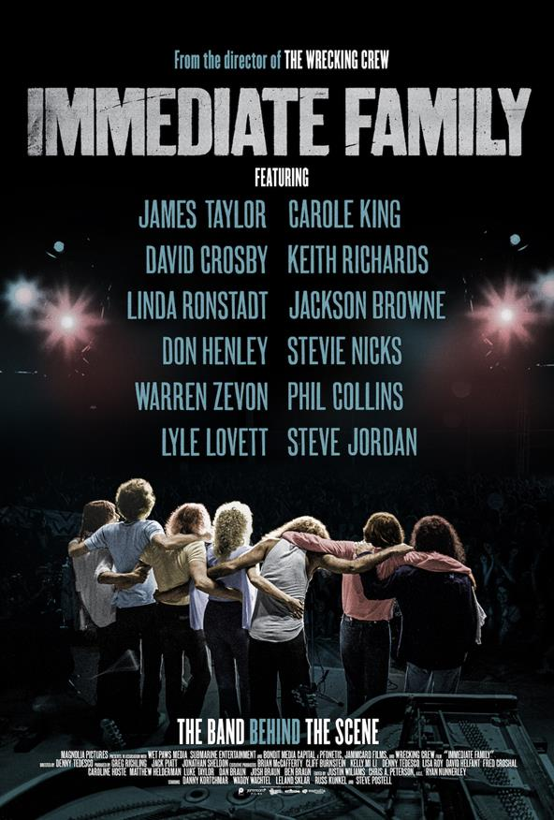
With Skin In The Game, The Immediate Family have tapped into the magical connection they have together and created a stunning collection of songs. And now with the album’s release, there is just one thing left to do. “We can’t wait to start touring again,” Postell shares, “and play this new music for our fans and the newcomers just finding out about us.”

The new album follows the band’s 2022 EP Live from Telefunken Soundstage, preceded by the critically acclaimed self-titled album and EPs, Can’t Stop Progress and Slippin’ and Slidin’. For more information on The Immediate Family, visit www.immediatefamilyband.com.

Skin in the Game track listing
Produced by The Immediate Family
- Whole Lotta Rock and Roll
- 24/7/365
- The Toughest Girl in Town
- Catch You on The Other Side
- Nobody Wants You
- Fragile Heart
- Confusion
- Party at the Graveyard
- Skin In the Game
- Love Suicide
- Looking Away
- Lost In the Shuffle
- Too Many Irons
- High Maintenance

Download press photo – credit: Jay Gilbert/Chris Schmitt

For promo album links contact:
Lucy Sabini – lucy.sabini@luciamediagroup.com – 917-864-0060
Robert Clyne – robert@clynemedia.com – 615-300-4666

Follow The Immediate Family on Social Media:
Website Facebook Twitter.X Instagram Spotify

About The Immediate Family
The Immediate Family (the modern iteration of a legendary studio ensemble known as “The Section”) is a unique group of iconic musicians composed of four of the most recorded, respected, and sought-after players in modern music: Danny Kortchmar (guitar and vocals), Waddy Wachtel (guitar and vocals), Leland Sklar (bass), Russ Kunkel (drums) and the addition of prominent touring, session guitarist and songwriter Steve Postell (guitar and vocals). Frequent collaborators both in the studio and on stage, their work can be heard on albums from Jackson Browne, James Taylor, Linda Ronstadt, Stevie Nicks, Keith Richards, Warren Zevon, Graham Nash, Neil Young, David Crosby, and many, many more. Kortchmar, Sklar, and Kunkel have worked together since the early 70s and made up three-quarters of The Section, best known for both their studio and live work in support of some of the top-selling singer/songwriters and solo singers in the history of music, as well as their acclaimed instrumental albums. (By the mid-70s, they were later joined by Wachtel). Collectively, these musicians helped define the sound of a generation.

About Quarto Valley Records
Founded by tech entrepreneur Bruce Quarto, the California-based independent label Quarto Valley Records represents Rock, Blues, Jazz and Americana genres with an impressive artist roster featuring legacy musicians Paul Rodgers, GRAMMY® award-winning Edgar Winter and Savoy Brown as well as the legendary talent that comprises The Immediate Family, GRAMMY® award-winning producer and renowned drummer and songwriter Tom Hambridge, GRAMMY® award-winning producer and percussionist Narada Michael Walden, blues-rock artist Sean Chambers, British blues sensation Bonham-Bullick, Wings member Denny Seiwell, acclaimed Americana singer-songwriter Al Staehely, the esteemed and soulful Richard T. Bear, and emerging artist Dominic Quarto. https://quartovalleyrecords.com.
Visit Quarto Valley Records on its social media pages: Facebook Twitter Instagram

Photo file 1: SKIN_IN_THE_GAME_COVER.JPG
Photo caption 1: Cover art for Skin In The Game. Photo by Jay Gilbert/Chris Schmitt. Cover artwork by Brian Porizek

Photo file 2: IF_DocumentaryPosterGraphic.JPG
Photo caption 2: Promotional graphic for the new documentary Immediate Family

Photo file 3: TIF_PRESS-1.JPG
Photo caption 3: The Immediate Family. Photo credit: Jay Gilbert/Chris Schmitt

