The Immediate Family announces February tour dates with special guest Elliot Easton

The Cars’ guitarist will be stepping in for Waddy Wachtel on a series of shows

New album Skin In The Game out on February 16

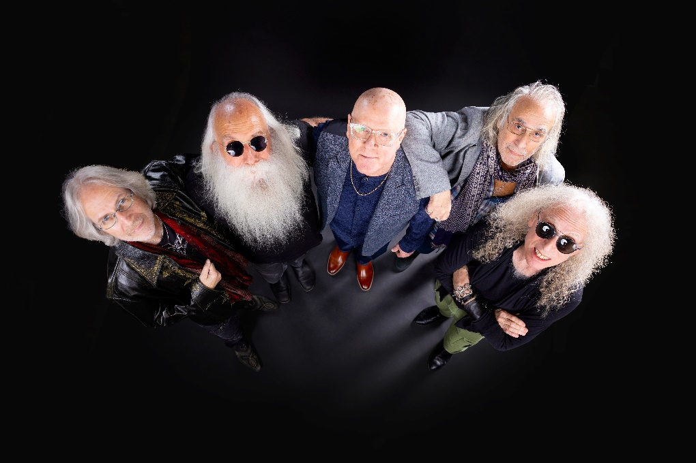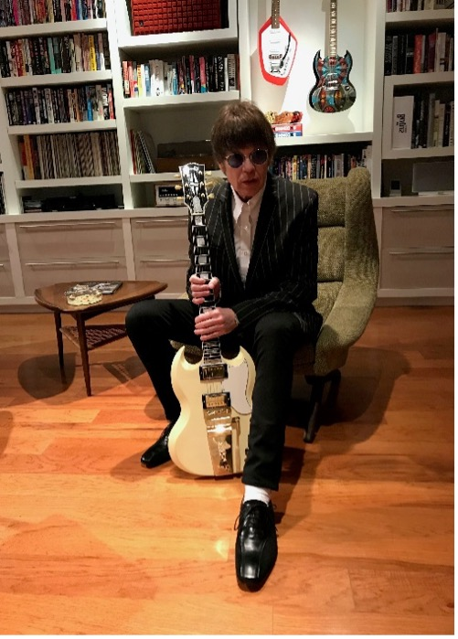

TIF photo by Jay Gilbert/Chris Schmitt - Elliot Easton photo by Rob Shanahan

February 6, 2024 – Revered supergroup The Immediate Family – composed of guitarists/singers/songwriters Danny Kortchmar, Waddy Wachtel and Steve Postell, and the renowned rhythm section of drummer Russ Kunkel and bassist Leland Sklar – announces a series of February tour dates in support of their much-anticipated upcoming album Skin in the Game, out on February 16 via Quarto Valley Records. This month’s shows will feature guest guitarist Elliot Easton, a friend of the band and key member of Rock and Roll Hall of Fame inductees The Cars, who will be filling in for Waddy Wachtel while he serves as long time musical director and lead guitarist for Stevie Nicks.
Kicking off February 13 with a sold-out show at Los Angeles’ The Mint, the tour includes a string of dates in California, before the band heads to Miami, FL to join the Rock Legends Cruise followed by additional shows in Florida. The list of tour dates is below.

“I am so incredibly honored that the Immediate Family has asked me to fill in for Waddy Wachtel,” notes Easton. “I have been influenced by so much of the music that they made while I was coming up and trying to learn about what made a great record, and how to construct catchy guitar parts! These guys are like my big brothers, and I’m so excited to have this opportunity to play with them. We’ll have some song surprises, and I just hope that folks enjoy the show!”

Danny Kortchmar commented, “Unfortunately, our brother Waddy is not going to be on our gigs for the next few weeks, but fortunately, we have our dear pal Elliot Easton subbing. A great cat and a wonderful player!”

Waddy Wachtel added, “I can’t think of anyone better to fill in for me than Elliot Easton. Not only is he a fantastic guitar player and a proven hitmaker, but he’s also a great guy and a fellow New Yorker. Why, he’s even from Queens! Thank you so much, Elliot! I will miss everyone, but I’ll see you all soon. Rock on, my family!”

February 2024 Tour Dates

- 2/13/24: Los Angeles, CA @ The Mint - SOLD OUT
- 2/14/24: Santa Barbara, CA @ Lobero Theatre – SOLD OUT
- 2/16/24: Livermore, CA @ Livermore Valley Arts Center
- 2/17/24: Saratoga, CA @ Montalvo Arts Center
- 2/22-2/26/24: Miami, FL @ Rock Legends Cruise
- 2/27/24: Ft. Pierce, FL @ Sunrise Theatre
- 2/28/24: Hallandale Beach, FL @ Sport of Kings Theater

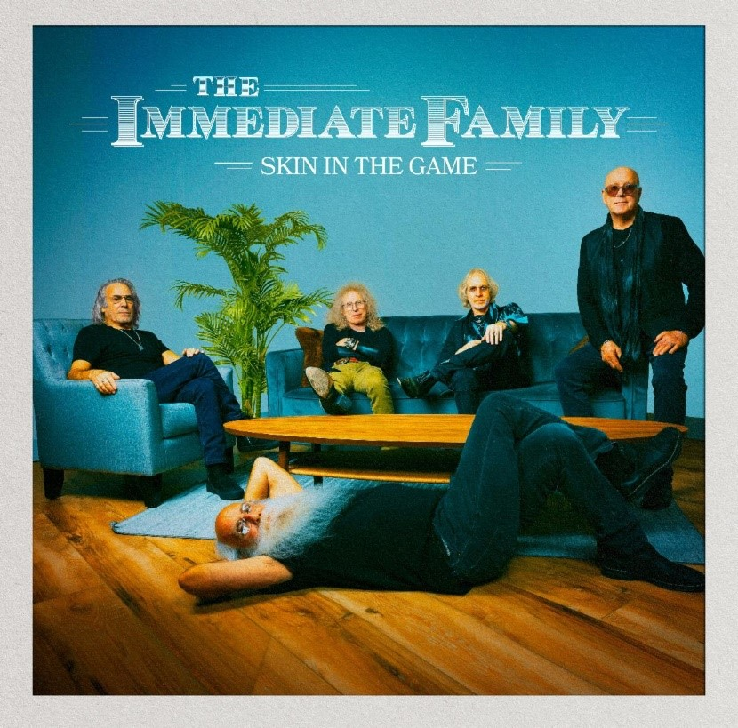
Download hi-res cover art
photo by Jay Gilbert/Chris Schmitt– cover artwork by Brian Porizek

Available worldwide February 16 via Quarto Valley Records, the new album Skin In The Game is a skillful combination of power and precision, fun and introspection, featuring soaring harmonies and a burst of R&B with the pure essence of rock and roll. Produced by the band, the new album’s thirteen original tracks and one cover tune exuberantly careen from the raucous opening track “Whole Lotta Rock and Roll” to the latest single/video, the title track “Skin In The Game” (view the video HERE), an insightful rocker that demonstrates what it means to be fully committed to craft and creativity and willing to risk it all without fear of failure. Other highlights include funky rockers such as “24/7/365,” “Confusion” and “Lost in the Shuffle” as well as gentler numbers, such as “Fragile Heart” and “Catch You on the Other Side.” On “Looking Away,” they effortlessly build the emotional drama by shifting from restrained acoustic guitars to a blast of electric guitar fury. Similarly, the band’s satiric edge can slide from the dark side on “Party at the Graveyard” to the lighter-hearted fun of “High Maintenance Girlfriend.” Pre-order the album HERE.

Sporting a resume unrivaled in rock history, this tight-knit quintet has collaborated with many of music's biggest names, including Keith Richards, Linda Ronstadt, James Taylor, Carole King, Jackson Browne, Stevie Nicks, Don Henley, Billy Joel, David Crosby, Neil Young and Joni Mitchell, to name a few. However, Skin In The Game gloriously reveals that their best collaborators are each other.

The tour and new album follow the recent release of the universally praised documentary Immediate Family, which is available now on streaming services via video-on-demand. Directed by Denny Tedesco (the filmmaker behind the lauded documentary The Wrecking Crew), Immediate Family has been featured by major media outlets such as the New York Times, Rolling Stone, Chicago Sun-Times, and Los Angeles Times, which proclaimed, “its glimpse of the last great era of live-in-studio recording is an enjoyable, personality-rich one.” Variety raved the Magnolia Pictures release as the “ultimate liner-note movie,” while the Hollywood Reporter hailed it as “time well spent with delightful subjects who played crucial roles in shaping the popular music of a ground-shifting era.” A Magnolia Pictures release, Immediate Family is available now on streaming platforms everywhere.

Watch the Official Trailer:
https://www.immediatefamilyfilm.com/

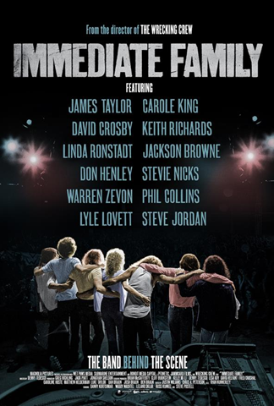

Download album press kit
Contact:
Lucy Sabini - lucy.sabini@luciamediagroup.com - 917-864-0060
Robert Clyne - robert@clynemedia.com - 615-300-4666

Follow The Immediate Family on social media:
Website Facebook Twitter.X Instagram Spotify

About The Immediate Family
The Immediate Family (the modern iteration of a legendary studio ensemble known as “The Section”) is a unique group of iconic musicians composed of four of the most recorded, respected, and sought-after players in modern music: Danny Kortchmar (guitar and vocals), Waddy Wachtel (guitar and vocals), Leland Sklar (bass), Russ Kunkel (drums) and the addition of prominent touring, session guitarist and songwriter Steve Postell (guitar and vocals). Frequent collaborators both in the studio and on stage, their work can be heard on albums from Jackson Browne, James Taylor, Linda Ronstadt, Stevie Nicks, Keith Richards, Warren Zevon, Graham Nash, Neil Young, David Crosby, and many, many more. Kortchmar, Sklar, and Kunkel have worked together since the early '70s and made up three-quarters of The Section, best known for both their studio and live work in support of some of the top-selling singer/songwriters and solo singers in the history of music, as well as their acclaimed instrumental albums. (By the mid-70s, they were later joined by Wachtel). Collectively, these musicians helped define the sound of a generation. The band is managed by Industry veterans, Fred Croshal of Croshal Entertainment Group and David Helfant of Arpeggio Entertainment, who also Executive Produced the band’s Documentary.

About Quarto Valley Records
Founded by tech entrepreneur Bruce Quarto, the California-based independent label Quarto Valley Records represents Rock, Blues, Jazz and Americana genres with an impressive artist roster featuring legacy musicians Paul Rodgers, GRAMMY® award-winning Edgar Winter and Savoy Brown as well as the legendary talent that comprises The Immediate Family, GRAMMY® award-winning producer and renowned drummer and songwriter Tom Hambridge, GRAMMY® award-winning producer and percussionist Narada Michael Walden, blues-rock artist Sean Chambers, British blues sensation Bonham-Bullick, Wings member Denny Seiwell, acclaimed Americana singer-songwriter Al Staehely, the esteemed and soulful Richard T. Bear, and emerging artist Dominic Quarto. https://quartovalleyrecords.com

Visit Quarto Valley Records on its social media pages:
Facebook Twitter Instagram

Photo file 1: TIF_PRESS-3.JPG
Photo caption 1: The Immediate Family (photo by Jay Gilbert/Chris Schmitt)

Photo file 2: ElliotEaston.JPG
Photo caption 2: Elliot Easton (photo by Rob Shanahan)

Photo file 3: SKIN_IN_THE_GAME_COVER.JPG
Photo caption 3: Cover art for Skin In The Game. Photo by Jay Gilbert/Chris Schmitt. Cover artwork by Brian Porizek

Photo file 4: IF_DocumentaryPosterGraphic.JPG
Photo caption 4: Promotional graphic for the new documentary Immediate Family

