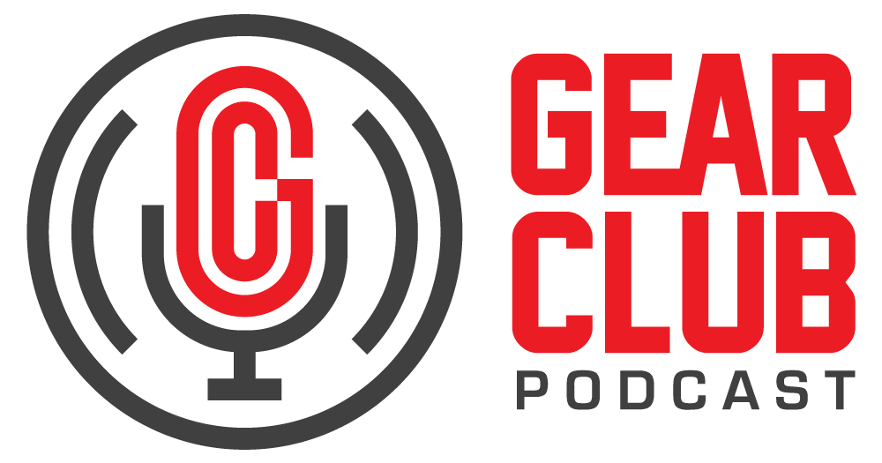

Press Release

Contact: Frank Wells

[frank.wells@clynemedia.com](mailto:frank.wells@clynemedia.com)

Tel: (615) 585-0597

**FOR IMMEDIATE RELEASE**

**Gear Club Podcast explores the making of new album by ZOPA, the rock band featuring Michael Imperioli**

* 1. *New York, NY, July 11, 2025* — The latest episode of [Gear Club Podcast](https://www.gear-club.net/), a conversation and listening party with the rock band ZOPA, is now live online at <https://www.gear-club.net/episodes/zopa>. The episode, titled “ZOPA: Diamond Vehicle,” features an in-depth discussion of the making of the band’s new album, *Diamond Vehicle*, which was produced, engineered, and mixed by Gear Club Podcast host John Agnello.
  2. ZOPA is a New York–based indie rock band that brings together the talents of three musicians: Michael Imperioli on guitar and lead vocals, Elijah Amitin handling bass, keyboards, vocals, and production, and Olmo Tighe on drums. Imperioli is best known for his Emmy Award–winning portrayal of Christopher Moltisanti on *The Sopranos*. Beyond acting, Imperioli is also an accomplished writer and musician. He previously appeared on Gear Club Episode 89, where he discussed the band’s origins and his artistic journey.

In the new episode, John sits down with Imperioli and his bandmates in ZOPA to listen through the album and give listeners a behind-the-scenes look at the recording, songwriting, creative process, and gear that went into this fantastic record.

Gear Club Podcast: “ZOPA: Diamond Vehicle” is available via most podcast apps, including [Apple Podcasts](https://itunes.apple.com/us/podcast/gear-club-podcast/id1187432394?mt=2), [Spotify](https://open.spotify.com/show/18LtEIKnOLXm7eg4Gd3b5o?si=D1V9wMAnRPirnXX2uNnlBg) and [YouTube](https://www.youtube.com/channel/UC40AkKz9GHpteMVDF1TDRKQ), and at [gearclubpodcast.com](https://www.gearclubpodcast.com).

Gear Club Podcast offers an engaging and often irreverent deep dive into the world of audio recording, shining a light on the techniques, experiences, and behind-the-scenes stories shared by some of the most respected engineers, producers, artists and innovators in the industry. Blending technical insight with candid conversations, each episode celebrates the craft and culture of recorded sound. The podcast is proudly sponsored by Eventide, a pioneer in audio effects and recording technology.

For the complete, ever-expanding catalog of Gear Club Podcasts, featuring timeless interviews with leading artists, engineers, producers and studio pros that have drawn 50,000 subscribers, visit <https://www.gear-club.net/>. Gear Club Podcast episodes are also available on most podcast apps including [Apple Podcasts](https://itunes.apple.com/us/podcast/gear-club-podcast/id1187432394?mt=2), [Spotify](https://open.spotify.com/show/18LtEIKnOLXm7eg4Gd3b5o?si=Y5XFpJ2KT0OhV7tQPWFUgQ), [SoundCloud](https://soundcloud.com/gearclub) and [YouTube](https://www.youtube.com/channel/UC40AkKz9GHpteMVDF1TDRKQ).

*...ends 316 words*

* 1. Photo File: GearClubPodcast_ZOPA.jpg   
     Photo Caption: The latest episode of Gear Club Podcast, “ZOPA: Diamond Vehicle,” is now online.

Clyne Media

Email: [frank.wells@clynemedia.com](mailto:frank.wells@clynemedia.com)

Tel: 615-662-1616, Mob: 615-585-0597

Clyne Media, Inc.,

169-B Belle Forest Circle, Nashville, TN 37221;

Web: <http://www.clynemedia.com>