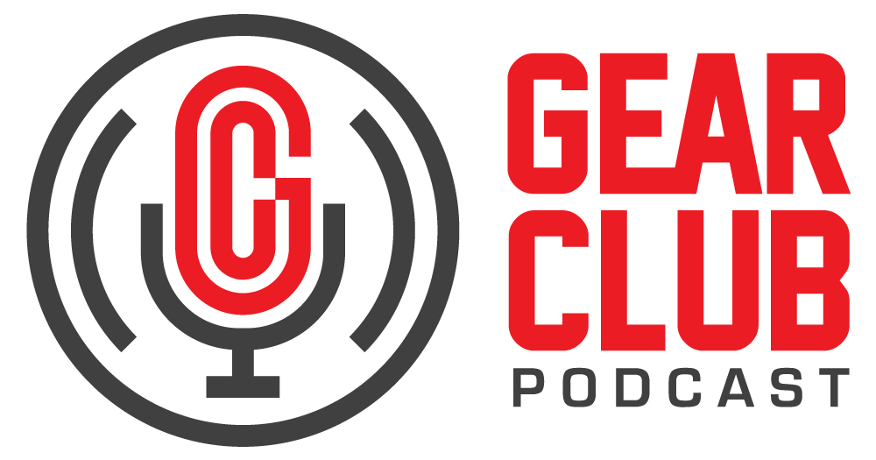

Press Release

Contact: Frank Wells

[frank.wells@clynemedia.com](mailto:frank.wells@clynemedia.com)

Tel: (615) 585-0597

**FOR IMMEDIATE RELEASE**

1. **Gear Club Podcast spotlights Ed Stasium’s immersive Dolby Atmos® remixes of The Ramones using Eventide plug-ins**
   1. *New York, NY, August 26, 2025* — The latest episode of [Gear Club Podcast](https://www.gear-club.net/) features legendary producer and engineer Ed Stasium discussing his groundbreaking work remixing The Ramones’ catalog in Dolby Atmos®. The episode, titled “Updating Punk Classics: Ed Stasium Talks mixing the Ramones, Talking Heads Using Eventide Plugins,” is now online at <https://www.gear-club.net/episodes/edimmersive>.

A longtime pioneer in creative recording techniques, Stasium shares how Eventide’s modern immersive plug-ins have become central tools in his process, bridging his classic analog methods with cutting-edge spatial audio.

Stasium, known for his work with The Ramones, Talking Heads and The Replacements, has a decades-long relationship with Eventide gear. He recalls relying on hardware such as the iconic H910 Harmonizer during the original sessions and now harnesses Eventide’s MicroPitch and Blackhole plug-ins to bring new depth and dimension to immersive remixes.

“I’ve been using Eventide forever; back then it was two 910s, now it’s MicroPitch and Blackhole in my Atmos template,” said Stasium. “These plug-ins let me stay true to the original recordings while opening up the mixes in a way that makes them come alive in immersive audio.”

In the episode, Stasium walks listeners through his Atmos mixes of Ramones classics including “I Wanna Be Sedated” and “Surfin’ Bird.” He explains how Eventide’s plug-ins allow him to recreate the signature effects of the original analog sessions while expanding them into a 3D soundfield. From positioning drum room mics in overhead channels to re-imagining guitar harmonizer effects across surround speakers, Stasium demonstrates how immersive technology is reshaping the way iconic albums can be experienced.

Listeners also gain insight into Stasium’s original recording process, from his use of multiple microphones and overdubs to the creative limitations – and innovations – of working in late-1970s studios. By blending those techniques with today’s immersive tools, he is able to preserve The Ramones’ raw energy while offering fans an entirely new way to experience the music.

Gear Club Podcast offers an engaging and often irreverent deep dive into the world of audio recording, shining a light on the techniques, experiences, and behind-the-scenes stories shared by some of the most respected engineers, producers, artists and innovators in the industry. Blending technical insight with candid conversations, each episode celebrates the craft and culture of recorded sound. The podcast is proudly sponsored by Eventide, a pioneer in audio effects and recording technology.

For the complete, ever-expanding catalog of Gear Club Podcasts, featuring timeless interviews with leading artists, engineers, producers and studio pros that have drawn 50,000 subscribers, visit <https://www.gear-club.net/>. Gear Club Podcast episodes are also available on most podcast apps including [Apple Podcasts](https://itunes.apple.com/us/podcast/gear-club-podcast/id1187432394?mt=2), [Spotify](https://open.spotify.com/show/18LtEIKnOLXm7eg4Gd3b5o?si=Y5XFpJ2KT0OhV7tQPWFUgQ), [SoundCloud](https://soundcloud.com/gearclub) and [YouTube](https://www.youtube.com/channel/UC40AkKz9GHpteMVDF1TDRKQ).

*...ends 426 words*

* 1. Photo File: GearClubPodcast_Stasium_Ramones.jpg   
     Photo Caption: The latest episode of Gear Club Podcast, “Updating Punk Classics: Ed Stasium Talks mixing the Ramones, Talking Heads Using Eventide Plugins,” is now online.

Clyne Media

Email: [frank.wells@clynemedia.com](mailto:frank.wells@clynemedia.com)

Tel: 615-662-1616, Mob: 615-585-0597

Clyne Media, Inc.,

169-B Belle Forest Circle, Nashville, TN 37221;

Web: <http://www.clynemedia.com>