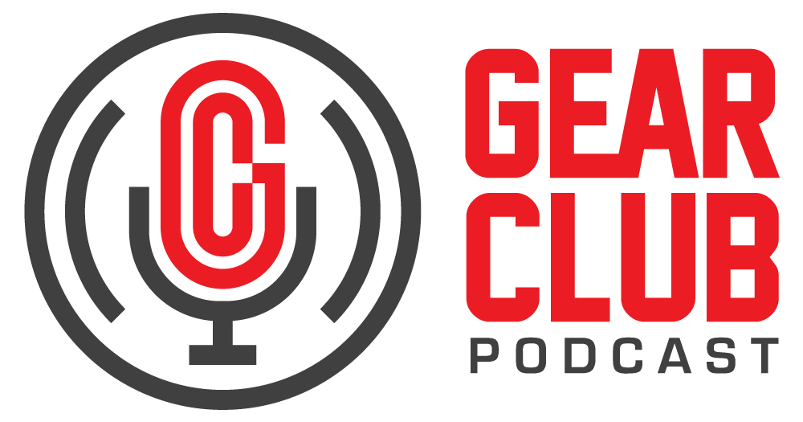

Press Release
Contact: Frank Wells
frank.wells@clynemedia.com
Tel: (615) 585-0597

FOR IMMEDIATE RELEASE

Gear Club Podcast #85 Features Conversation with Matt Wallace

— “A Better Island with Matt Wallace” covers the veteran producer/engineer’s shift to an ATMOS® mixing setup, among many other topics —

New York, NY, June 30, 2022 — The latest episode of Gear Club Podcast, “A Better Island with Matt Wallace,” is now live online at https://www.gear-club.net/episodes/85-matt-wallace, where you’ll also find a TIDAL playlist of recordings from Wallace’s career, including new ATMOS mixes of classic recordings by The Replacements.

Matt Wallace is a producer, engineer, and musician with over 30 years in the industry, working with the likes of Maroon 5, The Replacements, Faith No More, O.A.R, and Paul Westerberg. Lately, Matt’s been working extensively on new and catalog mixing in ATMOS from his studio in Van Nuys, CA. In this interview he takes listeners through the technical and artistic aspects of ATMOS mixing, his production philosophy, working with Faith No More and The Replacements, and why making records isn’t just about the gear.

Be sure to check out Matt’s new ATMOS mixes of classic Faith No More songs, released June 17th on Rhino Warner Music. They’re featured in Gear Club’s TIDAL playlist of the week, and also on Apple and Amazon music streaming services.

Gear Club Podcast provides an in-depth, and sometimes irreverent, look into the world of audio recording with stories told by leading practitioners of the art. The podcast is sponsored by Eventide.

Hosting Gear Club are Stewart Lerman and John Agnello. Lerman is a two-time GRAMMY®-winning music producer and recording engineer based in New York City. His music credits include Elvis Costello, Shawn Colvin, Neko Case, Sharon Van Etten, Patti Smith, The Roches, St. Vincent, Antony and the Johnsons, and David Byrne. His TV and film credits include The Life Aquatic with Steve Zissou, The Royal Tenenbaums, The Marvelous Mrs. Maisel, The Aviator, Vinyl, Cafe Society, Grey Gardens and Boardwalk Empire. Agnello’s career started at the Record Plant in New York City, where he was able to work on some legendary 80s albums by Cyndi Lauper, Aerosmith and John Mellencamp. Since then, he has worked with alt rock legends Dinosaur Jr, Sonic Youth, Son Volt and Patti Smith, and up-and-comers such as Phosphorescent, Kurt Vile and Twin Peaks.

For the complete, ever-expanding catalog of Gear Club Podcasts, featuring timeless interviews with leading artists, engineers, producers and studio pros that have drawn 50,000 subscribers, visit https://www.gear-club.net/. GearClub Podcast episodes are also available on most podcast apps including Apple Podcasts, Google Podcasts, Spotify, Soundcloud and YouTube.

...ends 386 words

Photo File: GearClubPodcast_Episode85_MattWallace.jpeg
Photo Caption: The latest episode of Gear Club Podcast, “Episode 85: A Better Island with Matt Wallace,” is now live online.

Clyne Media
Email: frank.wells@clynemedia.com
Tel: 615-662-1616, Mob: 615-585-0597
Clyne Media, Inc.,
169-B Belle Forest Circle, Nashville, TN 37221;
Web: http://www.clynemedia.com

