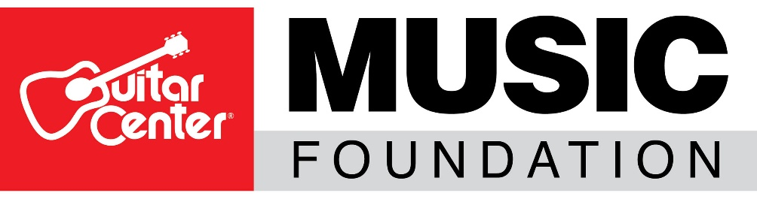

The Guitar Center Music Foundation Leverages the Reach of Guitar Center Stores and Website to Raise over $500K to Assist Music Programs in Need

In the last half of 2020, Guitar Center’s “Round Up Your Change” offer to round up their sale to support music programs across the U.S. was chosen by 52% of GC customers

Upperman High School in Baxter, TN, is one notable beneficiary from the program that received support for the school’s beloved music program, easing a bit of the pain from a difficult 2020 involving the pandemic and a series of other tragedies

WESTLAKE VILLAGE, Calif., March 8, 2021 – The Guitar Center Music Foundation (GCMF), a non-profit organization focused on granting instruments and equipment to music education and music therapy programs, is proud to have received more than $500,000 via a series of Guitar Center’s in-store and online fundraising initiatives known as the “Round Up Your Change” program with all funds used to help keep music education programs alive. During these fundraising drives, Guitar Center customers were given the option of donating to the Guitar Center Music Foundation by rounding up their purchase to the nearest dollar, giving customers an easy way to support music education during the challenging times of the current pandemic crisis.

Between July 5 – August 1 and September 7 – December 31, 2020, the “Round Up Your Change” programs were highly successful with 52% of Guitar Center customers opting to donate, with a total of 829,320 transactions at an average donation of 61 cents. With these donations, 28 music programs across the country were able to receive grants so far with more planned for 2021. Among the music programs that benefited from the “Round Up” donations include Upperman High School in Baxter, TN; Newton County Middle School in Decatur, MS; Jordan High School in Los Angeles, CA; Norfolk Middle School in Norfolk, NE; and others.

The musicians at Upperman High School were able to ease some of the pain of a particularly difficult 2020 with its recent grant from GCMF – in addition to the pandemic, the school’s community of Baxter, TN was also ravaged by tornadoes on March 3, 2020, and a number of other tragedies resulted in the loss of multiple members of the school’s tight family. The school’s Choir Director and Commercial Music instructor, Emily Phillips was especially thankful for the instrument grant which included new guitars, new keyboards for the practice rooms, and a full complement of drums and practice pads where before they were using buckets for the percussion units to keep the young musicians uplifted, inspired and engaged.

“This past year has been devastating, with natural disasters, the pandemic, and personal tragedy framing these months with heaviness and grief. But we know music is a healer, so there was no choice, but to keep at it,” said Emily Phillips, Choir Director and Commercial Music instructor at Upperman High School. “You can tell from the students’ demeanors how stressful this year has been, with funerals in our community being a regular occurrence and quarantines due to pandemic exposure making any sort of routine a non-reality. But then the truck from the Guitar Center Music Foundation showed up literally a week before the one-year anniversary of the major tornado, and it provided not only instruments and excitement, but also just the perfect distraction at the right moment for us. I don’t have the words to express my gratitude to all who contributed.”

David Helfant, Chairman of the Board of the Guitar Center Music Foundation, adds, “I am delighted that the ‘Round Up’ program has been so well received by the customers of Guitar Center. Despite the financial and personal challenges in this country due to the pandemic, people are still reaching into their pockets to help support music education and music therapy. It is a real testament to the kindness and compassionate of the public for music, music education and our foundation.”

Wayne Colwell, Guitar Center EVP, Store Operations, remarks, “Music participation is an essential element in the fabric of our society. At Guitar Center, we learned that more than ever this past year. In support of music programs around the country, we worked with the Guitar Center Music Foundation to develop the ‘Round Up Your Change’ program in our retail stores and online as a means to deliver the emotional healing experience one receives through that gift. A simple concept of ‘rounding up’ to the nearest dollar when checking out is helping to keep music education alive and available in our nation’s underprivileged schools and communities. We are grateful to the over 800,000 customers who helped us raise more than $500k in 2020. Guitar Center is dedicated to ensuring that music is an integral part of as many lives as possible.”

The next Guitar Center “Round Up Your Change” initiative began on February 28 and will run through March 27 in-store and online via Guitar Center’s ecommerce channels.

Music programs in need that would like to be considered for a grant from the Guitar Center Music Foundation should visit http://guitarcenterfoundation.org/grants/grants-info/ for more information.

Photo File 1: GuitarCenter_Upperman_Guitars.jpg
Photo Caption 1: Students from Upperman High School in Baxter, TN, holding their new guitars, the result of a grant from the Guitar Center Music Foundation, who drew from Guitar Center’s in-store and online fundraising initiatives known as the “Round Up Your Change” program.
Photo File 2: GuitarCenter_Upperman_Drums.jpg
Photo Caption 2: Students from Upperman High School in Baxter, TN, shown playing a new DW drum kit and a practice pad, which were part of a recent grant from the Guitar Center Music Foundation.
Photo File 3: GuitarCenter_Upperman_DrumBuckets.jpg
Photo Caption 3: Students from Upperman High School in Baxter, TN, shown playing “bucket drums,” which are what they used prior to receiving new musical instruments from the Guitar Center Music Foundation.
Photo File 4: GuitarCenter_Upperman_MarcusDavis.jpg
Photo Caption 4: Guitar Center Nashville Store Associate Marcus Davis helps assemble a drum kit, part of the musical instrument donation from the Guitar Center Music Foundation.

ABOUT THE GUITAR CENTER MUSIC FOUNDATION
The Guitar Center Music Foundation was founded as a 501(c)(3) in 2005. Since its inception, the Foundation has placed instruments in the hands of over 300,000 persons nationwide through grants to qualifying music education and music therapy programs. The Foundation’s mission is to support music education programs nationally by providing those in need with instruments and by advocating the benefits of music education and music therapy. For more information about the Guitar Center Music Foundation, please visit http://guitarcenterfoundation.org/

ABOUT GUITAR CENTER
Guitar Center is a leading retailer of musical instruments, lessons, repairs and rentals in the U.S. With nearly 300 stores across the U.S. and one of the top direct sales websites in the industry, Guitar Center has helped people make music for more than 50 years. Guitar Center also provides customers with various musician-based services, including Guitar Center Lessons, where musicians of all ages and skill levels can learn to play a variety of instruments in many music genres; GC Repairs, an on-site maintenance and repairs service; and GC Rentals, a program offering easy rentals of instruments and other sound reinforcement gear. Additionally, Guitar Center’s sister brands include Music & Arts, which operates more than 200 stores specializing in band & orchestral instruments for sale and rental, serving teachers, band directors, college professors and students, and Musician’s Friend, a leading direct marketer of musical instruments in the United States. For more information about Guitar Center, please visit www.guitarcenter.com.

FOR MORE INFORMATION PLEASE CONTACT:
Clyne Media | 615.662.1616 | pr@clynemedia.com
Guitar Center | 818.735.8800 | media@guitarcenter.com
Guitar Center Music Foundation | info@GuitarCenterFoundation.org

