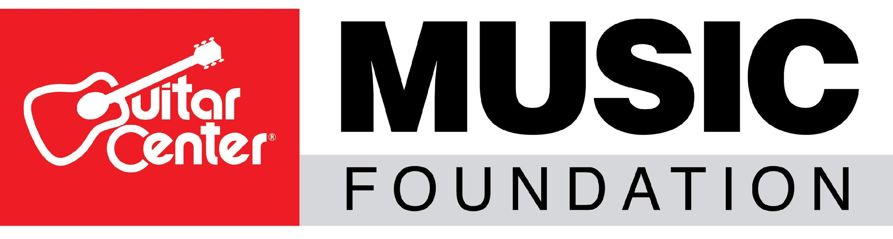
Guitar Center Relaunches Its Music Foundation with the Goal of Expanding Music Education Programs

As its first initiative, the foundation will provide instruments to various women’s music education programs in support of International Women’s Day on March 8

Westlake Village, CA (March 1, 2018) – Today, Guitar Center, the world’s largest instrument retailer, announced the relaunch of its non-profit organization, the Guitar Center Music Foundation. The foundation’s mission will be laser-focused on offering as many individuals as possible the invaluable experience of learning and playing a musical instrument.

Since its original founding in 2005, the foundation‘s charitable efforts have put instruments in the hands of over 200,000 persons nationwide during its rich history of supporting musicians through music education, music therapy programs and other music-centric non-profits.

As the retailer embarks on its 54th year, Guitar Center leadership has decided to expand and guide the organization into reestablishing the Guitar Center Music Foundation in order to provide a large spectrum of gear, as well as lessons and services, to various non-profit organizations that focus on music education.

Additionally, Guitar Center CEO Ron Japinga and Senior Vice President and Chief Customer Officer Jeannine D’Addario will join the board of directors alongside music industry veterans such as Phil Quartararo (Former CEO At Virgin Records, Warner Bros Records and EMI), Janie Hendrix (CEO of the Hendrix Experience), Don Lombardi (DW Drum Workshop Founder & Drum Channel CEO) and more to help shape the future of the foundation and its bright road map ahead.

“The Guitar Center Music Foundation is an exciting opportunity for us to use our resources to reach musicians of all ages and skill levels who may not have access to musical instruments,” said Ron Japinga, Guitar Center CEO. “Guitar Center has always advocated for musicians. We firmly believe that it all starts with fostering strong music education programs, and we’re proud to make that promise to current and future generations of musicians through the Guitar Center Music Foundation. We look forward to identifying new and powerful ways to bring more music into the world and driving positive change within our country’s music education system by giving more people the tools and access they need to find their sound.”

The foundation’s first initiative to help expand music education arrives in sync with International Women’s Day on March 8, which will include a grant of nearly $10,000 worth of instruments and equipment to music education programs that are specifically designed to provide women and girls the opportunity to learn and make music.

“The relaunch of the Guitar Center Music Foundation marks a new beginning for us and is met with a renewed energy and excitement,” said Jeannine D’Addario, Senior Vice President and Chief Customer Officer for Guitar Center. “We’ve always been about serving all musicians, but we know that in order to truly serve them, we need to look beyond our walls. As a member of the board and the Guitar Center family, as well a personal advocate for music education, I look forward to helping grow the foundation’s capabilities and reach to serve musicians of all kinds and musician hopefuls in underserved communities and underfunded schools.”

The relaunched Guitar Center Music Foundation will also stand as one of the largest music charity initiatives by the retailer to date, an impressive feat given Guitar Center’s history of donations to thousands of music educators and schools and its relief efforts to support musicians affected by the recent hurricanes and other natural disasters.

To learn more, visit GuitarCenterFoundation.org and follow @GuitarCenter for more news or discover ways to support the Guitar Center Music Foundation.

###

About Guitar Center:
Guitar Center is the world’s largest retailer of guitars, amplifiers, drums, keyboards, recording, live sound, DJ and lighting equipment. With more than 280 stores across the U.S. and one of the top direct sales websites in the industry, Guitar Center has helped people make music for more than 50 years. Guitar Center also provides customers with various musician based services, including Guitar Center Lessons, where musicians of all ages and skill levels can learn to play a variety of instruments in many music genres; GC Repairs, an on-site maintenance and repairs service; and GC Rentals, a program offering easy rentals of instruments and other sound reinforcement gear. Additionally, Guitar Center’s sister brands include Music & Arts, which operates more than 150 stores specializing in band & orchestral instruments for sale and rental, serving teachers, band directors, college professors and students, and Musician’s Friend, a leading direct marketer of musical instruments in the United States. With an unrivalled in-store experience, an industry-leading online presence and passionate commitment to making gear easy-to-buy, Guitar Center is all about enabling musicians and non-musicians alike to experience the almost indescribable joy that comes from playing an instrument. For more information about Guitar Center, please visit www.guitarcenter.com.

About the Guitar Center Music Foundation:
The Guitar Center Music Foundation was founded in 2005 by Larry Thomas, then former CEO of Guitar Center. Since its inception, the foundation has put instruments in the hands of over 200,000 persons nationwide through donations to qualifying music education and music therapy programs. The foundation’s mission is to support music education programs nationally by providing those in need with instruments and by advocating the benefits of music education. For more information about the Guitar Center Music Foundation, please visit www.GuitarCenterFoundation.org.

FOR MORE INFORMATION PLEASE CONTACT:
Clyne Media | 615.662.1616 | pr@clynemedia.com
Praytell Agency | guitarcenter@praytellagency.com
Guitar Center | 818.735.8800| media@guitarcenter.com

