CHRIS LORD-ALGE INTRODUCES REDNET
INTO HIS STUDIO

As the widespread integration of RedNet into the audio community continues, we were particularly excited to report the adoption of RedNet by the Multi-GRAMMY® Award winning mix engineer Chris Lord-Alge. His case study is presented here, in full, but we thought it necessary to send the cameras in!
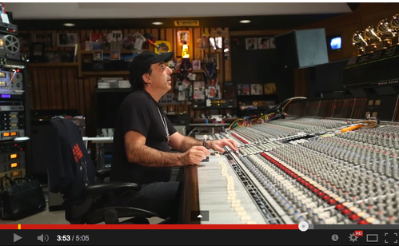
URL: http://youtu.be/zq7ZB68X5NY

For More Information About RedNet go to: www.focusrite.com/rednet

Contact: will.evans@focusrite.com

