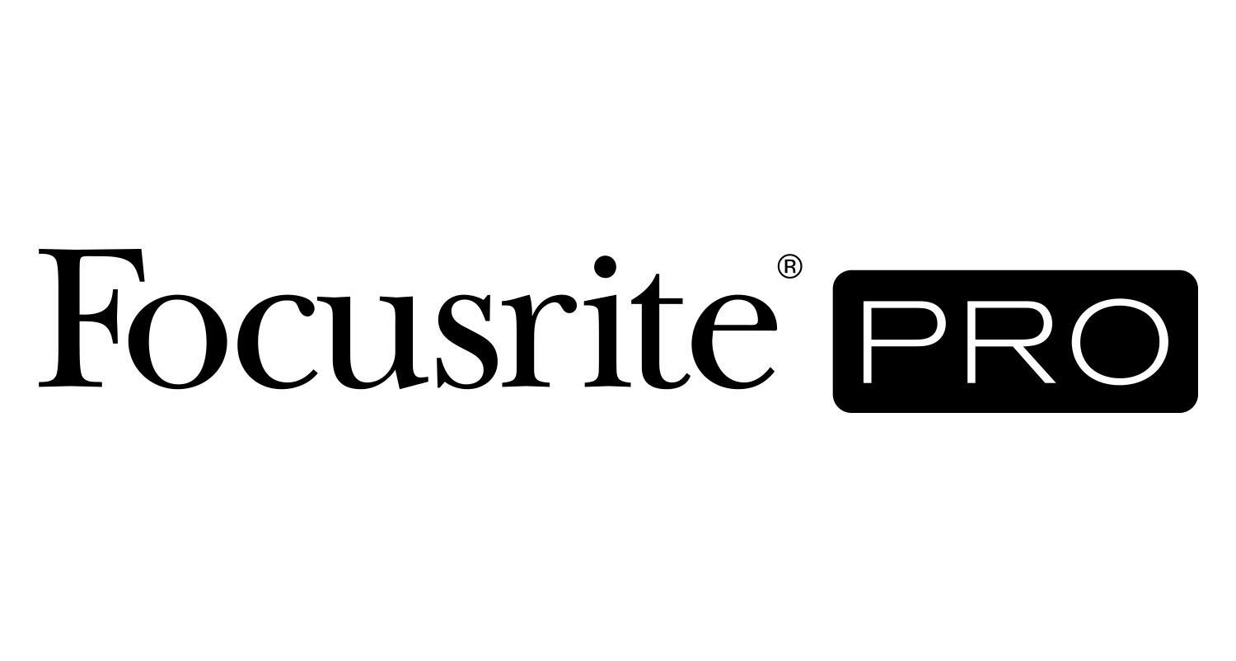
Focusrite RedNet Helps Engineer/Mixer Joe Zook Move into Dolby Atmos®

Los Angeles, CA, February 10, 2022 – Joe Zook began his career in music in Boulder, Colorado, playing guitar in bands while he was in elementary school and junior high. He went on to do some touring, but he always gravitated toward engineering. Spending time in the studio cutting demos, he began learning what happened on the other side of the glass. After working in Austin and then enrolling at the University of Miami, where he studied music theory, jazz, music business and digital audio, Zook decided that if he was really going to have a career in the business, he needed to move to Los Angeles.

In L.A., after several gigs where he got his real-world education, including working at Conway Studios, Sunset Sound and Sunset Sound Factory, Zook struck up a relationship with legendary producer/engineer Jack Joseph Puig. “I was assistant engineer/Pro Tools engineer, as well as sharing engineering and recording duties for Jack, and over the course of a few years, I got to work with a wide variety of artists including Mick Jagger, Sheryl Crow, John Mayer, Vanessa Carlton, No Doubt and dozens more. I learned so much, and then I just started tracking and working as an overdubbing engineer on my own. I slowly watched the percentage of my work going from 90% recording and 10% mixing, to those percentages just completely flipping, and over time I went to mixing 100%.” Today, Zook’s clients read like a who’s-who of the music industry, including AJR, Alessia Cara, Daisy The Great, Jacob Collier, Andy Grammer, Weezer, Modest Mouse, The Hives, One Direction, Pink, Katy Perry and U2. — to date, Zook has mixed and/or recorded albums totaling worldwide sales of over 80 million.

Zook recently upgraded his studio and installed a 7.1.4 Dolby Atmos® system with Focusrite Red 8Pre and RedNet R1 interfaces, alongside a wide variety of equipment including KRK speakers for monitoring. “All of the clients that I’ve been working with began asking me if I’m interested in getting into Atmos and prepping me on how it’s ramping up and how the demands are going to start to increase for immersive mixes,” stated Zook. “Initially I was very skeptical. So I started to do my own extensive research on the consumer side of it, as that is where the rubber meets the road. I began trying a few systems, as I felt I needed to get a true handle on what consumers were going to be hearing. I demo’ed several soundbars, and I started listening to Tidal and Apple Music streaming Atmos and comparing them to the stereo mixes of certain songs. And after about three weeks of checking that out, I knew it was something worth doing. What’s really exciting for me isn’t so much about digging up the past, but imagining how music could be made from scratch without the limitations of stereo.”

Zook began modifying his Los Angeles studio for the Atmos format, and his equipment now consists of a Mac Mini, a Focusrite Red 8Pre and RedNet R1, 13 KRK speakers (seven V-Series V6 speakers surrounding him with four V4s mounted on the ceiling and two S12.4 subwoofers under his desk), a UAD 2 Octo Core Core PCIe DSP Accelerator, and Avid Artist Control console. “My main focus is how it’s going to sound to people in the real world who have various sound bars or speaker systems,” said Zook. “I’d always check the mixes in the living room consumer system (Samsung Q950) and headphones to make sure they are translating to the consumer world as expected.”

Key to the setup in the new studio are the Red 8Pre and RedNet R1, which Zook is completely enamored with. “I really love the RedNet products because they’re very simple to use and they work flawlessly. A lot of times with Atmos, I find myself needing to mute, end, or solo all the speakers. The Focusrite gear allows me to do that and does it so easily. They’re very easy to use, and I never have crashes. Plus they never have problems booting up. Because of the format, there are different sound sources. So I can switch back and forth between a stereo mix or the Atmos mix or streaming off of Apple music or another service easily and quickly. The whole system operates via CAT5 cable and Thunderbolt. It’s bulletproof. Additionally, the sound quality is really good. I never have noticed any degradation in the signal. Everything is smooth. It’s awesome.”

Since Zook has begun mixing in Atmos, he has been extremely busy, and as predicted, he does not see this trend letting up any time soon. “99% of everything I have done in Atmos are brand new mixes,” stated Zook. “I do a stereo mix, and then the artist or label wants an Atmos version of that. This has been happening for almost all of my clients since May. The only Atmos mix that I’ve done so far for a legacy artist is from the catalog album Native by OneRepublic, which I originally mixed in stereo several years ago. Everything else has been new tracks.”

In the production process, going from mixing in stereo to the Atmos, “There’s a huge advantage to having mixed the original stereo version and then mixing it in Atmos,” says Zook. “Because, stereo stems for me, like the regular mix stems, are not enough to do what you can really do in Atmos. So when I make stems, I make a lot of keyboard stems, a lot of guitar stems and a lot of vocal stems, simply to give myself options. Going from one rig to the next, I might say, ‘Oh, I wish I would’ve separated these two instruments.’ So I just go back and make a quick stem. And maybe it’s just for the bridge. Maybe it’s the whole song, whatever. Having that stereo mix ready to pull from is extremely helpful for the way I work.”

As busy as Zook is, streamlining his workflow was a definite consideration when putting together the new studio. In addition to the audio quality and ease of use, Zook highlights how the RedNet gear has increased his efficiency regarding his workflow: “I don't have to noodle with anything. Once everything was set up, I didn’t have to go back and try and fix anything or dial anything in or reboot. Every time I turn the Focusrite gear on, I hit play, it works, and I'm done – it’s very simple. I haven't had to change anything since day one. Again, Focusrite makes their products just very easy to use, they sound great and are super reliable – and that gives me peace of mind.”

Photo file 1: JoeZook_Photo1.jpg
Photo caption 1: Joe Zook, pictured in his recently upgraded studio, complete with a 7.1.4 Dolby Atmos® system with Focusrite Red 8Pre and RedNet R1 interfaces

Photo file 2: JoeZook_Photo2.jpg
Photo caption 2: Joe Zook, working in his studio, whose setup includes a RedNet R1 interface (pictured)

Photo file 3: JoeZook_Photo3.jpg
Photo caption 3: Joe Zook’s recently upgraded studio, complete with a 7.1.4 Dolby Atmos® system with Focusrite Red 8Pre and RedNet R1 interfaces

Photo file 4: JoeZook_Photo4.jpg
Photo caption 4: Closeup of the workstation setup at Joe Zook’s recently upgraded studio

For further information, head to http://pro.focusrite.com or contact:
USA: Tom Edwards +1 (740) 637-5518 // Tom.edwards@focusrite.com,
Robert Clyne +1 (615) 662-1616 // robert@clynemedia.com

About Focusrite Pro
Focusrite Audio Engineering has pioneered professional audio recording technology spanning almost three decades. Focusrite Pro, the company’s Professional and Commercial division, meets the demands of recording, post-production, live sound and broadcast professionals. It consists of RedNet, a fully modular audio-over-IP solution, and the Red range, Focusrite’s flagship multi-format interfaces, along with the heritage ISA range of microphone preamplifiers and analogue signal processors. Focusrite Pro products have been developed to meet the needs of the most demanding applications through a relentless focus on ease of use, quality and reliability. Focusrite is based in High Wycombe, Buckinghamshire, with offices in Los Angeles and Hong Kong.

