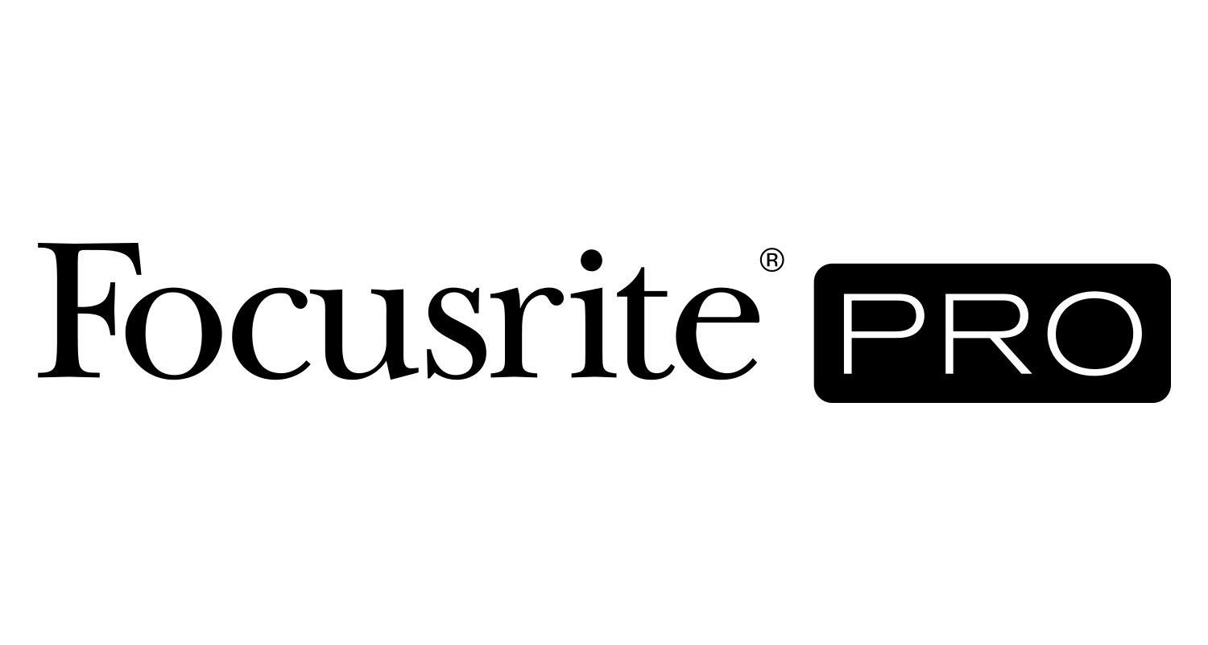
Heiga Studios Relies on Focusrite’s Red 16Line Interface and RedNet R1 Remote Controller

A staple of Miami’s production community, Heiga Studios is a one-stop shop for audio recording as well as audio and video post-production services, all using Focusrite Red 16Line and RedNet R1 technology to manage the studio’s entire signal path, workflow, and monitoring and make the upgrade to Dolby Atmos®

Los Angeles, CA, November 15, 2022 – Heiga Studios is celebrating its 10th anniversary in its current location in Miami’s downtown, where it has provided audio and/or post-production services for clients including Paramount Pictures, EA Games, 2K Games, Sony Music, Universal, Disney, Toyota and Burger King, as well as recordings for acclaimed artists including Prince Royce, Nicky Jam, Carlos Vives, Pedro Capo, CNCO, MicroTDH, HA*ASH, Kany Garcia, Abraham Mateo and Roberto Carlos. The studio’s beginnings go back to the 1990s, when owners Adrian Morales-Demori and Malury Imbernon met as pro audio students in their native Venezuela, later starting Heiga Studios in a garage there (and becoming husband and wife). They started a relocation process to Florida in 2000 (first Imbernon and then Morales-Demori). The business grew, with a subsequent relocation in 2012 to its current 3,200-square-foot facility in Miami.

Most recently, the facility underwent a complete infrastructure renovation, its signal path, workflow, and monitoring configurations now based on the Dante® protocol along with Red 16Line and RedNet R1 units from Focusrite. The paradigm-shifting implementation of the Focusrite units was overseen by Morales-Demori, who was introduced to the Red series when he was designing the Dante integration at another facility in 2020. “We had decided that we wanted to have Dolby Atmos® mixing capability at Heiga Studios, but the infrastructure needed for that seemed to mean that we’d have to buy a lot more equipment to manage it,” he recalls. “I realized that with the R1, we would be able to, for instance, easily switch between stereo and Atmos mix monitoring at the press of a single button. And the Red 16Line does a lot of things from a single unit, including letting us move between multiple DAWs and also act as a hub for Dante which we are regularly investing in more of in the studio. With both DigiLink and Thunderbolt connections on the Red 16Line, it’s easy to switch from Pro Tools | HD to a second DAW without the need to reconfigure option cards in the interface. We just change the host mode either in the RedNet Control software or on the device front panel and change DAWs. We’ve literally rebuilt the studio around Red systems, and it’s made a huge difference.”

Morales-Demori says the R1’s ability to switch seamlessly between stereo and immersive mixing is an enormous plus, allowing clients to shift mix formats between sessions and also to just as seamlessly toggle monitoring modes during sessions to check image and EQ compatibility between immersive and stereo. “All of this is accomplished at the push of a button, instead of having to re-patch every time,” he says. But just as important are the benefits for business. Imbernon remarks, “Being in charge of Heiga Studios as a CEO, my priority is to provide not only the tools our team needs but also a cost- and time-efficient workflow. Coming from an audio engineer background, I would also never sacrifice quality — I understand the trust artists give us when they are here to capture their art. These Focusrite system components meet all my standards out of the box. Their ability to create and switch between complex studio signal workflows, to switch to something like mixing Dolby Atmos, and to easily connect our analog equipment in our racks with anything in the digital domain like Dante or optical, allow our staff and outside producers/engineers to work easily when recording and mixing music making them the perfect gear to future-proof the continuous evolution of the studio. All of this, and the trust I have in Focusrite, was the key to rewire the entire studio.”

Photo file 1: Heiga_Photo1.jpg
Photo caption 1: Heiga Studios co-owner Adrian Morales-Demori controls a Focusrite Red 16Line unit

Photo file 2: Heiga_Photo2.jpg
Photo caption 2: Heiga Studios co-owner Adrian Morales-Demori controls a Focusrite RedNet R1 unit

Photo file 3: Heiga_Photo3.jpg
Photo caption 3: Gear array at Heiga studios, featuring a Focusrite Red 16Line unit

Photo file 4: Heiga_Photo4.jpg
Photo caption 4: Gear array at Heiga studios, featuring a Focusrite Red 16Line unit

Photo file 5: Heiga_Photo5.jpg
Photo caption 5: Gear array at Heiga studios, featuring a Focusrite Red 16Line unit

For further information, head to http://pro.focusrite.com or contact:
USA: Dan Hughley +1 (310) 341-7265 // daniel.hughley@focusrite.com
Robert Clyne +1 (615) 662-1616 // robert@clynemedia.com

About Focusrite Pro
Focusrite Audio Engineering has pioneered professional audio recording technology spanning almost three decades. Focusrite Pro, the company’s Professional and Commercial division, meets the demands of recording, post-production, live sound and broadcast professionals. It consists of RedNet, a fully modular audio-over-IP solution, and the Red range, Focusrite’s flagship multi-format interfaces, along with the heritage ISA range of microphone preamplifiers and analogue signal processors. Focusrite Pro products have been developed to meet the needs of the most demanding applications through a relentless focus on ease of use, quality and reliability. Focusrite is based in High Wycombe, Buckinghamshire, with offices in Los Angeles and Hong Kong.

