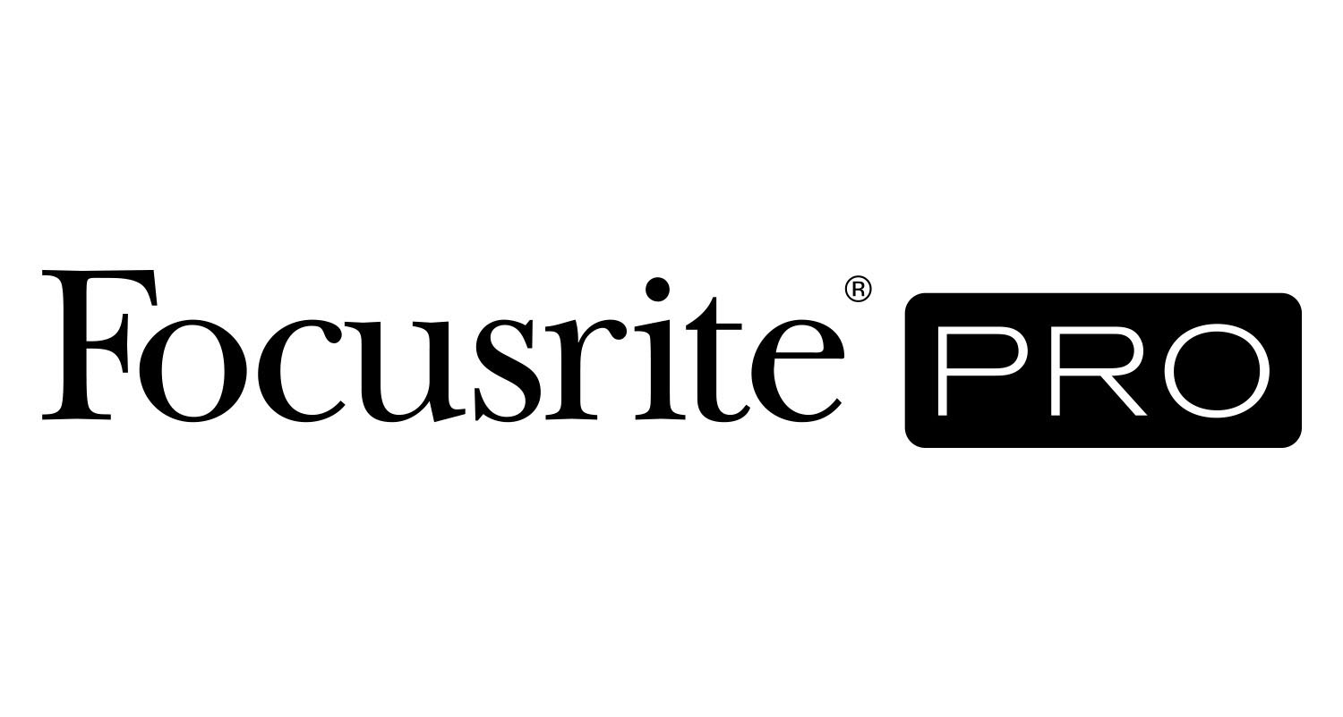

FOR IMMEDIATE RELEASE
Focusrite RedNet, Red and ISA Components Employed at U.K. Audio Post-Production House SNK Studios

NAB Show, Las Vegas, NV, April 8, 2019 – Award-winning UK-based audio post-production house SNK Studios has built an enviable reputation since its humble beginnings in 2003, when it started as a two-man operation working out of a single room in west London. SNK now occupies a six-floor building on the outskirts of Soho in central London, where Focusrite’s (booth C2052) ISA microphone preamplifiers, Red audio interfaces, and RedNet range of Dante™-networked audio converters and interfaces are integral to the facility’s ADR, voice-over recording, sound design, and television and cinema commercial music and mixing services.

“We’ve had a very long relationship with Focusrite gear, since having our first studio setup about 15 years ago,” says studios director and company co-founder Seb Juviler. “That studio had the original ISA 428 preamp, which had just been released by Focusrite. We’ve stuck with the ISAs ever since.”

The sprawling SNK facility, which was built by London-based studios powerhouse Miloco with equipment supplied by reseller Jigsaw24 and Scrub / HHB, also houses several dedicated audio book suites. “They all have an ISA One and are recording hundreds of audiobooks a year,” reports Juviler. SNK currently features four main audio post-production suites delivering short-form commercial audio for agencies and brands and ADR for dramas and features, each equipped with a Focusrite ISA Two dual mic preamp, he says. Plus they have additional 5.1 mix rooms and tracklay and prep systems often deploying Focusrite Scarlett IO. This complex network of interfaces connects the facility’s over 20 Pro Tools systems.

Paired variously with Audio-Technica, DPA, Neumann, Sanken and Sennheiser microphones available in the nine voice-over booths scattered liberally throughout the building, the Focusrite ISA preamps have served a long list of audio book clients, including Audible, Penguin Random House UK and US, Scholastic, Macmillan and others. They are also used for SNK’s foreign dubbing and international versioning work — including shows destined for streaming platforms and international broadcasters.

“Then we’ve got the Atmos suite, which has two ISA 428 Mk II four-channel preamps,” he adds. The Dolby Atmos room, designated Studio 7, is the result of a collaboration between Dolby Europe, acoustician Nick Whitaker, Miloco Builds and speaker manufacturer ADAM Audio. It was completed in 2017 and is Dolby-certified to handle SNK’s bread-and-butter work; short-form commercials for television and cinema presentation, typically in 5.1 and 7.1, Juviler says.

Studio 7 features several Focusrite RedNet interfaces that provide access in to and out of the room’s Avid Pro Tools HDX systems. “We worked closely with the guys at Jigsaw who spec’d the room,” says Juviler. “The RedNet interfaces offer the ability to handle the quantity of channels and objects for Dolby Atmos. Plus, the product line is very modular, so you can pick and choose what you need. Jigsaw were keen to use RedNet for that reason.”

He continues, “They’re running brilliantly, and they sound great. They’ve been in for nearly two years now and work seamlessly with Pro Tools and the Sync I/O, and the BSS Soundweb London signal processor, which handles the audio outputs and mapping.”

More recently, he says, “We’ve put three new Red 16Line’s and new Mac Pro computers into the commercial suites. They can connect up and remote-control preamps and things like that in those rooms. We might be looking at moving some space around in the future and building one big shared live room, so having those Red 16Lines future-proofs the main post suites. If we do build a room, we can quite easily take advantage of RedNet’s Dante networking capabilities, which would be great.”

Photo file 1: studio7.jpg
Photo caption 1: Studio 7 at SNK Studios, featuring several Focusrite RedNet interfaces that provide access in to and out of the room’s Avid Pro Tools HDX systems.

For further information, head to http://pro.focusrite.com or contact:
USA: Dan Hughley +1 (310) 322 5500 // dan.hughley@focusrite.com
Robert Clyne +1 (615) 662-1616 // robert@clynemedia.com

About Focusrite Pro
Focusrite Audio Engineering has pioneered professional audio recording technology spanning almost three decades. Focusrite Pro, the company’s Professional and Commercial division, meets the demands of recording, post-production, live sound and broadcast professionals. It consists of RedNet, a fully modular audio-over-IP solution, and the Red range, Focusrite’s flagship multi-format interfaces, along with the heritage ISA range of microphone preamplifiers and analogue signal processors. Focusrite Pro products have been developed to meet the needs of the most demanding applications through a relentless focus on ease of use, quality and reliability. Focusrite is based in High Wycombe, Buckinghamshire, with offices in Los Angeles and Hong Kong.

