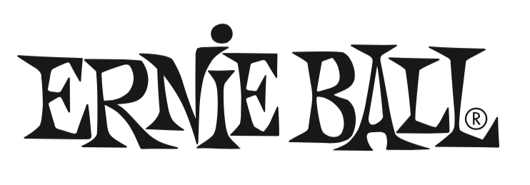

FOR IMMEDIATE RELEASE

Ernie Ball Expands Cable Line with New Sizes of Braided Cables

- Company expands extensive selection of high-quality instrument, microphone, patch and speaker cables that are ultra durable, include a 99.95% oxygen-free copper conductor, are dual-shielded for durability & low noise, and come with a limited lifetime warranty.

(The NAMM Show, Anaheim, CA – January 24, 2019) – Ernie Ball (Booth 4320, D5), the world's premier manufacturer of guitar strings, musical instrument accessories and volume pedals, has expanded its line of instrument cables to now offer 10-foot and 18-foot premium braided cables (braided instrument cables were previously only available as a 25-foot option).

These new braided cables offer ultra-durable, flexible construction; noise-free design with dual-shielding protection; 99.95% oxygen-free copper to resist corrosion; flexible, tangle-resistant performance; clear tone with crisp highs, tight mids and rich harmonics; roadworthy construction; and a limited lifetime warranty.

The new 10- and 18-foot braided cables will be available February 2019 with U.S. pricing as follows:

10ft Standard -- $19.99
10ft Gold Tip -- $21.99
18ft Standard -- $29.99
18ft Gold Tip -- $32.99

Photo file 1: EB_Braided10.JPG
Photo caption 1: Ernie Ball’s 10-foot braided cable

Photo file 2: EB_Braided18.JPG
Photo caption 2: Ernie Ball’s 18-foot braided cable

About Ernie Ball:
In 1962, veteran player and teacher Ernie Ball created Slinkys®, the iconic light gauge electric guitar strings widely revered by hundreds of guitar greats including Eric Clapton, Keith Richards, Jimmy Page, Paul McCartney, Metallica, Brad Paisley, Slash, John Petrucci, The Edge and John Mayer. In addition to industry-standard strings, as well as hand-crafted high-end Music Man® guitars and basses, Ernie Ball Inc. offers state-of-the-art instrument accessories that are carried in more than 6,000 stores in the U.S. and 120 countries worldwide. The family-run company maintains its founder's dedication to preserving the musician's playing experience and delivering superior sound quality through the development of new products, such as Cobalt Slinkys, M-Steel, Earthwood and the revolutionary Element Shield Packaging, keeping each set as fresh as the day they were made. The company also fosters artist development through musician-focused programs such as the world's largest and longest running Battle of the Bands, where unsigned bands compete each year for the chance to play live on national tours, festivals and events. Visit them online at www.ernieball.com and www.music-man.com.

FOR PRESS INQUIRIES, PLEASE CONTACT:
Clyne Media, Inc. / info@clynemedia.com

FOR PRODUCT INFORMATION, PLEASE CONTACT:
Ernie Ball Customer Service / customerservice@ernieball.com

Ernie Ball/Music Man is exhibiting at Booth 4320, D5 at the 2019 NAMM Show in Anaheim, California.

