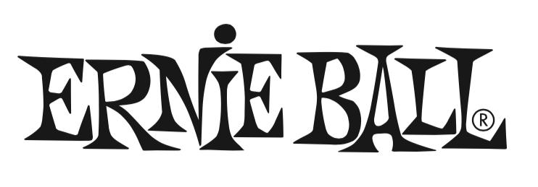

For Immediate Release

Ernie Ball Announces NeverRust String Technology and Replacement Guarantee

- Ernie Ball guarantees strings to never rust or they’ll replace them absolutely free.
- New electric and acoustic guitar strings feature exclusive plasma plating technology for unmatched rust and corrosion resistance up to 300% more than traditional strings.
- Ernie Ball NeverRust technology provides up to 32% greater tensile strength than other string sets.

(The NAMM Show, Anaheim, CA – January 21, 2016) – Ernie Ball (Booth 5440, Hall B), the world's leading manufacturer of guitar strings, musical instrument accessories and volume pedals, announces a major breakthrough in string technology: Ernie Ball NeverRust utilizes a proprietary plasma plating process that provides an unprecedented level of rust and corrosion resistance – up to 300% greater than traditional string sets.

Available on select Ernie Ball electric and acoustic string sets, including Slinkys®, the world’s most popular strings, Ernie Ball’s NeverRust technology also provides up to 32% greater tensile strength than traditional string sets. Derived from tireless research and development by Ernie Ball president Brian Ball and his engineering team, the primary objective was to create an exclusive process that eliminates the potential for rust and corrosion widely associated with guitar strings. Proudly manufactured in the USA, Ernie Ball’s NeverRust plating technology also completely eliminates the use of harmful chemicals and hazardous byproducts, resulting in a more environmentally friendly manufacturing process.

“Guitar strings are one of the most demanding and often overlooked components of a guitarist’s signal chain,” said Brian Ball. “NeverRust technology is the result of our endless dedication and pursuit to improve a musician’s playing experience by developing strings that last longer, resist rust, and breakage – especially for guitarists who sweat and play hard night after night.”

“From the introduction of our first custom-gauged Slinky strings in 1962 to our exclusive Cobalt, M-Steel and now NeverRust technologies, Ernie Ball strives to give guitarists the innovation, performance and reliability they demand in guitar strings,” Ball continued.

Ernie Ball’s NeverRust guarantee commits to replacing any covered set of strings absolutely free up to one-year from purchase. Ernie Ball NeverRust strings will be available in May 2016.

Photo file 1: EB_NeverRust_Photo1.JPG
Photo caption 1: Ernie Ball Regular Slinky strings with NeverRust technology

Photo file 2: EB_NeverRust_Photo2_Earthwood_PB.JPG
Photo caption 2: Ernie Ball Earthwood Phosphor Bronze strings with NeverRust technology.

Photo file 3: EB_NeverRust_Photo3_PromoGraphic.JPG
Photo caption 3: Ernie Ball NeverRust promotional graphic.

About Ernie Ball:
In 1962, veteran player and teacher Ernie Ball created Slinkys®, the iconic light gauge electric guitar strings widely revered by hundreds of guitar greats including Eric Clapton, Keith Richards, Jimmy Page, Paul McCartney, Metallica, Brad Paisley, Slash, John Petrucci, The Edge and John Mayer. In addition to industry-standard strings, as well as hand-crafted high-end Music Man® guitars and basses, Ernie Ball Inc. offers state-of-the-art instrument accessories that are carried in more than 6,000 stores in the U.S. and 120 countries worldwide. The family-run company maintains its founder's dedication to preserving the musician's playing experience and delivering superior sound quality through the development of new products, such as Cobalt Slinkys, M-Steel, Earthwood and the revolutionary Element Shield Packaging, which hermetically seals guitar strings to keep each set as fresh as the day they were made. The company also fosters artist development through musician-focused programs such as the world's largest and longest running Battle of the Bands, where unsigned bands compete each year for the chance to play live on national tours, festivals and events. Visit them online at www.ernieball.com and www.music-man.com.

FOR MORE INFORMATION PLEASE CONTACT:

Sarah Chavey | ANTHEMIC Agency | sarah@anthemicagency.com
Robert Clyne | Clyne Media Inc.| Robert@clynemedia.com

Ernie Ball/Music Man is exhibiting at Booth 5440 (Hall B) at the 2016 NAMM Show in Anaheim, California.

