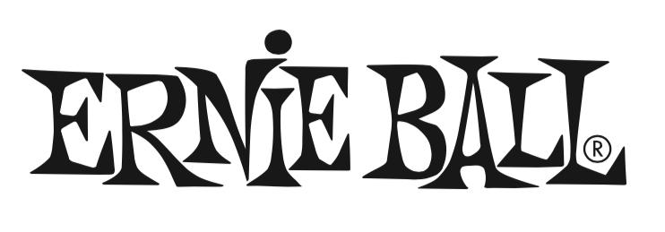

For Immediate Release

Ernie Ball Showcases Expanded Accessories Lineup at NAMM 2016

- Ernie Ball unveils new products highlighting commitment to world-class guitar and bass accessories

(The NAMM Show, Anaheim, CA – January 21, 2016) – Ernie Ball (Booth 5440, Hall B), the world's leading manufacturer of guitar strings, musical instrument accessories and volume pedals, unveils an expanded line-up of guitar and bass accessories at NAMM 2016. The company is showcasing a new range of Ultraflex instrument cables; the new Flex Tune tuner; a Polylock self-locking guitar and bass strap; and a new Pick Buddy adhesive-free pick holder.

“At NAMM 2016 we’re showing our retail partners that we’re strengthening our position in the accessories market in a big way,” said Brian Ball, President of Ernie Ball. “Ernie Ball is committed to providing guitarists and bassists with innovative improvements on traditional designs as well as giving dealers a comprehensive line of accessories that will help contribute to their bottom line.”

Ernie Ball will also be offering a new Ultraflex cable series including instrument, speaker, and patch cables. The cables feature premium construction, connectors and internal wire and combine clear sound with low handling noise and road-tough durability. The Ernie Ball Ultraflex cable line will consist of 10-foot and 20-foot straight instrument cables, 25-foot coiled instrument cables, a 10-foot speaker cable, and 6-inch patch cables.

The Flex Tune tuner offers Chromatic, Guitar, Bass, Violin and Ukulele tuning modes, a large, vibrant 2-inch LCD display, selectable sensor modes for mic or clip vibration, precise pitch calibration, and dual-axis 360-degree pivot arm. The Flex Tune is powered by a three-volt lithium battery.

Ernie Ball’s Polylock guitar and bass straps feature a patent-pending self-locking mechanism that securely holds the strap without the need for modification or bulky hardware. Adjustable from 38 to 67 inches, the Polylock easily fastens to the instrument’s existing strap buttons. Polylock is available now for $24.99 SRP

Ernie Ball’s Pick Buddy is a compact, adhesive-free pick holder that mounts on a guitar or bass to keep a pick close at hand. It’s made from a special thermoplastic material that’s removable and reusable and safe for use on all guitar finishes. Pick buddy is available now for $4.99 SRP

Photo file 1: EB_FlexTune.JPG
Photo caption 1: Ernie Ball’s new FlexTune tuner

Photo file 2: EB_FlexTune_PromoGraphic.JPG
Photo caption 2: Ernie Ball FlexTune tuner promotional graphic

Photo file 3: EB_PickBuddy_Guitar.JPG
Photo caption 3: Ernie Ball’s Pick Buddy with guitar

Photo file 4: EB_PickBuddy.JPG
Photo caption 4: Ernie Ball’s Pick Buddy

Photo file 5: EB_Polylock.JPG
Photo caption 5: Ernie Ball’s Polylock guitar strap

Photo file 6: EB_Polylock_MxPx.JPG
Photo caption 6: Ernie Ball’s Polylock guitar strap, being used by MxPx’s Mike Herrera

About Ernie Ball:
In 1962, veteran player and teacher Ernie Ball created Slinkys®, the iconic light gauge electric guitar strings widely revered by hundreds of guitar greats including Eric Clapton, Keith Richards, Jimmy Page, Paul McCartney, Metallica, Brad Paisley, Slash, John Petrucci, The Edge and John Mayer. In addition to industry-standard strings, as well as hand-crafted high-end Music Man® guitars and basses, Ernie Ball Inc. offers state-of-the-art instrument accessories that are carried in more than 6,000 stores in the U.S. and 120 countries worldwide. The family-run company maintains its founder's dedication to preserving the musician's playing experience and delivering superior sound quality through the development of new products, such as Cobalt Slinkys, M-Steel, Earthwood and the revolutionary Element Shield Packaging, which hermetically seals guitar strings to keep each set as fresh as the day they were made. The company also fosters artist development through musician-focused programs such as the world's largest and longest running Battle of the Bands, where unsigned bands compete each year for the chance to play live on national tours, festivals and events. Visit them online at www.ernieball.com and www.music-man.com.

FOR MORE INFORMATION PLEASE CONTACT:

Sarah Chavey | ANTHEMIC Agency | sarah@anthemicagency.com
Robert Clyne | Clyne Media Inc.| Robert@clynemedia.com

Ernie Ball/Music Man is exhibiting at Booth 5440 (Hall B) at the 2016 NAMM Show in Anaheim, California.

