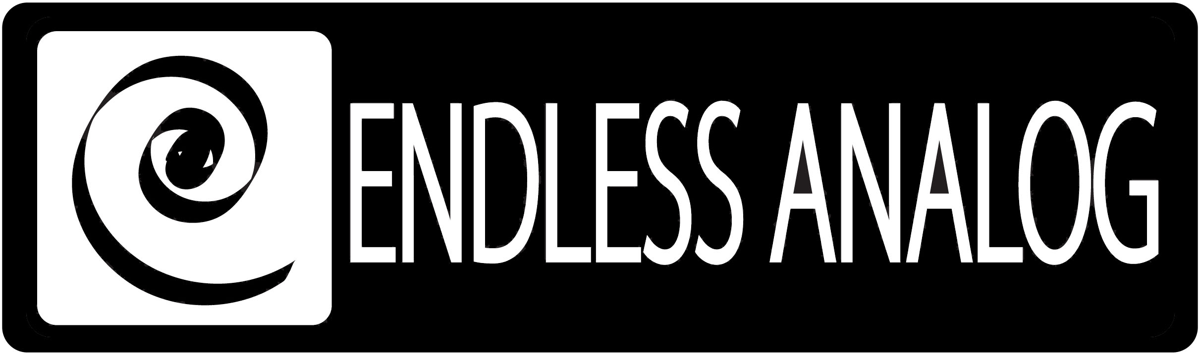

PRESS RELEASE
Media Contact: Robert Clyne
Clyne Media, Inc.
Robert@clynemedia.com
Tel: (615) 662-1616
Fax: (615) 662-1636

FOR IMMEDIATE RELEASE

BUDDY MILLER AND MIKE POOLE CHOOSE

ENDLESS ANALOG’S CLASP®

— Nashville pros rediscover their sonic roots while staying in the digital realm, keeping an efficient and inspired workflow in the studio —

NASHVILLE, TN, November 17, 2010 — Nashville-based Buddy Miller and Mike Poole have carved out impressive resumes, both working together and separately. As consummate music professionals, Miller and Poole are extremely in-demand throughout the Nashville music community and beyond. Miller’s credits include production and/or instrumental work with super-producer T-Bone Burnett and such artists as Emmylou Harris, Patty Griffin, Shawn Colvin, Alison Kraus, Solomon Burke and Robert Plant; and Poole’s work includes sessions with Patty Griffin, David Rawlings & Gillian Welch, Martina McBride, Keith Urban and many more. Both are involved in Robert Plant’s new Band of Joy project – Miller as instrumentalist, producer and band member, and Poole as engineer and mixer. Recently, Miller and Poole began using Endless Analog’s CLASP® (Closed Loop Analog Signal Processor) system, which uniquely integrates analog tape machines into the digital audio production workflow. It has already proven to be revolutionary tool for them, bridging their analog tape roots with the convenience and efficiency of digital workflow. Miller and Poole purchased CLASP from Vintage King Audio.

“CLASP is the only game in town,” states Miller. “You lose something when you’re not going through tape, and there’s nothing else that does what CLASP does, allowing you to integrate your DAW and tape machines together. I admit, I bought into the all-digital workflow, but after revisiting analog tape, I realized it’s such a stark contrast, and I had to go back. And when combined with the editing capabilities of Pro Tools, it’s the best of both worlds.”

Poole particularly appreciates the efficiency of CLASP. He states, “When you use CLASP, you do not have to be transferring takes back-and-forth from a tape machine into Pro Tools – it’s all in real time. It makes the work go faster because you’re not having to deal with synchronization, transfers or manual realignment. The overdub process is a lot faster. Both Buddy and I like to work on analog tape, and the CLASP lets us use analog more efficiently in conjunction with the digital workstation. Additionally, I love the zero-latency monitoring – performers are a lot more comfortable when they are hearing their voice and instruments in real time with no latency. Also, with CLASP you only need one tape reel, so you’re not keeping dozens of master reels around, and it reduces overall tape cost for a project.”

Already, Miller and Poole have used CLASP on a session for Lee Ann Womack, who was recording a song for a Loretta Lynn tribute album. They are planning on using it during upcoming sessions for Miller’s collaborative album with Emmylou Harris, Shawn Colvin and Patty Griffin.

“It is very rewarding to be able to go back to my roots,” stated Miller, referencing his career beginnings, immersed in the sound of tracks recorded to analog tape. “And to be able to keep focus in the studio. There is no down time while you dump tracks between machines, which can be a real groove buster for the session. CLASP keeps the momentum going, and keeps the sound classic and warm.”

About CLASP
CLASP is the world’s first and only pro audio hardware that lets you record on real analog tape with digital speed. CLASP provides sample accurate tape synchronization with zero latency analog monitoring while delivering a true Analog front end recording solution for Pro Tools and other DAW’s. Already being used by top artists, producers and engineers worldwide, CLASP is re-inventing analog for the digital age. CLASP is employed by a diverse range of artists, engineers, producers and facilities, including Lenny Kravitz (at his new Bahamas-based Gregory Town Sound recording facility); Michael W. Smith; Denis Savage, engineer for Celine Dion; Butch Walker (Panic at the Disco, Pink, Avril Lavigne); producers Nathan Chapman, Dave Cobb, Chuck Ainlay, John Fields and Tom “T-Bone” Edmunds; and studio facilities such as Clearwater, Florida’s Cleartrack Productions, Los Angeles, California’s Hemispheres Recording and Austria’s Prime Studios. Analog tape manufacturers recommended by Endless Analog for use with CLASP include ATR Magnetics and RMG International.

For more information, please visit http://www.endlessanalog.com.
… ends 657 words
###

About Endless Analog
Founded by inventor, musician and record producer Chris Estes, Endless Analog is a Nashville-based company developing and manufacturing innovative boutique audio processing products for the recording and broadcast market sectors. The first of these products is the critically acclaimed CLASP® (Closed Loop Analog Signal Processor). In developing CLASP, Estes' vision was simple: to create a revolutionary product that would, for the first time in history, bring user-friendly and cost-effective analog tape recording to every studio environment around the world. It is this bridging of worlds – analog and digital, old and new, classic and modern – that defines Endless Analog's growing product line and visionary approach to their craft.

Contact information:
Endless Analog – Amy Becker – 3212 West End Ave, Suite 500, Nashville, TN 37203 – www.endlessanalog.com – amy@endlessanalog.com – 866-929-4446

