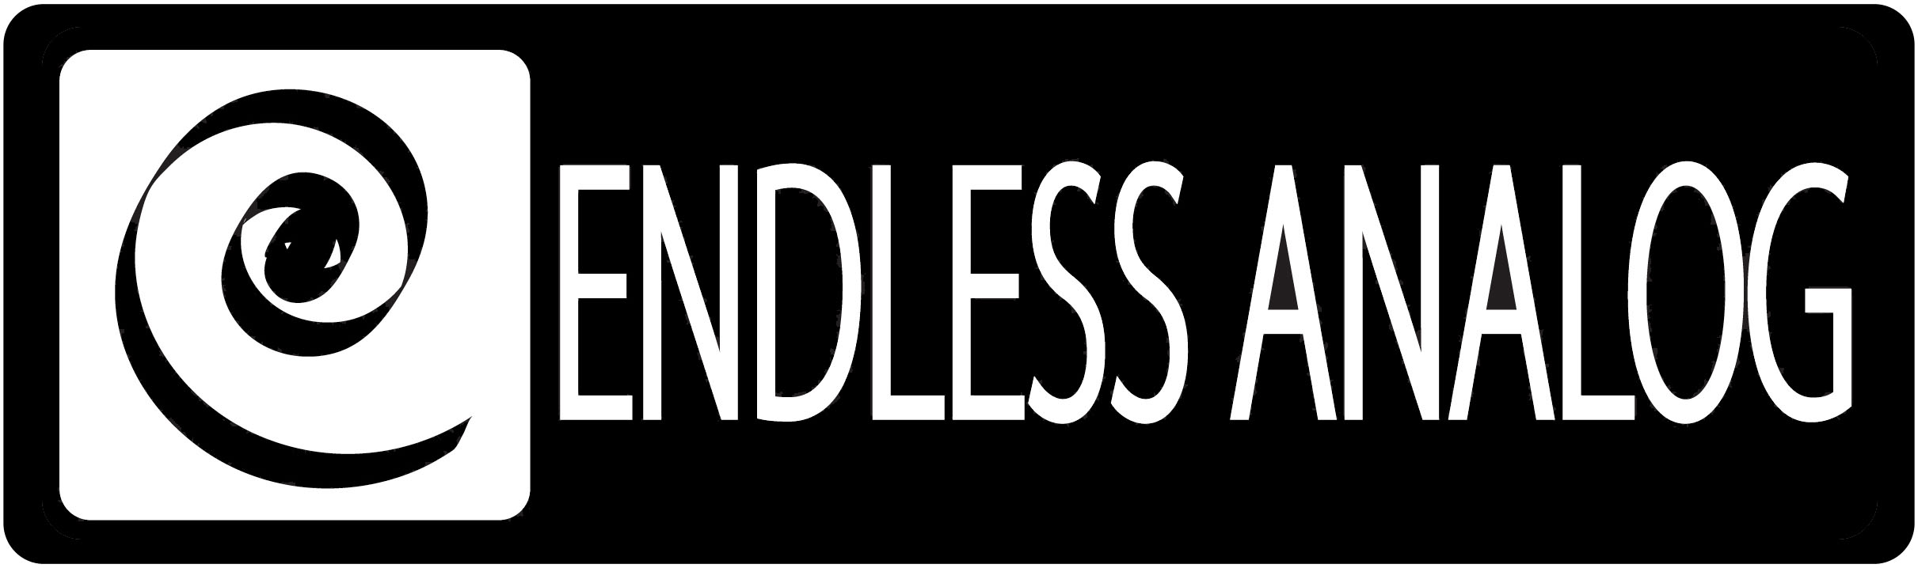

PRESS RELEASE
Media Contact: Robert Clyne
Clyne Media, Inc.
Robert@clynemedia.com
Tel: (615) 662-1616
Fax: (615) 662-1636

FOR IMMEDIATE RELEASE

GREG COLLINS CHOOSES CLASP® (CLOSED LOOP ANALOG SIGNAL PROCESSOR) TO RECORD UPCOMING KISS ALBUM

— Co-producing with KISS’s Paul Stanley, Collins is able to get the warm sound of analog tape while not having to sacrifice any of the convenience of digital recording, thanks to CLASP® —

NASHVILLE, TN, June 21, 2011 — Engineer/producer Greg Collins, known for his work with No Doubt, U2, Matchbox Twenty, and dozens of other top acts, was looking for ways to evolve the sound he and rock legends KISS had achieved on their first collaboration, 2009’s Sonic Boom, as the band records their new upcoming LP. Sonic Boom was recorded on analog tape and edited in Pro Tools, but the two processes were separate from each other, necessitating frequent extended pauses in recording for tape transfers. The recording of the new LP, on the other hand, makes good use of Endless Analog’s CLASP® (Closed Loop Analog Signal Processor) system, which uniquely integrates analog tape machines into the digital audio production workflow. With CLASP, Collins and the band can use analog tape while tracking to Pro Tools in real time, opening up the sonic space of tape to the convenient editing capabilities of the digital recording workspace.

Collins recalls, “I first heard about CLASP through an engineer friend of mine named Ryan Boesch, and then again from Dave Cobb, who was using the box with The Secret Sisters. People were talking about CLASP, and I wanted to check it out. I went to Endless Analog’s web site and saw Bryan Lenox giving a pretty thorough description, and this was right around the time we were making plans for the new KISS album, and I knew it would be the perfect opportunity for me to put CLASP to good use. We had done a majority recording for Sonic Boom using tape, and we loved the sound, but punch-ins were challenging at times, and getting the tracks into Pro Tools for editing took a lot of time. But mainly, we enjoyed the process of using tape, and everyone enjoys the convenience that digital recording offers. If there had been a way with that first record to get the best of both worlds at the same time, we would have done it. And now there is that reality [with CLASP], so we had to give it a try. I sat down with Paul Stanley, who is once again producing, while I am co-producing, engineering and mixing. Paul really knows his way around a studio, but he lets me manage the gear side of things. He gave the go-ahead to use CLASP, so we went for it.”

Once they acquired CLASP, Endless Analog President/Founder and CLASP inventor Christopher Estes made a personal visit. Collins continues, “I got in touch with Chris, and he was good enough to come out and set us up on the first day in the studio, and he stuck with us through the first few days of tracking to make sure that it was all going smoothly, which it did. And it was such a good experience. For me, the tape sound, for a hard rock band, is the ideal sound. It deals with the transients in a way that’s really nice and easy on the ears. Drums for instance – it keeps them sounding punchy and powerful, but not ‘painful,’ like you might associate with a digitally recorded drum sound. Tape is an important part of the right sound, and CLASP makes it possible to not have to sacrifice any of the perks of digital.”

Collins is fond of several things that CLASP makes possible. “For me, maybe the most beneficial thing about CLASP was that it allowed me to easily A-B different sounds – monitoring the sounds pre-CLASP, or through CLASP with different tape speeds and other factors like EQ alignment curve. When it is that easy to compare different sounds, it gives you all sorts of opportunities to mold the sound the way you want it, before it gets recorded. In that situation, it is not a big challenge to hear what works best at which tape speed. We used some 30 ips and some 15 ips – and of course, mixing those different tape speeds wouldn’t be possible without CLASP. It allows you to go back to adjusting the sound for tape, like the old days, but now you’re implementing tape in a more deliberate way – there doesn’t have to be any guess-work. And aside from all that, it made doing punch-ins on guitar and bass completely non-destructive, just as it would be with a regular Pro Tools session, only we’re hitting tape in the process.”

Commenting on the use of CLASP during the KISS sessions, Paul Stanley stated, “CLASP allows us to go ‘back to analog’ for all the warmth and classic sonic characteristics but with all the convenience and advantages of Pro Tools. It's a no brainer and you just can't lose with CLASP. I'm a believer."

Collins also recalls how nice it was to keep things moving. “There was zero downtime needed for transferring the tracks into Pro Tools. The band is so tight and well-rehearsed, and it’s so great to just start a session and knock out a song in two or three takes. A few punch-ins and the track is pretty much there. It’s so efficient; it just keeps the creativity and performance going. And the band loves the sound. Honestly, every time the guys walked in the control room for playback, everybody was so impressed – they said, ‘It sounds even better than last time, and we loved what it sounded like last time.’”

Visit www.endlessanalog.com for more information.

About CLASP
CLASP (Closed Loop Analog Signal Processor) is the world’s first and only pro audio hardware that lets you record on real analog tape with digital speed. CLASP provides sample accurate tape synchronization with zero latency analog monitoring while delivering a true Analog front end recording solution for Pro Tools and other DAW’s. Already being used by top artists, producers, and engineers worldwide, CLASP is re-inventing analog for the digital age. CLASP is employed by a diverse range of artists, engineers, producers and facilities, including Lenny Kravitz (at his new Bahamas-based Gregory Town Sound recording facility); Michael W. Smith; John Shanks (Bon Jovi, Melissa Etheridge, Keith Urban); Fraser T. Smith (Adele, Cee Lo Green, Taio Cruz); Denis Savage, engineer for Celine Dion; Butch Walker (Panic at the Disco, Pink, Avril Lavigne); producers Nathan Chapman, Dave Cobb, Chuck Ainlay, John Fields and Tom “T-Bone” Edmunds; and studio facilities such as England’s legendary Abbey Road Studios, Clearwater, Florida’s Cleartrack Productions, Los Angeles, California’s Hemispheres Recording and Austria’s Prime Studios. Analog tape manufacturers recommended by Endless Analog for use with CLASP include ATR Magnetics and RMG International.

… ends 1080 words
###

Photo File: Stanley_Collins_CLASP.JPG
Photo Caption: Shown L-R: Paul Stanley of KISS and engineer/co-producer Greg Collins in the studio with CLASP (Closed Loop Analog Signal Processor).

About Endless Analog
Founded by inventor, musician and record producer Christopher Estes, Endless Analog is a Nashville-based company developing and manufacturing innovative boutique audio processing products for the recording and broadcast market sectors. The first of these products is the critically acclaimed CLASP® (Closed Loop Analog Signal Processor). In developing CLASP, Estes' vision was simple: to create a revolutionary product that would, for the first time in history, bring user-friendly and cost-effective analog tape recording to every studio environment around the world. It is this bridging of worlds – analog and digital, old and new, classic and modern – that defines Endless Analog's growing product line and visionary approach to their craft.

Contact information:
Endless Analog – Amy Becker – 3212 West End Ave, Suite 500, Nashville, TN 37203 – www.endlessanalog.com – amy@endlessanalog.com – 866-929-4446

