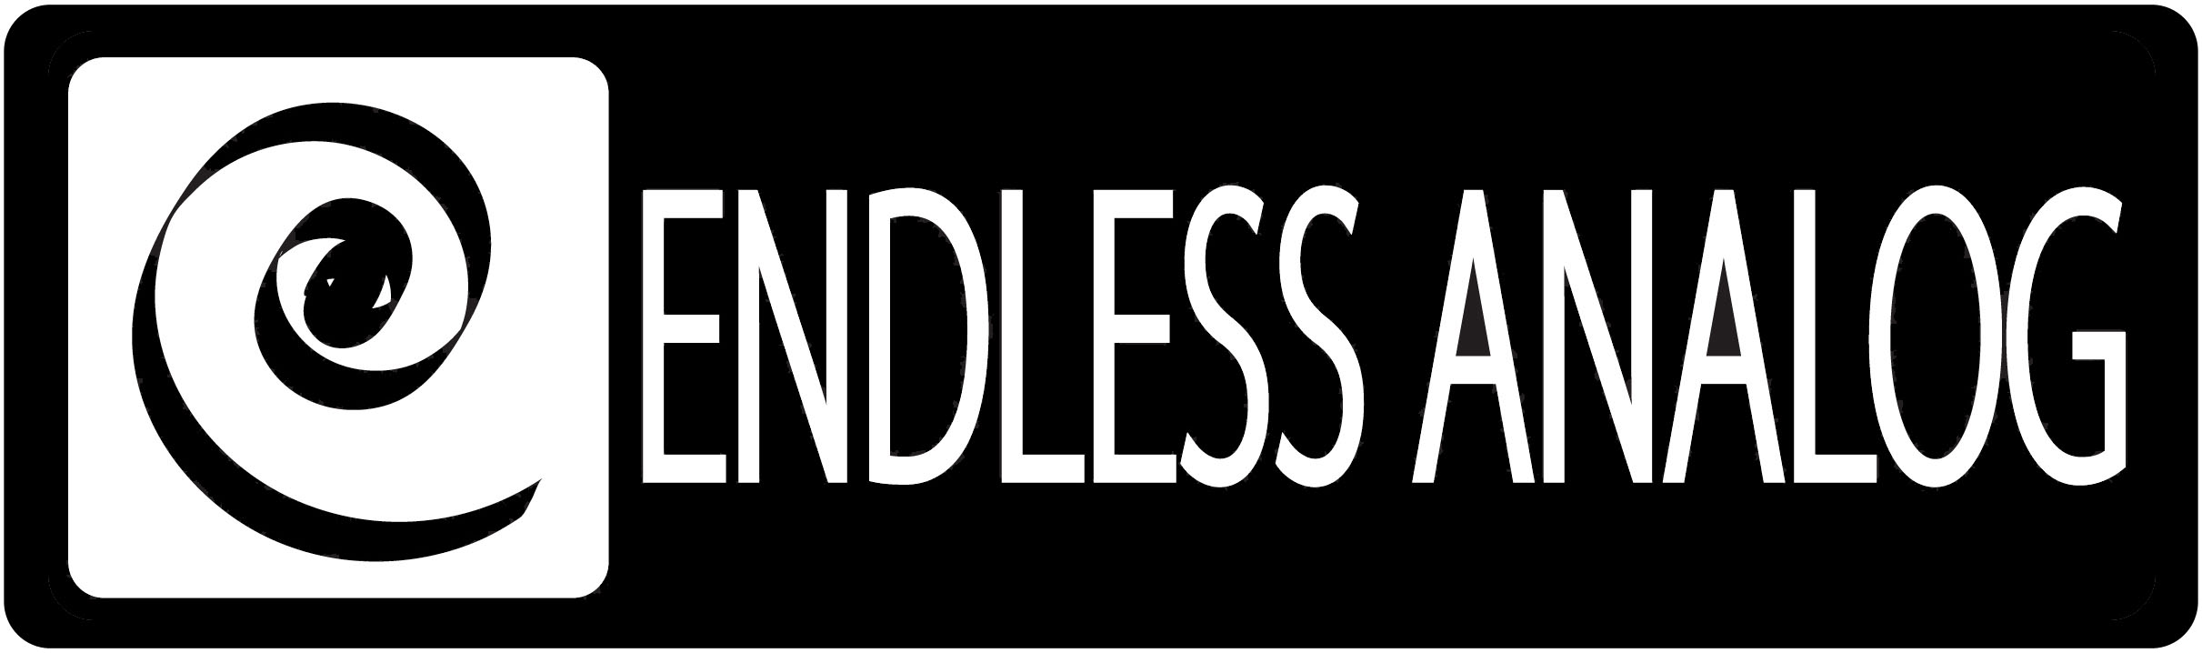

PRESS RELEASE
Media Contact: Robert Clyne
Clyne Media, Inc.
Robert@clynemedia.com
Tel: (615) 662-1616
Fax: (615) 662-1636

FOR IMMEDIATE RELEASE

PRODUCER FRASER T. SMITH BRIDGES NEW AND classic sounds WITH ENDLESS ANALOG’S CLASP®

— The first CLASP® purchaser in the U.K., Smith knows the importance of rich sound, even on the most contemporary pop and dance tracks, and CLASP is now one of his essential tools to get him there —

NASHVILLE, TN, April 6, 2011 — Endless Analog’s CLASP® (Closed Loop Analog Signal Processor) system, which uniquely integrates analog tape machines into the digital audio production workflow, has recently become an integral part of the studio setup of award-winning British producer, songwriter, mix engineer and multi-instrumentalist Fraser T. Smith. In fact, Smith has the distinction of being the first in the U.K. to purchase CLASP, and of being among CLASP’s highest-profile users to date. One of the hottest writer -producers in today’s pop music scene, Smith’s discography includes tracks on recent smash albums from Adele and Cee Lo Green and a track on Britney Spears’ new album, Femme Fatale, as well as work with such talents as Taio Cruz, Clare Maguire, James Morrison and more. Dedicated to warm, nuanced sound, he is a firm supporter of the use of analog tape in the recording studio, and his recent purchase of CLASP has revolutionized his workflow and helped him capture the classic sounds he is looking for while producing thoroughly modern dance and pop tracks.

Smith became acquainted with CLASP through a friend in Los Angeles, who knew of CLASP through Nathan Chapman, best known as Taylor Swift’s producer. He recalls, “I knew Nathan’s work on the fantastic Taylor Swift stuff, and my friend was reiterating how great CLASP is, so I felt compelled to visit Endless Analog’s website and learn a bit about the box. I was struck by the amount of engineers, producers and musicians who I totally respect, giving their endorsement and raving about CLASP. I knew I had to get one immediately.”

Smith’s signal chain was already utilizing a mix of classic and modern, with a vintage Otari Mark-III analog tape machine. “We were already using the tape machine, but we were bouncing stuff out after we recorded it in, as many engineers do,” he states. “I figured if we could integrate CLASP in the way I hoped, it would save many steps in the recording process and indeed improve the sound across the board. And that’s what happened.”

It did not take long for Smith to fully appreciate CLASP. He notes, “It is so flawless. Basically we can’t even tell it’s working, which is a great thing. We can just hear the difference. It’s invisible. A lot of other producers and engineers are using CLASP and tape intentionally to get a more traditional sound, but I use it in a different way – on modern dance records – and I think this shows the versatility of tape and of CLASP. Aside from vocals, bass, guitar and drum tracks, I’m tracking all my drum machines and synths through it - it’s incredible.”

CLASP has also helped Smith get great performances from his artists. “When you’re tracking with an amazing singer like Cee Lo or Adele, the zero-latency monitoring really helps the performers deliver at the top of their game. And because they’re hearing that richness in real time, we get to record some magical moments. Artists like that feel at home when they are in the vocal booth, and out of the corner of their eye, they can see tape roll. And beyond that, there is no time wasted waiting for tracks to bounce or tape to rewind. And finally, when the mixing starts, I find the tracks so much easier to blend, because I’m using less EQ and compression. The tape has put its own natural EQ and compression on the track, which is better all-around.”

Smith’s star will continue to rise throughout 2011, as he is currently working on high-profile projects with such artists as Natalie Findlay, Rough Diamondz, and The Kooks. Through it all, he will be working with analog tape and his CLASP. “It’s an unbelievable system,” he adds. Visit www.endlessanalog.com and www.frasertsmith.com for more information.

About CLASP
CLASP (Closed Loop Analog Signal Processor) is the world’s first and only pro audio hardware that lets you record on real analog tape with digital speed. CLASP provides sample accurate tape synchronization with zero latency analog monitoring while delivering a true Analog front end recording solution for Pro Tools and other DAW’s. Already being used by top artists, producers, and engineers worldwide, CLASP is re-inventing analog for the digital age. CLASP is employed by a diverse range of artists, engineers, producers and facilities, including Lenny Kravitz (at his new Bahamas-based Gregory Town Sound recording facility); Michael W. Smith; John Shanks (Bon Jovi, Melissa Etheridge, Keith Urban); Fraser T. Smith (Adele, Cee Lo Green, Taio Cruz); Denis Savage, engineer for Celine Dion; Butch Walker (Panic at the Disco, Pink, Avril Lavigne); producers Nathan Chapman, Dave Cobb, Chuck Ainlay, John Fields and Tom “T-Bone” Edmunds; and studio facilities such as England’s legendary Abbey Road Studios, Clearwater, Florida’s Cleartrack Productions, Los Angeles, California’s Hemispheres Recording and Austria’s Prime Studios. Analog tape manufacturers recommended by Endless Analog for use with CLASP include ATR Magnetics and RMG International.

… ends 803 words
###

Photo File: FraserTSmith_CLASP.JPG
Photo Caption: Award-winning British producer, songwriter, mix engineer and multi-instrumentalist Fraser T. Smith, pictured with his CLASP® system from Endless Analog.

About Endless Analog
Founded by inventor, musician and record producer Chris Estes, Endless Analog is a Nashville-based company developing and manufacturing innovative boutique audio processing products for the recording and broadcast market sectors. The first of these products is the critically acclaimed CLASP® (Closed Loop Analog Signal Processor). In developing CLASP, Estes' vision was simple: to create a revolutionary product that would, for the first time in history, bring user-friendly and cost-effective analog tape recording to every studio environment around the world. It is this bridging of worlds – analog and digital, old and new, classic and modern – that defines Endless Analog's growing product line and visionary approach to their craft.

Contact information:
Endless Analog – Amy Becker – 3212 West End Ave, Suite 500, Nashville, TN 37203 – www.endlessanalog.com – amy@endlessanalog.com – 866-929-4446

