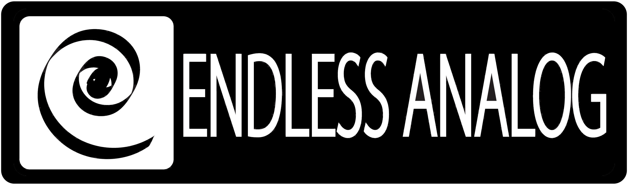

PRESS RELEASE
Media Contact: Robert Clyne
Clyne Media, Inc.
Robert@clynemedia.com
Tel: (615) 662-1616
Fax: (615) 662-1636

FOR IMMEDIATE RELEASE

DAVE COBB CHOOSES CLASP® FOR SECRET SISTERS

— Universal Republic’s retro-styled Secret Sisters, produced by Cobb and executive produced by T-Bone Burnett, were recorded with analog tape while keeping a modern workflow recording pace, thanks to Endless Analog’s CLASP® —

NASHVILLE, TN, September 27, 2010 — Los Angeles-based producer, engineer and composer Dave Cobb has worked with some of the biggest names in neo-traditional country and roots music – Shooter Jennings, Oak Ridge Boys, Waylon Jennings, Jamey Johnson and Brooke White, to name a few. He recently discovered a promising young sister act, The Secret Sisters, composed of Laura and Lydia Rogers. As producer of the group’s upcoming debut album, which is being overseen by Executive Producer and GRAMMY®-winning roots music legend T-Bone Burnett, and set to be released on Universal Republic, Cobb is using the opportunity to masterfully match the Sisters’ unique vintage sound, reminiscent of classic late 1950s country-pop, with period-accurate recordings. A huge piece of that puzzle is Endless Analog’s CLASP® (Closed Loop Analog Signal Processor), the critically acclaimed pro audio product that invisibly merges real Analog Tape with Pro Tools and other DAWs.

Cobb first became aware of CLASP through online recording forums. “It piqued my interest immediately,” notes Cobb, “because I’ve always been into tape, and matching it with Pro Tools in this seamless way makes a really convenient, fast and easy workflow. CLASP seemed like the perfect marriage of the two. It lets me just work, and not have to think! Designer Chris Estes from Endless Analog gave me a demo at my L.A. studio, and I bought it on the spot. I’ve always had two-track tape machines, but lately I wasn’t using them quite as much. But now that CLASP has come along, it has completely solidified my workflow, and I’m back to using tape machines all the time.”

The Sisters’ project provided the perfect opportunity for Cobb to put the CLASP to great use. The album’s tracking sessions are taking place in Nashville at Blackbird Studio A, and Cobb made sure to go to every length to attain the classic sounds they were seeking. “We used a bunch of Universal Audio mic pre-amps, old RCA ribbon mics, Neumann U48s – all very period-correct stuff,” he recalls. “There’s something really pleasing and honest about records from the 50s, 60s and 70s. CLASP enables us to get that classic sound with modern convenience. We used super-minimal mic-ing, period-correct compressors, instruments and setup, and gave the studio a vintage atmosphere. Really, the only difference in the way we tracked it now versus how they would have done it 50-plus years ago is that we have computers to act as a big storage device. With CLASP, we’re able to use one roll of tape, and just constantly hit ‘tape,’ and immediately it’s transferred into Pro Tools. We even used live slap going down to the chambers, and we were able to print it all to tape just as they would have done back then. All the sounds are coming from the rooms, the performers, the mics, the vintage mic-pre’s, and the tape, just like years ago. Pro Tools for us is a storage and editing medium only.”

He points out how CLASP has made their faithfulness to the vintage sound possible. He notes, “If we’d done it before CLASP came along, we’d have spent probably $12,000 on tape alone, but with CLASP, you only need one roll. We were able to keep every pass we did on the computer – not that we needed a ton of passes – but we were able to keep them all and easily comp between those passes with the convenience of Pro Tools. And we were able to get the classic analog tape sounds without spending a fortune on tapes.”

As Cobb continues to work on projects at his L.A.-based 1974 Studio and elsewhere, he will be sure to keep CLASP as an integral part of his signal chain. He states, “I don’t have to use plug-ins anymore to try and get the sounds I’m looking for. CLASP opens the doors to sounds that just don’t really exist in the digital realm. Classic-sounding records with modern convenience, that’s what CLASP allows us to do.”

For more information, please visit www.endlessanalog.com

About CLASP
CLASP is the world’s first and only pro audio hardware that lets you record on real analog tape with digital speed. CLASP provides sample accurate tape synchronization with zero latency analog monitoring while delivering a true Analog front end recording solution for Pro Tools and other DAW’s. Already being used by top artists, producers and engineers worldwide, CLASP is re-inventing analog for the digital age. CLASP is employed by a diverse range of artists, engineers, producers and facilities, including Lenny Kravitz (at his new Bahamas-based Gregory Town Sound recording facility); Michael W. Smith; Denis Savage, engineer for Celine Dion; producers Nathan Chapman, Dave Cobb, Chuck Ainlay, John Fields and Tom “T-Bone” Edmunds; and studio facilities such as Clearwater, Florida’s Cleartrack Productions, Los Angeles, California’s Hemispheres Recording and Austria’s Prime Studios. Analog tape manufacturers recommended by Endless Analog for use with CLASP include ATR Magnetics and RMG International.

For more information, please visit http://www.endlessanalog.com.
… ends 820 words
###

Photo File: EndlessAnalog_Cobb.JPG
Photo Caption: Producer Dave Cobb at Blackbird Studios, Nashville, TN.

About Endless Analog
Founded by inventor, musician and record producer Chris Estes, Endless Analog is a Nashville-based company developing and manufacturing innovative boutique audio processing products for the recording and broadcast market sectors. The first of these products is the critically acclaimed CLASP® (Closed Loop Analog Signal Processor). In developing CLASP, Estes' vision was simple: to create a revolutionary product that would, for the first time in history, bring user-friendly and cost-effective analog tape recording to every studio environment around the world. It is this bridging of worlds - analog and digital, old and new, classic and modern - that defines Endless Analog's growing product line and visionary approach to their craft.

Contact information:
Endless Analog – Amy Becker – 3212 West End Ave, Suite 500, Nashville, TN 37203 – www.endlessanalog.com – amy@endlessanalog.com – 866-929-4446

