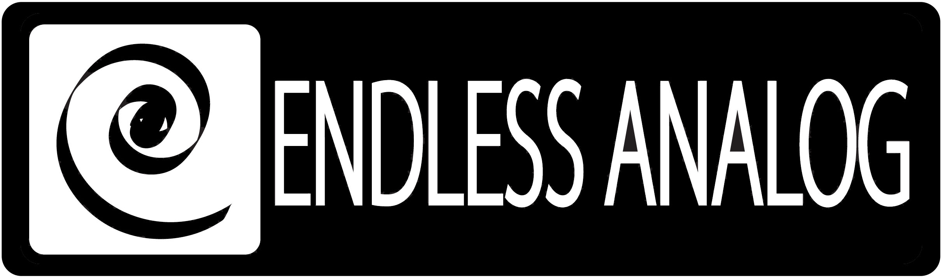

PRESS RELEASE
Media Contact: Robert Clyne
Clyne Media, Inc.
Robert@clynemedia.com
Tel: (615) 662-1616
Fax: (615) 662-1636

FOR IMMEDIATE RELEASE

Producer Nathan Chapman Finds The Best Of Both Worlds Using Endless ANALOG’s Revolutionary CLASP® System

— GRAMMY®-winning producer uses CLASP® to capitalize on current digital technology while retaining analog warmth and tone —

NASHVILLE, TN, March 28, 2010 — Award-winning producer and multi-instrumentalist Nathan Chapman, who recently garnered an Album of the Year GRAMMY® for his work on Taylor Swift’s LP Fearless, and who himself has twice won nominations for Producer of the Year by the ACM, knows sound. And that’s why Chapman has wholeheartedly embraced the revolutionary CLASP® (Closed Loop Analog Signal Processor) system, the critically-acclaimed product that finally brings the worlds of analog and digital audio truly together. CLASP was developed, invented, manufactured and is exclusively distributed by Nashville-based Endless Analog. Chapman believes that CLASP brings him and the artist together like no other piece of technology ever has, giving him the ability to tap into the legendary warmth of analog on his classic MCI 24-track deck and still have all the speed and convenience of his Pro Tools DAW.

Chapman, who has recorded as a multi-instrumentalist for artists including Trisha Yearwood and John Oates, written songs recorded by Martina McBride and other hit country artists, and produced artists ranging from Jewel to Point of Grace, recently purchased the CLASP system.

“The thing that put me over the edge would be the direct monitoring,” he explains. “When you hook up the CLASP system, the singer is hearing their vocal instantaneously. You’re not dealing with converting in and out of Pro Tools and the latency you get from that. It’s miniscule latency, but it’s significant enough to make a singer uncomfortable. This totally eliminates that – it’s just easier to sing, it’s easier to play, and that’s a really good thing.”

Chapman also points out that the CLASP system acts as the ultimate bridge between vintage analog equipment and modern digital audio systems by reconnecting vintage processing with classic analog tape recording. “The vintage microphones, pre amps, compressors that we love [were] designed to hit tape and have that color added to it,” he explains. “You have to hit tape [or else] you take away one [critical] ingredient that the original designer intended. I find that my preamps and my compressors open up and they sound better when they’re getting the tape ‘love.’ The really important thing that CLASP is bringing to modern recording is helping vintage gear sound like it’s supposed to.”

In fact, the CLASP system allowed Chapman to move from “in the box” recording and mixing to being able to bring his classic MCI JH-24 analog tape machine out of storage and connect it with his Pro Tools system in his home studio, utilizing a Neve 8816 summing mixer for direct monitoring from tape. It was an easy and, Chapman emphasizes, important transition for him. “It’s completely revolutionized the way I feel about my home studio: that I have something that’s state of the art, cutting edge. Now my studio is competitive with any studio, and I’m proud of that. And having the analog color of the tape, the sound coming from my MCI deck, being able to incorporate that with guitar tones, it’s just been awesome. I’m just a proud owner and I really appreciate what these guys have done to help make recording fun again. CLASP gives me the ability to add different colors, how hard I want to hit the tape, which channel I want to use -- all those kinds of things have just been amazing for me. So anybody out there that’s wondering how do you go from completely in-the-box at your home studio to incorporating the CLASP system, it’s really not that long of a journey, and when you make it you’ll know that it’s worth it.”

CLASP is a hardware and software system that integrates Analog Tape Recorders with Digital Audio Workstations using a proprietary method called SST® (sample synchronization technology). CLASP delivers a true analog front end recording solution with the sonic character of the user’s tape machine. No other product comes close to approximating what CLASP effectively accomplishes. CLASP is employed by a diverse range of artists, engineers, producers and facilities, including Lenny Kravitz (at his new Bahamas-based Gregory Town Sound recording facility); Michael W. Smith; producers Nathan Chapman, Dave Cobb, Chuck Ainlay, John Fields and Tom “T-Bone” Edmunds; and studio facilities such as Austin, Texas’ Yellow Dog Studios, Los Angeles, California’s Hemispheres Recording and Austria’s Prime Studios.

For more information, please visit http://www.endlessanalog.com.
… ends 710 words
###

Photo File: Chapman_CLASP.JPG
Photo Caption: GRAMMY®-winning producer Nathan Chapman, with his CLASP® (Closed Loop Analog Signal Processor) system from Nashville-based Endless Analog.

About Endless Analog
Endless Analog founder and esteemed record producer Chris Estes’ vision was simple: to create a revolutionary product that would, for the first time in history, bring user-friendly analog tape recording to every studio environment around the world. As an avid believer that the sound of analog tape is superior to that of digital, and after acquiring his first tape machine several years ago, a Studer A 827, Chris developed and created CLASP (Closed Loop Analog Signal Processor). The CLASP system solves the age-old analog tape dilemma by simplifying the recording process and allowing the user to save thousands of dollars in time and tape archiving expense. Dust off your tape machine and get ready to once again hear the warm sound of analog tape flowing through your monitors. Recording analog has never been so easy, effortless, and endless.

Chris Estes is a Nashville-based Producer, Mixer, and Songwriter who enjoys working with a variety of artists spanning several diverse genres. Over the past 10 years a few of his clients have included Billy Mann (Teddy Geiger, Jessica Simpson), Ryan Tedder (One Republic), Major Bob Music (Lane Turner), Krystal Myers (Forefront), Michael Tait (D.C. Talk), Universal Music Group, Curb Records, EMI/CMG, TVT Records, Elektra Records, In Pop/Elevate Records, Gaither Music Group, Dreamworks Nashville and countless independent artists.

Contact information:
Endless Analog – Amy Becker – 3212 West End Ave, Suite 500, Nashville, TN 37221 – www.endlessanalog.com – amy@endlessanalog.com – 866-929-4446

