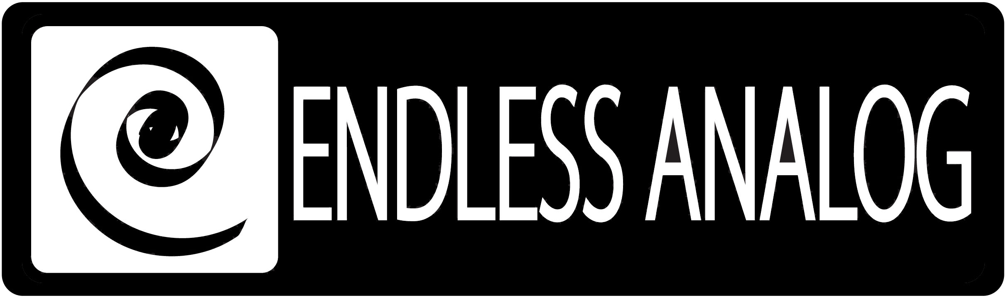

PRESS RELEASE
Media Contact: Robert Clyne
Clyne Media, Inc.
Robert@clynemedia.com
Tel: (615) 662-1616
Fax: (615) 662-1636

FOR IMMEDIATE RELEASE

ENDLESS ANALOG FOUNDER/PRESIDENT CHRIS ESTES ADDRESSES THE CONSERVATORY OF RECORDING ARTS & SCIENCES IN ARIZONA

— Inventor-manufacturer of CLASP® (Closed Loop Analog Signal Processor) provides
unique insights into analog recording and the use of CLASP, effectively
bridging the worlds of digital and analog —

NASHVILLE, TN, May 7, 2010 — The Conservatory of Recording Arts & Sciences (CRAS) recently hosted two days of workshops and seminars with Chris Estes, Founder/President of Endless Analog, the Nashville-based manufacturer and distributor of the revolutionary, critically acclaimed CLASP® (Closed Loop Analog Signal Processor). Estes led four in-studio sessions at CRAS, where students and faculty were given the unique hands-on opportunity to experience CLASP and learn Estes’ insights on analog recording, ranging from tracking methods right through the final mix. Drawing upon his vast experience on both sides of the glass and as an inventor, Estes discussed analog recording and worked closely with the Conservatory’s Director of Education Kevin Becka and Conservatory Technician Jeff Harris for the sessions. Estes used CLASP to merge Studio A’s Studer A 827 analog recorder and the Pro Tools HD system into a singular system.

“Our time with Chris and CLASP was a mind blower for both faculty and students,” commented Kevin Becka. “CLASP is an inspirational piece of gear. It gives artists, engineers and producers an incredible array of tools for cutting great sounding tracks. We were easily able to audition and record tracks at different tape speeds during a session, giving us the ability to do overdubs with more or less tape saturation depending on the instrument. Students could easily hear the quality difference between straight digital recordings and tracks cut through CLASP.”

CLASP is a hardware and software system that integrates Analog Tape Recorders with Digital Audio Workstations using a proprietary method called SST® (sample synchronization technology). CLASP delivers a true analog front end recording solution with the sonic character of the user’s tape machine. No other product comes close to approximating what CLASP effectively accomplishes. CLASP is employed by a diverse range of artists, engineers, producers and facilities, including Lenny Kravitz (at his new Bahamas-based Gregory Town Sound recording facility); Michael W. Smith; producers Nathan Chapman, Dave Cobb, Chuck Ainlay, John Fields and Tom “T-Bone” Edmunds; and studio facilities such as Austin, Texas’ Yellow Dog Studios, Los Angeles, California’s Hemispheres Recording and Austria’s Prime Studios. Analog tape manufacturers recommended by Endless Analog for use with CLASP include ATR Magnetics and RMG International.

“I am very impressed with the Conservatory’s faculty, students and curriculum,” stated Chris Estes. “CRAS has a vibrant, dedicated pool of students and renowned instructors with a passion for recording. The school offers an excellent way for these talented individuals to get their start and education in the recording industry. I am proud to have been able to address them, and I am thrilled with the support they have shown for the CLASP system.”

Based in Tempe, Arizona, with a satellite campus in Gilbert, Arizona, The Conservatory of Recording Arts & Sciences is a premier audio recording, sound engineering and music production school teaching both analog and digital recording concepts from day 1 of their 30-week program. Every Conservatory student learns tape alignment on Otari and Studer 24-track tape machines, and the Conservatory has eight studios running both 24-track analog tape and Pro Tools HD 2 TDM systems. Over 800 students a year go through the Conservatory's program, and in 2010, the Conservatory had 27 students credited on 55 GRAMMY®-nominated records with six GRAMMY winners on albums from Green Day, Booker T. Jones, Beyoncé and more.

For more information, please visit http://www.endlessanalog.com.
… ends 426 words
###

Photo File: EndlessAnalog_CRAS.JPG
Photo Caption: Pictured L-R: Session drummer Dowell Davis; CRAS instructor Tony Nunes; CRAS Director of Education Kevin Becka; and Endless Analog Founder/President and CLASP inventor Chris Estes.

About Endless Analog
Endless Analog founder and esteemed record producer Chris Estes’ vision was simple: to create a revolutionary product that would, for the first time in history, bring user-friendly analog tape recording to every studio environment around the world. As an avid believer that the sound of analog tape is superior to that of digital, and after acquiring his first tape machine several years ago, a Studer A 827, Chris developed and created CLASP (Closed Loop Analog Signal Processor). The CLASP system solves the age-old analog tape dilemma by simplifying the recording process and allowing the user to save thousands of dollars in time and tape archiving expense. Dust off your tape machine and get ready to once again hear the warm sound of analog tape flowing through your monitors. Recording analog has never been so easy, effortless, and endless.

Chris Estes is a Nashville-based Producer, Mixer, and Songwriter who enjoys working with a variety of artists spanning several diverse genres. Over the past 10 years a few of his clients have included Billy Mann (Teddy Geiger, Jessica Simpson), Ryan Tedder (One Republic), Major Bob Music (Lane Turner), Krystal Myers (Forefront), Michael Tait (D.C. Talk), Universal Music Group, Curb Records, EMI/CMG, TVT Records, Elektra Records, In Pop/Elevate Records, Gaither Music Group, Dreamworks Nashville and countless independent artists.

Contact information:
Endless Analog – Amy Becker – 3212 West End Ave, Suite 500, Nashville, TN 37203 – www.endlessanalog.com – amy@endlessanalog.com – 866-929-4446

