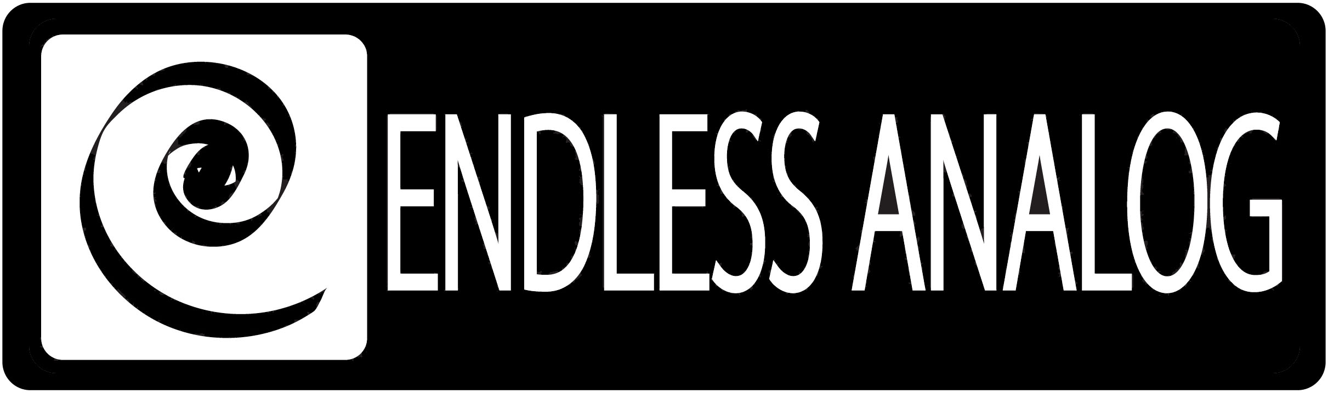

PRESS RELEASE
Media Contact: Robert Clyne
Clyne Media, Inc.
Robert@clynemedia.com
Tel: (615) 662-1616
Fax: (615) 662-1636

FOR IMMEDIATE RELEASE

Aerosmith and Producer Jack Douglas Use Endless Analog’s CLASP™ on Sessions for Upcoming Album

— Aerosmith’s new album, the first in eight years, will feature a rich analog sound made possible with the use of CLASP™ (Closed Loop Analog Signal Processor) —

131st AES CONVENTION, NEW YORK, NY, October 21, 2011 — Excitement among fans is electric at the news that Aerosmith is hard at work on their 14th studio album, set to be released in spring 2012. It is a testament to the band’s legacy as one of the greatest bands in the world that each new Aerosmith album release is still such a huge event. Fans have been clamoring for a new set of material since 2001’s Just Push Play and 2004’s bluesy covers album Honkin’ on Bobo, and the sessions for the new record are rendering something very special – something that producer Jack Douglas is calling “raw” and “nasty.” Aerosmith’s decision to again collaborate with Douglas, who helmed sessions for the band’s classic 1970s LP’s Get Your Wings, Toys in the Attic and Rocks, indicates that the band is trying to capture an old-school, classic vibe on the new set. Helping Douglas, engineer Warren Huart and the band achieve the right sound is Endless Analog’s CLASP™ (Closed Loop Analog Signal Processor) system [booth 228], which uniquely integrates analog tape into the digital audio workstation environment. Together, they have all become huge CLASP devotees, and in fact they are using four CLASP units on the sessions.

The band began sessions in July at two Aerosmith-affiliated Boston-area studios: Pandora’s Box, which the band owns, and the Boneyard, guitarist Joe Perry’s personal studio. Two CLASP units are present at Pandora’s Box – one connected to a 16-track two-inch Studer A800 analog tape machine for recording drums, and one connected to a 24-track two-inch A800 MkIII for recording everything else. At the Boneyard, another CLASP is connected to an additional 24-track two-inch A800 MkIII for overdubs. A fourth CLASP will adorn a yet-to-be-announced Los Angeles studio when sessions move to the west coast later this year.

Douglas, who, aside from his tenure with Aerosmith, is noted for his work with John Lennon, the New York Dolls, The Who and other classic acts, stated, “CLASP is revolutionary. We’re sticklers for big, fat analog sound, so this CLASP system was just perfect for us. And we’re so happy that Chris [Estes, CLASP inventor] came along and was able to hook us up with the stuff, and we really love it. The album’s gonna sound amazing. It has that rich, fat sound of analog and we have the convenience of being able to edit in Pro Tools, so we really love CLASP and what it’s let us do. Normally, if we were using tape, we’d be using reels and reels. But CLASP lets us use the same reel over and over again. And then normally we’d have to break for a few days to dump everything into Pro Tools for editing, but CLASP allows us to do real-time transfer. And we can record at any tape speed we want.”

Huart, best known for his work with top-selling acts like The Fray, Augustana, Kris Allen, Better Than Ezra and many others, added, “The reality is that recording with tape just makes things sound better. Every single piece of digital equipment you buy tries to make it sound like tape. CLASP is fantastic because it does what digital is trying to do for you by actually using real tape. It’s been a godsend in the studio as Aerosmith is capturing such a powerful, classic sound.”

Brad Whitford, one of Aerosmith’s two guitarists, stated, “Absolutely amazing sound, the CLASP. You forget what it sounds like to hear these instruments actually going to tape. It’s the only way to go. You hit that tape, and you get all those rich harmonics. People are going to hear this album, and they’re going to say, ‘There’s something different going on here,’ and the difference is CLASP. CLASP all the way.”

Watch for Aerosmith’s upcoming LP in May 2012, and visit www.endlessanalog.com and www.aerosmith.com for more information.

About CLASP
CLASP (Closed Loop Analog Signal Processor) is the world’s first and only pro audio hardware and software that lets you record on real analog tape with digital speed. CLASP provides sample accurate tape synchronization with zero latency analog monitoring while delivering a true Analog front end recording solution for Pro Tools and other DAW’s. Already being used by top artists, producers, and engineers worldwide, CLASP has re-invented analog for the digital age. CLASP is employed by a diverse range of artists, engineers, producers and facilities, including Lenny Kravitz (at his new Bahamas-based Gregory Town Sound recording facility); Aerosmith; Beck; KISS; Warren Huart (The Fray); Jack Douglas (Aerosmith, John Lennon, New York Dolls); Michael W. Smith; John Shanks (Bon Jovi, Melissa Etheridge, Keith Urban); Fraser T. Smith (Adele, Cee Lo Green, Taio Cruz); Denis Savage, engineer for Celine Dion; Butch Walker (Panic at the Disco, Pink, Avril Lavigne); producers Nathan Chapman, Dave Cobb, Chuck Ainlay, and studio facilities such as England’s legendary Abbey Road Studios, Clearwater, Florida’s Cleartrack Productions and Austria’s Prime Studios. Analog tape manufacturers recommended by Endless Analog for use with CLASP include ATR Magnetics and RMG International.
… ends 830 words
###

Photo File: Douglas_Huart.JPG
Photo Caption: Shown L-R: Aerosmith producer Jack Douglas and engineer Warren Huart, with CLASP™ from Endless Analog, which they are using on sessions for Aerosmith’s upcoming LP.

About Endless Analog
Founded by inventor, musician and record producer Christopher Estes, Endless Analog is a Nashville-based company developing and manufacturing innovative audio processing products for the recording, broadcast and consumer market sectors. The first of these products is the critically acclaimed CLASP™ (Closed Loop Analog Signal Processor). In developing CLASP, Estes' vision was simple: to create a revolutionary product that would, for the first time in history, bring user-friendly and cost-effective hybrid analog-digital workstation recording to every studio environment around the world. CLASP successfully bridges all audio worlds – analog and digital, old and new, classic and modern – and this defines Endless Analog's growing product line and visionary approach to their craft.

Contact information:
Endless Analog – Amy Becker – 3212 West End Ave, Suite 500, Nashville, TN 37203 – www.endlessanalog.com – amy@endlessanalog.com – 866-929-4446

Endless Analog is exhibiting at booth 228 at AES 2011 in New York City, NY.

