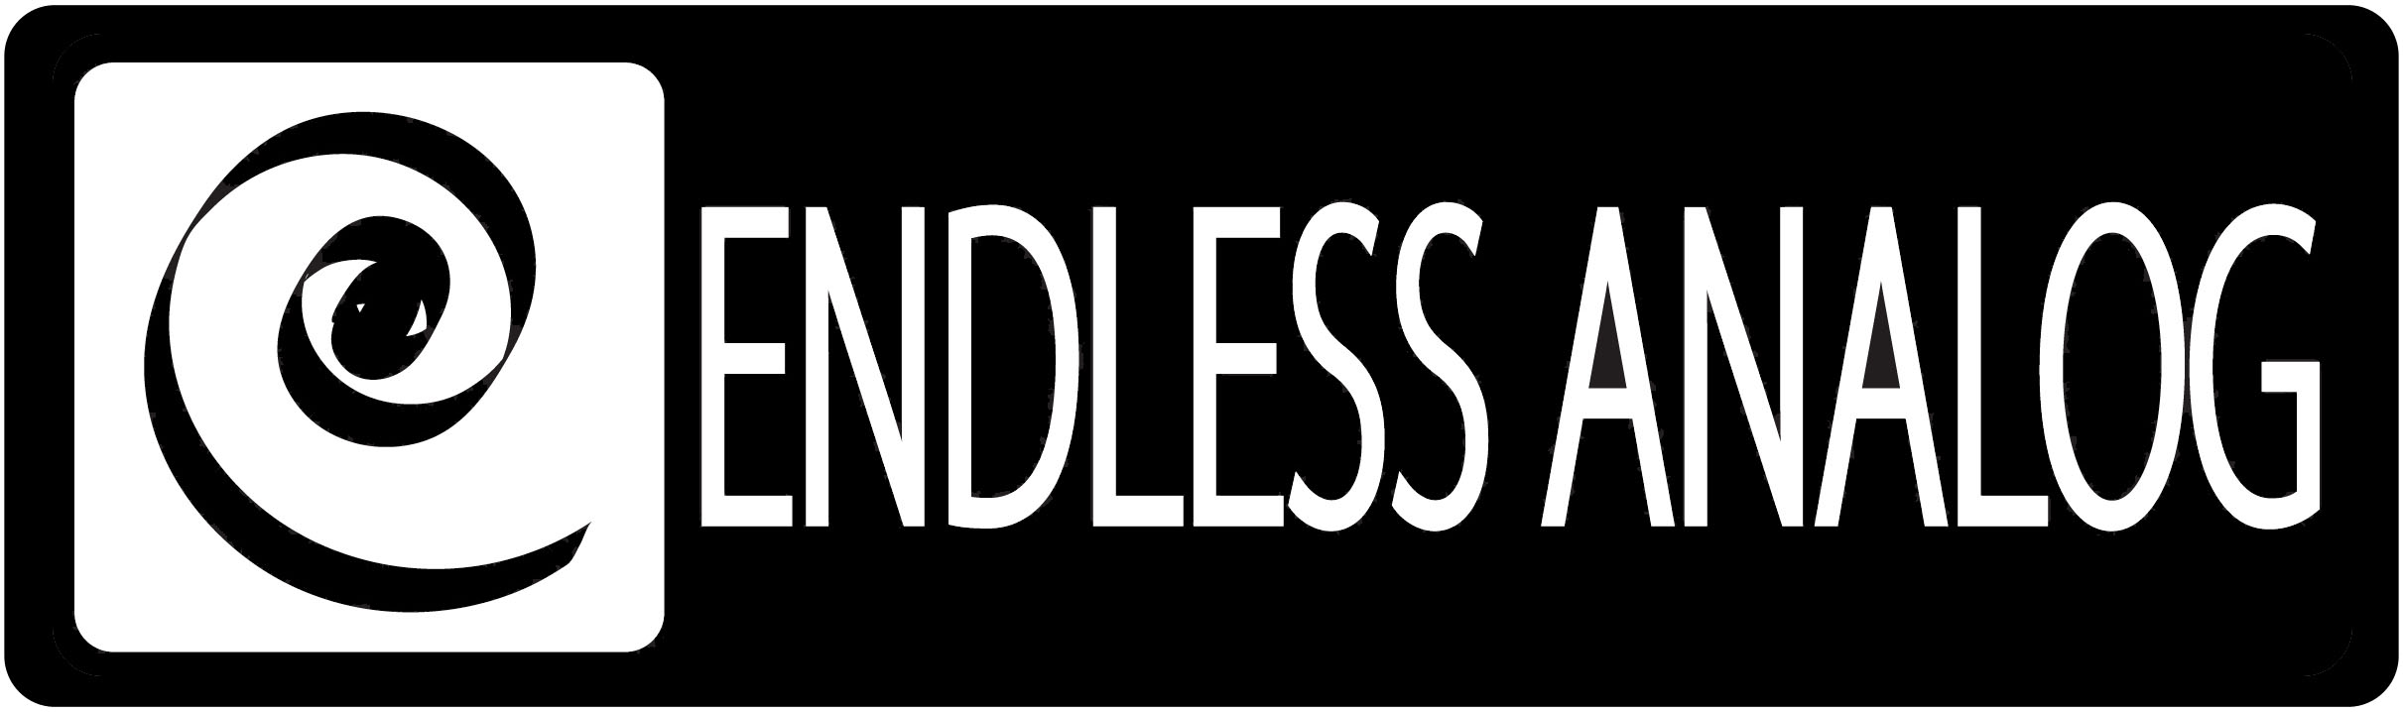

PRESS RELEASE
Media Contact: Robert Clyne
Clyne Media, Inc.
Robert@clynemedia.com
Tel: (615) 662-1616
Fax: (615) 662-1636

FOR IMMEDIATE RELEASE

MSR Studios becomes first new york city facility to purchase clasp® from endless analog

129th AES CONVENTION, SAN FRANCISCO, CA, November 5, 2010 — MSR Studios, a multi-room, full-service tracking and mixing complex located just off Times Square in midtown Manhattan, has become the first recording facility in New York City to purchase a CLASP® (Closed Loop Analog Signal Processor) system from Endless Analog (booth 617). CLASP is the critically acclaimed professional audio product that invisibly merges real Analog Tape with Pro Tools and other DAWs. It provides an elegant hybrid workflow that allows real-time analog tracking and overdubbing under the fast and efficient control of a familiar workstation interface. MSR purchased CLASP from Vintage King Audio.

Bradshaw Leigh, chief engineer at MSR Studios, which has a long and rich history in the city as the former site of Legacy and, before that, Right Track Recording, observes that regular studio clients such as the Roots, Erykah Badu, Neil Young and others prefer to work on analog tape. “But they all wind up doing the same thing, which is they all track to tape and then immediately transfer to Pro Tools,” he comments. “That gives them, in a sense, the worst of both worlds, because they can’t fix what they’re working on and get the analog sound at the same time. So they get the minimum benefits of tape before they transfer to Pro Tools.”

But with CLASP, says Leigh, “I think what’s great about it is that they can get the analog sound and use their normal Pro Tools workflow. It gives the absolute best of both worlds.”

Leigh is looking forward to introducing his younger engineers to MSR’s newly acquired CLASP system. “I can take a young engineer that’s never touched an analog tape deck and have him not be intimidated to use analog tape, because he can sit there and work with what he understands, which is Pro Tools. I think what’s going to be great about using CLASP is that they can get the analog sound and use their normal workflow.”

Leigh suspects that eighty to ninety percent of the people who want to incorporate analog tape into their DAW workflow don’t realize that recording and overdubbing can’t easily be done in real time, due to the gap between the tape machine’s record and repro heads. “I have had so many clients ask me to hook up an analog 24-track in front of Pro Tools and put it in sync. You can’t do that; there has to be a delay, otherwise you’re not getting the analog sound.” CLASP eliminates that problem through its latency-free analog monitor path.

MSR Studios houses two tracking/mixing rooms, one featuring an SSL J Series console and the other a Euphonix System 5, with another SSL J Series console in a dedicated mix room. The CLASP unit will be available for use in any of the studios, says Leigh: “We have it racked up and pre-wired on DL connectors, so it can be pretty much inserted anywhere.”

As a designer and manufacturer of audio equipment, Leigh appreciates the work that founder/president Chris Estes and Endless Analog have put into the CLASP system, he says. “I was just so floored by the elegant, perfect execution. It shows a lot of work, a lot of thought, went into it.” But he does admit to some initial misconceptions about the system. “When we had the demo I was not going to even go into the room, because I figured it was an input switching box and it had to be a kluge. I just happened to stick my head in and saw how wonderfully it was done. As soon as I saw how well it was executed I bought it in a heartbeat.”

About CLASP
CLASP is the world’s first and only pro audio hardware that lets you record on real analog tape with digital speed. CLASP provides sample accurate tape synchronization with zero latency analog monitoring while delivering a true Analog front end recording solution for Pro Tools and other DAW’s. Already being used by top artists, producers and engineers worldwide, CLASP is re-inventing analog for the digital age. CLASP is employed by a diverse range of artists, engineers, producers and facilities, including Lenny Kravitz (at his new Bahamas-based Gregory Town Sound recording facility); Michael W. Smith; Denis Savage, engineer for Celine Dion; Butch Walker (Panic at the Disco, Pink, Avril Lavigne); producers Nathan Chapman, Dave Cobb, Chuck Ainlay, John Fields and Tom “T-Bone” Edmunds; and studio facilities such as Clearwater, Florida’s Cleartrack Productions, Los Angeles, California’s Hemispheres Recording and Austria’s Prime Studios. Analog tape manufacturers recommended by Endless Analog for use with CLASP include ATR Magnetics and RMG International.

For more information, please visit http://www.endlessanalog.com.
… ends 766 words
###
Photo File: EndlessAnalog_MSR.JPG
Photo Caption: Bradshaw Leigh, chief engineer at MSR Studios, pictured holding his CLASP® system from Endless Analog.

About Endless Analog
Founded by inventor, musician and record producer Chris Estes, Endless Analog is a Nashville-based company developing and manufacturing innovative boutique audio processing products for the recording and broadcast market sectors. The first of these products is the critically acclaimed CLASP® (Closed Loop Analog Signal Processor). In developing CLASP, Estes' vision was simple: to create a revolutionary product that would, for the first time in history, bring user-friendly and cost-effective analog tape recording to every studio environment around the world. It is this bridging of worlds – analog and digital, old and new, classic and modern – that defines Endless Analog's growing product line and visionary approach to their craft.

Contact information:
Endless Analog – Amy Becker – 3212 West End Ave, Suite 500, Nashville, TN 37203 – www.endlessanalog.com – amy@endlessanalog.com – 866-929-4446

Endless Analog is exhibiting at booth 617 at the 129th AES Convention in San Francisco, CA.

