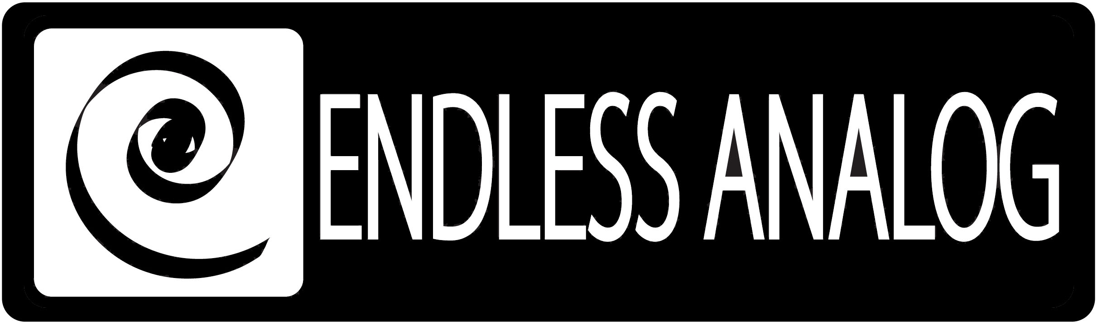

PRESS RELEASE
Media Contact: Robert Clyne
Clyne Media, Inc.
Robert@clynemedia.com
Tel: (615) 662-1616
Fax: (615) 662-1636

FOR IMMEDIATE RELEASE

THE CONSERVATORY OF RECORDING ARTS & SCIENCES IS THE FIRST SCHOOL TO BRIDGE HYBRID AUDIO PRODUCTION WITH

ENDLESS ANALOG’S CLASP®

— Premier audio recording, sound engineering and music production school takes delivery of two CLASP® (Closed Loop Analog Signal Processor) units so students can truly learn the art of analog recording with digital workflow —

129th AES CONVENTION, SAN FRANCISCO, CA, November 5, 2010 — The Conservatory of Recording Arts & Sciences (CRAS) has just taken delivery of two Endless Analog CLASP® (Closed Loop Analog Signal Processor) systems (booth 617) for their Tempe and Gilbert, Arizona campus facilities. The Conservatory made the decision to add CLASP to its flagship A Studios after Chris Estes, Founder/President of Endless Analog, the Nashville-based manufacturer and distributor of the revolutionary, critically acclaimed CLASP system, held two days of intense workshops and seminars at the school back in May. The CLASP units will be used in conjunction with CRAS’s SSL 4000 Series consoles, Studer A-820 2-inch 24-track analog tape machines, Digidesign’s Pro Tools HD and a host of other real-world recording gear. Additionally, beginning in 2011, CRAS will become the first audio school to teach and certify their students on the operation of CLASP.

“We had CLASP here for a two-day demo, and it was immediately obvious that this is the next step in hybrid audio production,” says Conservatory Administrator Kirt Hamm. “The cost and time issues that put analog tape on the back burner are nullified by CLASP. It allows us to expose our students to the sonic palette that only tape can offer while still maintaining the speed and capabilities of digital audio workflow. We are proud to be the first audio recording school in the world to certify students in the operation of CLASP.”

The remarkable CLASP has reinvented analog tape recording for the digital age, and it has opened up other production techniques never before possible: namely, processing digitally-recorded audio to analog tape and back to the DAW, using variable tape speeds within the same session.

Based in Tempe, Arizona, with a satellite campus in Gilbert, Arizona, The Conservatory of Recording Arts & Sciences is a premier audio recording, sound engineering and music production school teaching both analog and digital recording concepts from day 1 of their 30-week program. Every Conservatory student learns tape alignment on Otari and Studer 24-track tape machines, and the Conservatory has eight studios running both 24-track analog tape and Pro Tools HD 2 TDM systems. Over 800 students a year go through the Conservatory's program, and in 2010, the Conservatory had 27 students credited on 55 GRAMMY®-nominated records with six GRAMMY winners on albums from Green Day, Booker T. Jones, Beyoncé and more.

About CLASP
CLASP is the world’s first and only pro audio hardware that lets you record on real analog tape with digital speed. CLASP provides sample accurate tape synchronization with zero latency analog monitoring while delivering a true Analog front end recording solution for Pro Tools and other DAW’s. Already being used by top artists, producers and engineers worldwide, CLASP is re-inventing analog for the digital age. CLASP is employed by a diverse range of artists, engineers, producers and facilities, including Lenny Kravitz (at his new Bahamas-based Gregory Town Sound recording facility); Michael W. Smith; Denis Savage, engineer for Celine Dion; Butch Walker (Panic at the Disco, Pink, Avril Lavigne); producers Nathan Chapman, Dave Cobb, Chuck Ainlay, John Fields and Tom “T-Bone” Edmunds; and studio facilities such as Clearwater, Florida’s Cleartrack Productions, Los Angeles, California’s Hemispheres Recording and Austria’s Prime Studios. Analog tape manufacturers recommended by Endless Analog for use with CLASP include ATR Magnetics and RMG International.

For more information, please visit http://www.endlessanalog.com.
… ends 547 words
###

Photo File: EndlessAnalog_CRAS.JPG
Photo Caption: Pictured is Conservatory Administrator Kirt Hamm with CLASP. Photo by Brad Reed.

About Endless Analog
Founded by inventor, musician and record producer Chris Estes, Endless Analog is a Nashville-based company developing and manufacturing innovative boutique audio processing products for the recording and broadcast market sectors. The first of these products is the critically acclaimed CLASP® (Closed Loop Analog Signal Processor). In developing CLASP, Estes' vision was simple: to create a revolutionary product that would, for the first time in history, bring user-friendly and cost-effective analog tape recording to every studio environment around the world. It is this bridging of worlds – analog and digital, old and new, classic and modern – that defines Endless Analog's growing product line and visionary approach to their craft.

Contact information:
Endless Analog – Amy Becker – 3212 West End Ave, Suite 500, Nashville, TN 37203 – www.endlessanalog.com – amy@endlessanalog.com – 866-929-4446

Endless Analog is exhibiting at booth 617 at the 129th AES Convention in San Francisco, CA.

