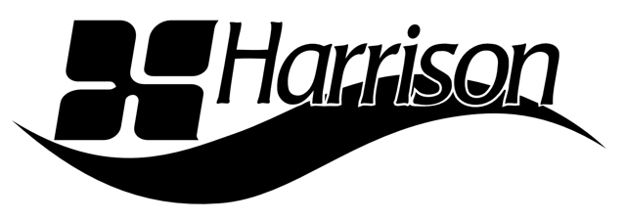

FOR IMMEDIATE RELEASE

Harrison in the Lineup for AES Nashville Spring Training 2021 Exhibition

— The console maker will demonstrate version 7 of its unique Mixbus and Mixbus32C DAWs during the free event on March 31 —

Nashville, TN, March 25, 2021 — Audio console and software maker Harrison has clinched a spot in the lineup for the AES Nashville Section’s Spring Training Exhibition 2021, a free in-person live sound training event and exhibition to be held March 31, 2021, at SoundCheck Nashville. The Music City-born company will be featuring its Mixbus v7 and Mixbus32C v7 DAWs, and its catalog of plugins, during the event.

“Engineers looking to make ‘in the box’ mixes that sound like hit records have discovered that Mixbus delivers exactly the results they were striving for,” says Gary Thielman, President of Harrison. “At AES Nashville’s Spring Training, we’ll be showing the newly released version 7 of Mixbus and Mixbus32C, which feature the new ‘TapeX’ recording GUI with take management, input source routing, track arming, metering – all the operational elements needed to bring the dedicated feel and streamlined control of true linear multi-track recording to the DAW world.”

Founded in 1975 as a console manufacturer, Harrison translated its renowned analog heritage and its prowess in automated digital control into fully digital console versions at the request of premier filmmakers who wanted digital consoles that both functioned and sounded exactly like their analog predecessors. That same sonic signature and console operational feel was later translated into the full-featured Mixbus DAW and then into the flagship Mixbus32C workstation. Mixbus32C improves on the Mixbus platform with an exact emulation of the original Harrison 32C console made famous as instrumental to the sound of Michael Jackson’s Thriller, Paul Simon’s Graceland and iconic productions by Janet Jackson, AC/DC, Led Zeppelin, ELO, Genesis, Blondie and Supertramp, to name but a few.

Included with Mixbus and Mixbus32C are Harrison’s ACE Range and x42 series plug-ins offering core dynamics, reverb, EQ, filters, delay, gain, digital peak limiting and MIDI filter functionality. Also included are workflow plugins – the ACE Inline Scope, Inline Spectrogram and MIDI Monitor, and the x42 stereo routing tools. Synth, organ and drum instrument plugins are also provided.

Optional for Mixbus and Mixbus32C, and all DAWs through AAX, VST and AU compatibility, is Harrison’s AVA range of plugins – the AVA Vocalflow and BassFlow task-designed channel strips, Mastering EQ, DeEsser, the surround-capable four-band Multiband Compressor with advanced features like a sidechain key, the highly configurable 18-band Spectral Compressor, and the LegacyQ plugin version of the Harrison MPC film console EQ.

“We invite our current and future customers to join us at the Spring Training event to experience firsthand Mixbus v7, Mixbus32C v7 and our full suite of plugins,” says Thielman.

Learn more about Harrison at www.harrisonconsoles.com.

Learn more and register for the free March 31 AES Nashville Sprint Training Exhibition at http://aesnashville.org/spring-training/.

...ends 435 words

Photo 1: 32c7-TapeX Recorder.png
Photo 1 caption: Harrison’s TapeX recording GUI – with take management, input source routing, track arming and metering – has been introduced as integral to the new version 7 of Harrison’s Mixbus and Mixbus32C DAWs. The workstations and Harrison plugins will be demonstrated at the AES Nashville Section’s Spring Training Exhibition 2021, March 31

Photo 2: 32c7-Mixer.png
Photo 2 caption: The mixer interface of Harrison’s Mixbus32C v7 DAW. The workstation faithfully emulates the iconic Harrison 32C console

Photo 3: 32c7-Editor.png
Photo 3 caption: The editor GUI of Harrison’s Mixbus32C v7 DAW

Harrison
750 Jim Parker Drive
Suite 103
Smyrna, TN USA 37167
Phone: +1 (615) 768-5501
Email: info@harrisonconsoles.com

