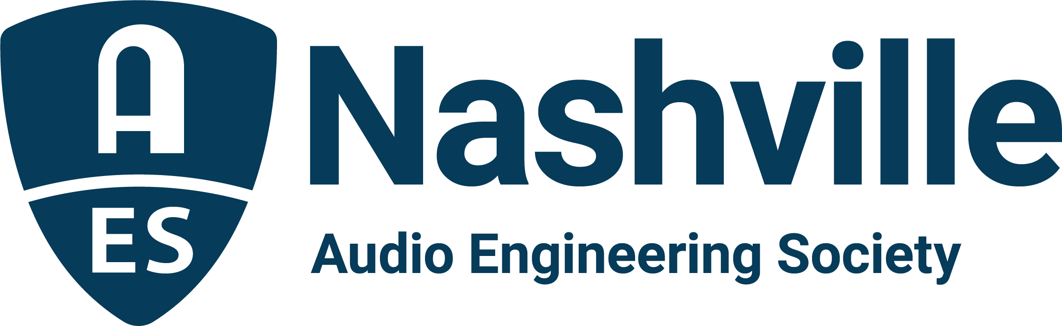

FOR IMMEDIATE RELEASE

AudioMasters 2026 announces VIP Engineers and industry sponsors for 28th annual charity tournament supporting Nashville Engineer Relief Fund

— Live Day and Studio Day events bring together top audio professionals for community, competition and a great cause —

Nashville, TN, May 5, 2026 — The AudioMasters Benefit Golf Tournament returns May 14–15, 2026, to Harpeth Hills Golf Course in Nashville, once again uniting the professional audio community in support of the Nashville Engineer Relief Fund (NERF). This year’s event will feature two distinguished VIP Engineers representing the best of live sound and studio recording: famed FOH engineer Bob Workman for the DiGiCo AudioMasters Live Day on Thursday, May 14, and renowned studio engineer Bob Olhsson for the API AudioMasters Studio Day on Friday, May 15.

A cherished tradition within the Nashville audio community, now in its 28th year, the AudioMasters blends friendly competition with meaningful connection, bringing together engineers, producers, manufacturers and industry pros for two days of golf, networking and giving back. Sponsors contribute to the fun at each hole around the course, offering contests, giveaways, plentiful food and beverage offerings, and a chance to meet face-to-face with some of the top names in audio.

“The AudioMasters is about more than fun times on the course – it’s about showing up for each other,” says event co-founder Jim Kaiser. “The sense of community here is real, and the support we generate for NERF directly impacts people in our industry when they need it most. One of many highlights of each day is honoring legends in our community as our guest VIP Engineers. The players and sponsors will get to meet Bob Workman and Bob Olhsson as they are chauffeured around the course this year, a special treat for all.”

Live Day VIP – Bob Workman
Bob Workman is a Nashville-based live sound veteran widely regarded as one of the industry’s most respected front-of-house engineers and production managers. Best known for his longtime role with The Charlie Daniels Band, Workman spent decades shaping the band’s powerful live sound while overseeing global touring operations. His work extends beyond the console into product innovation, including collaboration with Bob Heil on the development of the Heil PR 31 BW microphone, a widely adopted solution for drums and guitar cabinets. With deep expertise in high-fidelity reinforcement, complex signal chains and live broadcast production, Workman remains a trusted consultant and a cornerstone figure in live audio, known for his precision, reliability and roots in American music traditions.

Studio Day VIP – Bob Olhsson
Bob Olhsson is a legendary recording and mastering engineer whose career began at Motown Records during its most influential era. Joining the label in 1965, he quickly became part of the team behind countless classic recordings, working with artists such as Stevie Wonder, Marvin Gaye and Smokey Robinson. Olhsson contributed to iconic tracks including “Signed, Sealed, Delivered,” and participated in landmark album projects like What’s Going On, helping shape Motown’s meticulous and enduring sound. Known for his philosophy of capturing performances at the source, his work bridges the golden age of analog recording and modern production. Based in Nashville, Olhsson continues to share his expertise across recording, mastering and vinyl production, remaining an influential voice in the craft of music-making.

AudioMasters 2026 will again feature strong support from leading manufacturers and organizations across the pro audio industry, with DiGiCo and API serving as Title Sponsors for Live Day and Studio Day, respectively. Proceeds from the event benefit the Nashville Engineer Relief Fund, which provides critical assistance to members of the audio community facing financial difficulties.

Additional AudioMasters 2026 sponsors include: AES Show Nashville, Audio-Technica, Autra, Belmont University, Blackbird Studios, Black River Entertainment, Clair Global, Clyne Media, Corky’s Ribs & BBQ Brentwood, Covered Bridge Recording, CTS AVL, Design Technik, DPA, Ergolab Stealth, Focusrite, Genelec, Gold Pacific Studios, Immersive Design Labs, L-Acoustics, Nashville Recording Supply, the Recording Academy Producers & Engineers Wing, QSC, RCF, the Recording Studio Insurance Program, RF Venue, Sensaphonics, Solid State Logic, Sound Emporium, Sound Image, Spectrum Sound, Teegarden Audio, Trew Audio, VEVA Sound, Violet Audio, Vision2 Marketing, Waves Distro and Welcome to 1979 Studios.

Single-player and foursome registration, along with a limited number of sponsorship opportunities, are available online.

For more information and to register, visit https://birdease.com/28thAnnualAudiomastersGolfTourna.

The AudioMasters Benefit Golf Tournament serves as the primary fundraising event for the Nashville Engineer Relief Fund, a homegrown 501(c)(3) nonprofit dedicated to supporting local audio professionals during times of crisis. The tournament is produced by the AES Nashville Section with event coordination by Karen Dunn of KMD Productions.

Link: AudioMasters Benefit Golf Tournament
...ends 715 words

Photo File 1: AudioMasters_2026.JPG
Photo Caption 1: The AudioMasters Benefit Golf Tournament returns May 14–15, 2026, to Harpeth Hills Golf Course in Nashville, TN featuring VIP guests Bob Workman (Live Day, Thursday, May 14, presented by DiGiCo) and Bob Olhsson (Studio Day, May 15, presented by API).

Photo File 2: Bob_Workman.JPG
Photo Caption 2: FOH engineer Bob Workman will be the course VIP for The DiGiCo AudioMasters Live on Thursday, May 14.

Photo File 3: Bob_Ohlsson.JPG
Photo Caption 3: Studio engineer Bob Olhsson will be the course VIP for The API AudioMasters studio-focused day, Friday, May 15.

For more information about sponsorships and play for AudioMasters 2026, contact Karen Dunn: karen@kmdpro.com or (925) 708-0307.

