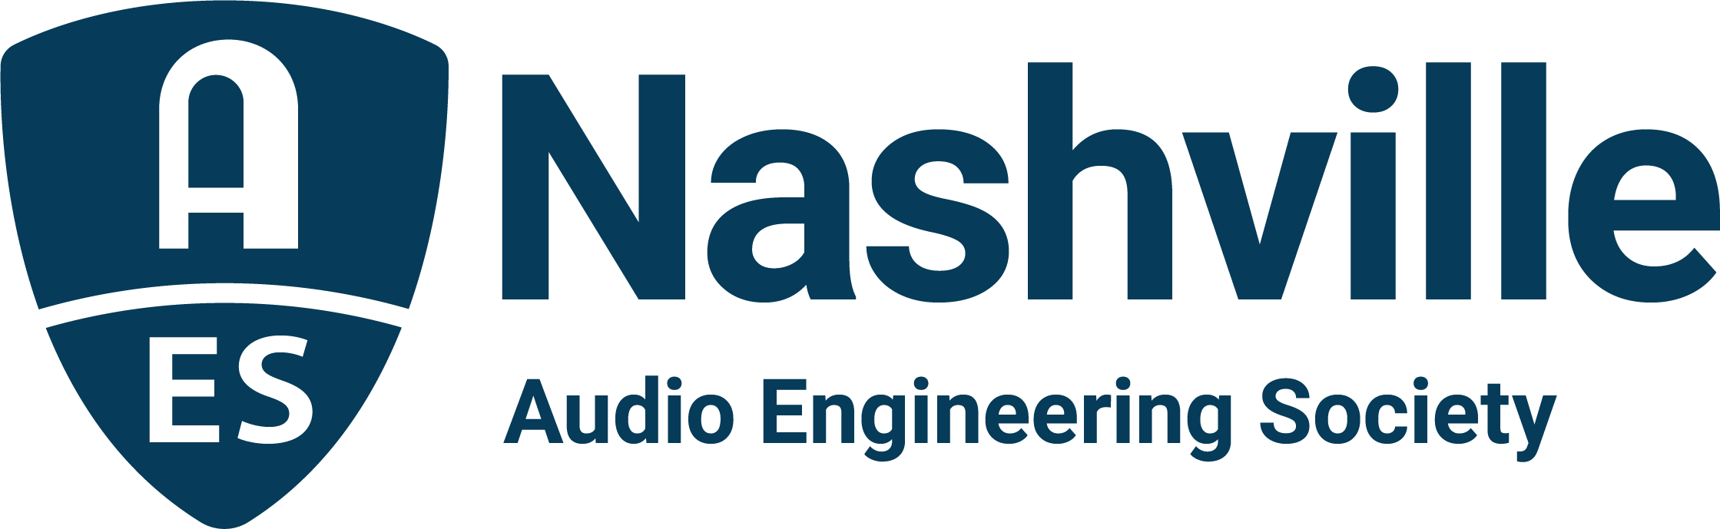

FOR IMMEDIATE RELEASE

AudioMasters 2026 brings Nashville audio community together in support of the Nashville Engineer Relief Fund

— 28th annual two-day benefit tournament at Harpeth Hills Golf Course is the primary funding source for the homegrown charity, enabling the fund to provide a hand-up to local audio pros in need —

Nashville, TN, June 1, 2026 — The 28th Annual AudioMasters Benefit Golf Tournament returned to Harpeth Hills Golf Course in Nashville on May 14–15, once again bringing together members of the professional audio community from across the country in support of the Nashville Engineer Relief Fund (NERF). Hosted by the AES Nashville Section, the two-day event welcomed engineers, producers, manufacturers, studio owners, live sound professionals, musicians, educators and students for a memorable gathering centered around community, connection and charitable support.

Thursday’s “DiGiCo AudioMasters Live” highlighted Nashville’s live sound community and featured renowned front of house engineer and production manager Bob Workman as the day’s VIP Engineer. Friday’s “API AudioMasters” focused on the recording and studio community and welcomed legendary engineer Bob Olhsson as VIP Engineer. Both VIPs spent time meeting players and sponsors throughout the tournament, sharing stories and celebrating the spirit of the Nashville audio community.

AudioMasters 2026 continued its long-standing tradition of blending friendly competition with industry camaraderie, while raising significant funds to help support Nashville-area audio professionals and their families during times of hardship. Throughout both days, players and sponsors transformed the course into a celebration of the professional audio industry, with branded activities, contests, giveaways, food and beverage stations, networking opportunities and plenty of memorable moments shared across the fairways.

“The AudioMasters continues to represent the very best of our industry,” states Jim Kaiser, NERF Board Chair. “It’s always inspiring to see everyone come together to enjoy the event and to support members of our community in times of financial hardship. The generosity of our sponsors, players, volunteers, and supporters makes a meaningful impact in our community.”

In addition to the tournament play itself, attendees gathered during the popular 19th Hole receptions and awards presentations, distributing competition prizes and trophies as a capstone to one of the Nashville audio industry’s most anticipated annual traditions.

AudioMasters 2026 was made possible through the support of numerous sponsors and partners across the professional audio industry. DiGiCo returned as title sponsor for the AudioMasters Live, while API was once again title sponsor for the original AudioMasters Friday day of play.

Additional sponsors included Adam Audio, AES Show Nashville, Audio-Technica, Autra, Belmont University, Blackbird Studios, Black River Entertainment, Clair Global, Clyne Media, Corky’s Ribs & BBQ Brentwood, Covered Bridge Recording, CTS AVL, Design Technik, DPA, Ergolab Stealth, Focusrite, Genelec, Gold Pacific Studios, Immersive Design Labs, L-Acoustics, Nashville Recording Supply, the Recording Academy Producers & Engineers Wing, QSC, RCF, the Recording Studio Insurance Program, RF Venue, Sensaphonics, Solid State Logic, Sound Emporium, Sound Image, Spectrum Sound, Teegarden Audio, Trew Audio, VEVA Sound, Violet Audio US, Vision2 Marketing, Waves Distro and Welcome to 1979 Studios.

The AudioMasters Benefit Golf Tournament serves as the primary fundraising event for the Nashville Engineer Relief Fund, a 501(c)(3) nonprofit organization dedicated to assisting members of Nashville’s audio community during times of illness, crisis and financial hardship. Event coordination for AudioMasters 2026 was provided by Karen Dunn of KMD Productions.

Planning is already underway for AudioMasters 2027 as the tournament continues its mission of supporting, celebrating, and uniting Nashville’s professional audio community.

For more information on the Nashville Engineer Relief Fund visit https://theaudiomasters.org/nerf/.

...ends 520 words

Photo File 1: DiGiCo_AudioMasters_2026.JPG
Photo Caption 1: The AudioMasters Benefit Golf Tournament returned May 14–15, 2026, to Harpeth Hills Golf Course in Nashville, TN featuring title sponsor DiGiCo on Thursday, May 14.

Photo File 2: API_AudioMasters_2026.JPG
Photo Caption 2: The AudioMasters Benefit Golf Tournament returned May 14–15, 2026, to Harpeth Hills Golf Course in Nashville, TN featuring title sponsor API on Friday, May 15.

Photo File 3: Bob_Workman.JPG
Photo Caption 3: FOH engineer Bob Workman served as the course VIP for The DiGiCo AudioMasters Live on Thursday, May 14.

Photo File 4: Bob_Olhsson.JPG
Photo Caption 4: Studio engineer Bob Olhsson served as the course VIP for The API AudioMasters on Friday, May 15.

For more information about sponsorships and play for next year’s AudioMasters 2027 tournament, contact Karen Dunn: karen@kmdpro.com or (925) 708-0307.

