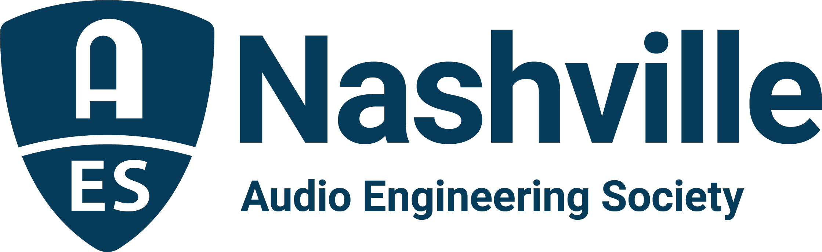

FOR IMMEDIATE RELEASE

AudioMasters Nashville Benefit Golf Tournament announces May 2026 dates

— Players and sponsors return to Harpeth Hills Golf Course in support of the Nashville Engineer Relief Fund, May 14-15, 2026 —

Nashville, TN, January 9, 2026 — The Audio Engineering Society Nashville Section has announced dates for the 28th Annual AudioMasters Nashville Benefit Golf Tournament, set to take place May 14–15, 2026, once again at the scenic Harpeth Hills Golf Course, in benefit of the Nashville Engineer Relief Fund (NERF). Firmly established as a cornerstone event for the Nashville professional audio community, the AudioMasters Tournament draws in players and sponsors from across the country for two days of golf, community connection and giving back. From each day’s shotgun start to the always-anticipated 19th hole awards dinner and reception, the tournament offers a relaxed yet engaging atmosphere where audio engineers, producers, musicians, studio owners, manufacturers and audio students come together in support of a shared cause.

“For more than twenty-five years, the Nashville Engineer Relief Fund has built a legacy that continues to strengthen and support the community,” states Jim Kaiser, NERF Board Chair. “The AudioMasters isn’t just about having an enormous amount of fun – its primary focus illustrates the way our community shows up for one another. Each year, we see professionals from every corner of the industry come together to support colleagues in times of real need, and that sense of camaraderie is what keeps this event so meaningful.”

Sponsors play a central role in shaping both days of the AudioMasters Tournament experience – with Thursday, May 14, being designated the “DiGiCo AudioMasters Live,” focused on our live sound community, and Friday, May 15, as the “API AudioMasters,” focused on our studio community. More than thirty sponsors transform the course with branded activations, player gifts, food and beverage offerings, contests, and creative surprises that keep the event lively and memorable. Players enjoy a well-paced day on the course while building relationships that extend far beyond the fairways.

Single-player and foursome registration, along with a wide range of sponsorship opportunities – including title sponsorships, hole sponsorships, drink carts, player gifts, comfort tents, contests, and more – are now available online.

The AudioMasters Nashville Benefit Golf Tournament serves as the primary fundraising event for the Nashville Engineer Relief Fund, a homegrown 501(c)(3) nonprofit dedicated to supporting local audio professionals during times of crisis. The tournament is produced by the AES Nashville Section with event coordination by Karen Dunn of KMD Productions.

...ends 371 words

Link: AudioMasters Benefit Golf Tournament
Photo File: AudioMasters_2026.JPG
For more information about sponsorships and play for AudioMasters 2026, contact Karen Dunn: karen@kmdpro.com or (925) 708-0307.

