### Los Angeles Unified School District

**OFFICE OF COMMUNICATIONS**

333 S. Beaudry Ave., 24th floor

Los Angeles, CA 90017

Phone: (213) 241-6766

FAX: (213) 241-8952

www.lausd.net

1200 N. Cornwell St.

Los Angeles, CA 90033

(323) 342-0428

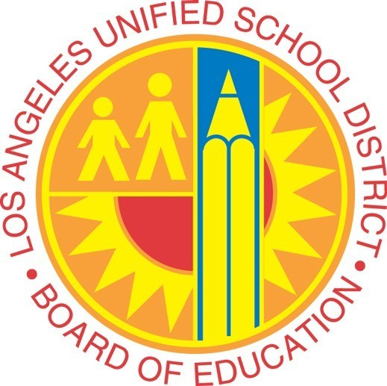

**Media Advisory**

**CONTACT: FOR IMMEDIATE RELEASE**

**Monica Carazo, 213-241-6766 May 14, 2018**

**On-site contacts: Paula Salvatore and Andrew Blumberg, 323-871-5001**

**School contact: Avah Ham and Barbara Jones, 213-241-6766**

**Students to Record Songs in Legendary Capitol Studios**

**WHAT:** Fourth- and fifth-grade students from Nestle Avenue Charter will record vocals at the legendary Capitol Studios, located in the landmark Capitol Records building in Hollywood.

The singers from Nestle Avenue Charter will record “With a Little Help from My Friends” by The Beatles, “Lovely Day” by Bill Withers and the Disney classic “When You Wish Upon a Star.”

Under the direction of music teacher Avah Ham, the students will sing in Studio A, where such performers as Frank Sinatra, Nat King Cole, Michael Bublé and Imagine Dragons have recorded since 1956.

**Note**: Photos will be permitted only in Studio A. Photos of the building or hallway are not allowed.

**WHEN:** Thursday, May 17, 10 a.m. to noon PDT

**WHERE:**  Capitol Records Building  
1750 Vine St., Studio A  
Los Angeles 90028

**###**