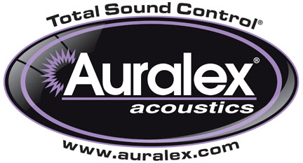

FOR IMMEDIATE RELEASE

Auralex® Now Shipping UtiliTek™ Sound Absorbent Panels

— Based on Auralex®’s popular ProPanel series, UtiliTek™ panels
offer contractors and system integrators a cost-effective solution in
acoustical control —

INDIANAPOLIS, IN, August 13, 2012 – Auralex® Acoustics, Inc., the world’s leading brand of acoustical treatments and soon to celebrate its 35th anniversary, is now shipping its UtiliTek™ sound absorbers. Designed based on input from leading contractors and system integrators, the UtiliTek panels are similar in function, performance and design to Auralex’s acclaimed ProPanel series, but at an even more attractive price point that still yields top-notch aesthetics and performance. UtiliTek panels are fabric covered, acoustically absorptive panels designed to reduce unwanted room reflections and reverberation, providing a more accurate and articulate listening experience. UtiliTek panels are highly effective and lightweight, are composed of Class A fire-rated materials and feature a recycled absorbent core.

UtiliTek is available in four thicknesses and two edge profiles. The beveled-edge style is available in 2'x2'x1", 2'x4'x1" and 2'x4'x2" sizes. The square-edge style is available in a 2'x4'x3" size that is perfect for corner mounting between two walls or across wall/ceiling junctures for moderate low-frequency control.

“As part of our ongoing commitment to the sound contracting/fixed installation market sectors, we wanted to offer solutions for contractors working with the tighter budgets that are common in today’s economy,” stated Eric Smith, Auralex Founder and President. “UtiliTek panels can be employed in a wide variety of installations, including clubs, live performance venues, restaurants/bars, houses of worship, corporate, municipal and residential installations.”

For more information, please visit www.auralex.com.

Photo Files: UtiliTek-Sandstone_Photo1.JPG, UtiliTek-Sandstone_Photo2.JPG

About Auralex Acoustics, Inc.
Located in Indianapolis, Auralex Acoustics was founded in 1977 with a mission to provide top-performing acoustical treatment products at the best possible value. Since then, thousands of satisfied Auralex customers have experienced improved acoustics, expert advice and exceptional customer service. Auralex products enjoy widespread use among prominent artists, producers, engineers, corporations, celebrities and government agencies worldwide.

Auralex Acoustics has become the industry leader in innovative sound control solutions and continues to enjoy rapid growth through an international network of authorized dealers. Visit the Auralex Web site at www.auralex.com. Auralex can be reached via email at auralexinfo@auralex.com or by calling 1-800-959-3343.

# # #
PR Contact Info:
Clyne Media, Inc.
615-662-1616
info@clynemedia.com

