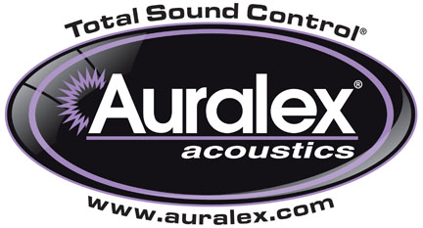

FOR IMMEDIATE RELEASE

Auralex® Is Now Shipping Its Sustain™ v2 Bamboo Sound Diffusors

Indianapolis, IN, August 31, 2015 – Auralex® Acoustics, Inc., the world’s leading brand of acoustical treatments, is now shipping enhanced “v2” models of the acclaimed and popular Sustain™ Bamboo Sound Diffusors. The new and improved design is based on customer input and extensive testing.

These handmade, environmentally friendly bamboo sound diffusors offer increased performance and exceptional craftsmanship and aesthetics to complement any space. They feature sharper angles and updated construction that enhances the premium performance that these diffusors are known for.

In addition to enhanced v2’s of the popular Sustain Prism™, Sustain Lens™, Sustain QuadraTec™ and Sustain Pyramid™, Auralex is offering the new Sustain Metro™ Bamboo diffusor. The Sustain Metro™ adds a contemporary cityscape aesthetic to your space, while its exacting design eliminates flutter echoes and evenly disperses acoustical energy throughout your environment.

Auralex Sustain v2 Bamboo Sound Diffusors Features:
- Material: Environmentally Friendly Bamboo is sustainably grown and harvested
- Optional Absorption and Advanced Diffusion: Can be back-filled with Mineral Fiber or Studiofoam™
- Sizes: 23-inch x 23-inch (Depth varies depending on model)
- Mounting: Wall, ceiling or drop grid mounting options (model-dependent)
- Finish: Natural Bamboo
- Mathematically and geometrically engineered for optimized diffusion characteristics

For more information, please visit www.auralex.com.

Photo File 1: Sustain_V2_Series.JPG
Photo Caption 1: Pictured L-R: Auralex’s family of Sustain™ v2 Bamboo Sound Diffusors. Auralex Sustain Lens™ v2, Sustain Prism™ v2, Sustain QuadraTec™ v2, Sustain Pyramid™ v2 and Sustain Metro™ v2.

Photo File 2: Sustain_V2_Metro.JPG
Photo Caption 2: Sustain Metro™ v2, from Auralex’s family of Sustain™ v2 Bamboo Sound Diffusors.

About Auralex® Acoustics, Inc.
Located in Indianapolis, Auralex® Acoustics was founded in 1977 with a mission to provide top-performing acoustical treatment products at the best possible value. Since then, thousands of satisfied Auralex customers have experienced improved acoustics, expert advice and exceptional customer service. Auralex products enjoy widespread use among prominent artists, producers, engineers, corporations, celebrities and government agencies worldwide.

Auralex Acoustics has become the industry leader in innovative sound control solutions and continues to enjoy rapid growth through an international network of authorized dealers. Visit the Auralex Web site at www.auralex.com. Auralex can be reached via email at auralexinfo@auralex.com or by calling 1-800-959-3343.

# # #
PR Contact Info:
Clyne Media, Inc.
615-662-1616
info@clynemedia.com

