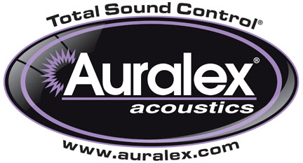

FOR IMMEDIATE RELEASE

Auralex® Now Shipping Studiofoam T™ Acoustic Absorption Panels

— Studiofoam T™ eliminates standing waves and flutter echo —

INDIANAPOLIS, IN, FEBRUARY 27, 2013 – Auralex® Acoustics, Inc., the world’s leading brand of acoustical treatments and currently celebrating its 35th anniversary, is now shipping its new Studiofoam T™ Acoustic Absorption Panels. Auralex's latest Studiofoam™ profile, Studiofoam T provides the absorption performance that Studiofoam is famous for with a more contemporary look. Studiofoam T eliminates standing waves and flutter echo while reducing unwanted reflections. The unique 2" profile is available in a 2' x 2' or 2' x 4' format and can be mixed with other Auralex Studiofoam profiles, making possible a wide variety of aesthetic designs.

The new panels’ unique design features a repeating T profile pattern, making them appropriate for a variety of professional and residential applications. The panels are available in three popular colors and are made from Auralex’s long-lasting, melamine-free formula, which won’t crumble with age. The Auralex Studiofoam T was developed out of Auralex’s clients’ desire to have a price-conscious Studiofoam solution with a completely unique and modern aesthetic. This upscale design offers increased low-frequency absorption and a tasteful, seamless appearance.

Features:
- Eliminates standing waves and flutter echo
- Reduces unwanted reflections
- Decreases slap-back and room ring
- Tames full-frequency bandwidth
- Available colors: charcoal, burgundy & purple
- Unique aesthetic at home in residential settings
- Easy installation using Foamtak™ spray adhesive, Tubetak Pro™ liquid adhesive or E-Z Stick Pro™ Tabs
- Proprietary Auralex formula that lasts and lasts

For more information, please visit www.auralex.com.

Photo Files: Studiofoam-T_Photo1.JPG, Studiofoam-T_Photo2.JPG

About Auralex® Acoustics, Inc.
Located in Indianapolis, Auralex® Acoustics was founded in 1977 with a mission to provide top-performing acoustical treatment products at the best possible value. Since then, thousands of satisfied Auralex customers have experienced improved acoustics, expert advice and exceptional customer service. Auralex products enjoy widespread use among prominent artists, producers, engineers, corporations, celebrities and government agencies worldwide.

Auralex Acoustics has become the industry leader in innovative sound control solutions and continues to enjoy rapid growth through an international network of authorized dealers. Visit the Auralex Web site at www.auralex.com. Auralex can be reached via email at auralexinfo@auralex.com or by calling 1-800-959-3343.

# # #
PR Contact Info:
Clyne Media, Inc.
615-662-1616
info@clynemedia.com

