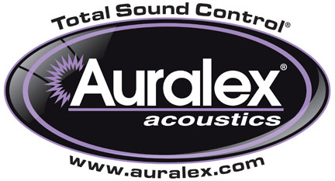

FOR IMMEDIATE RELEASE

Auralex® Now Shipping SonoFiber™ Panels

INDIANAPOLIS, IN, JUNE 26, 2013 – Auralex® Acoustics, Inc., the world’s leading brand of acoustical treatments and currently celebrating its 35th anniversary, is now shipping its new SonoFiber™ Panels, available in charcoal gray and arctic white.

SonoFiber is the perfect solution for contractors and system integrators with projects requiring a Class A fire rating without the aesthetic demands of designer treatments such as fabric-covered panels. SonoFiber is ideal for nightclubs, restaurants, gymnasiums, houses of worship, multi-purpose rooms and any other commercial or industrial environment where aesthetic concerns are secondary to performance and safety.

SonoFiber is a 1" thick natural fiber acoustic absorptive panel that offers significant advantages over the more traditional Class A melamine foam alternatives, including:
• Lower cost per square foot
• Sound absorption coefficients equal to or better than 2" thick melamine products
• A flexible form that will not puncture or break like melamine panels
• Safe, easy, dust-free installations

For more information, please visit www.auralex.com.

Photo Files: SonoFiber_White.JPG, SonoFiber_Black.JPG

About Auralex® Acoustics, Inc.
Located in Indianapolis, Auralex® Acoustics was founded in 1977 with a mission to provide top-performing acoustical treatment products at the best possible value. Since then, thousands of satisfied Auralex customers have experienced improved acoustics, expert advice and exceptional customer service. Auralex products enjoy widespread use among prominent artists, producers, engineers, corporations, celebrities and government agencies worldwide.

Auralex Acoustics has become the industry leader in innovative sound control solutions and continues to enjoy rapid growth through an international network of authorized dealers. Visit the Auralex Web site at www.auralex.com. Auralex can be reached via email at auralexinfo@auralex.com or by calling 1-800-959-3343.

# # #
PR Contact Info:
Clyne Media, Inc.
615-662-1616
info@clynemedia.com

