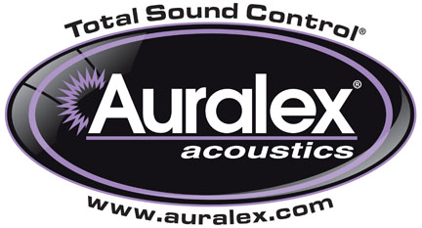

FOR IMMEDIATE RELEASE

Auralex® Offers SonicPrint™ Artistic Acoustical Panels

— Award-winning acoustical panels help users control acoustics without sacrificing aesthetics; design options are limitless —

INDIANAPOLIS, IN, JULY 8, 2013 – Auralex® Acoustics, Inc., the world’s leading brand of acoustical treatments and currently celebrating its 35th anniversary, is offering its award-winning SonicPrint™ Acoustical Panels, the latest innovation in acoustical absorption. Combining Auralex’s renowned acoustical treatment technology with custom-printed images, SonicPrint Acoustical Panels allow contractors and systems integrators to choose from Auralex’s “art” gallery or submit their own (or clients’ own) design for a look that’s truly one-of-a-kind. SonicPrint panels help users control reflected acoustical energy in a way that optimizes the acoustical architecture of their room without sacrificing aesthetics.

Sonic Print Acoustical Panels are available in a variety of custom sizes. SonicPrint can be ordered through authorized Auralex dealers. To discuss your project with an Auralex application specialist, please email auralexinfo@auralex.com or call 1-800-959-3343. For more information, please visit www.auralex.com.

Photo Files: SonicPrint_Photo1.JPG, SonicPrint_Photo2.JPG, SonicPrint_Photo3.JPG

About Auralex® Acoustics, Inc.
Located in Indianapolis, Auralex® Acoustics was founded in 1977 with a mission to provide top-performing acoustical treatment products at the best possible value. Since then, thousands of satisfied Auralex customers have experienced improved acoustics, expert advice and exceptional customer service. Auralex products enjoy widespread use among prominent artists, producers, engineers, corporations, celebrities and government agencies worldwide.

Auralex Acoustics has become the industry leader in innovative sound control solutions and continues to enjoy rapid growth through an international network of authorized dealers. Visit the Auralex Web site at www.auralex.com. Auralex can be reached via email at auralexinfo@auralex.com or by calling 1-800-959-3343.

# # #
PR Contact Info:
Clyne Media, Inc.
615-662-1616
info@clynemedia.com

