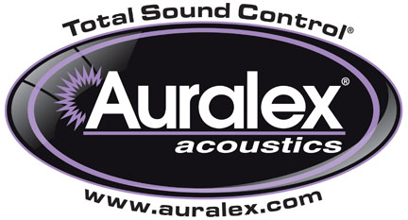

FOR IMMEDIATE RELEASE

Auralex® Introduces SheetBlok-AF™ Sound Isolation Barrier Material

— Designed with contractors and system integrators in mind, SheetBlok-AF™ is a finish-grade isolation product more effective than solid lead at stopping the transmission of sound —

INDIANAPOLIS, IN, JUNE 28, 2012 – Auralex® Acoustics, Inc., the world’s leading brand of acoustical treatments and soon to celebrate its 35th anniversary, introduces its new SheetBlok-AF™ Sound Isolation Barrier material. Based on the company’s popular SheetBlok™ construction-grade sound barrier product, SheetBlok-AF is a thin, dense isolator with a Class A fire-rated PVC laminate on its surface for a finished look. It is intended as a solution for improved sound isolation between adjacent spaces in the retrofit market where aesthetic appearance is important, but invasive construction and demolition are impossible. With an STC rating of 27 or greater, SheetBlok-AF is at least 6dB more effective than solid lead at stopping the transmission of sound. It acts as a thin, dense sound barrier layer in wall, ceiling and floor systems and is most effective when used as one component of a multi-layered construction scheme, as described in Auralex’s widely respected Acoustics101™ publication.

SheetBlok-AF has been designed with consideration for the contractor/system integrator who is doing either retrofit or new construction. SheetBlok-AF can be implemented in offices, apartments, studios, home theaters and anywhere an increase in sound isolation is desired. No wall construction (or reconstruction) is necessary, and SheetBlok-AF is fully paintable to coordinate with any decor.

SheetBlok-AF will be supplied in 4’x10’ sheets that can be trimmed to fit with a utility knife or metal shears. It is affixed with trowel-applied adhesive, which allows proper positioning and alignment during installation. With careful installation techniques, a virtually seamless appearance will result.

SheetBlok-AF will be available July 2012. For more information, please visit www.auralex.com.

Photo File: SheetBlok-AF.JPG

About Auralex Acoustics, Inc.
Located in Indianapolis, IN, Auralex Acoustics was founded in 1977 with a mission to provide top-performing acoustical treatment products at the best possible value. Since then, thousands of satisfied Auralex customers have experienced improved acoustics, expert advice and exceptional customer service. Auralex products enjoy widespread use among prominent artists, producers, engineers, corporations, celebrities and government agencies worldwide.

Auralex Acoustics has become the industry leader in innovative sound control solutions and continues to enjoy rapid growth through an international network of authorized dealers. Visit the Auralex Web site at www.auralex.com. Auralex can be reached via email at auralexinfo@auralex.com or by calling 1-800-959-3343.

# # #
PR Contact Info:
Clyne Media, Inc.
615-662-1616
info@clynemedia.com

