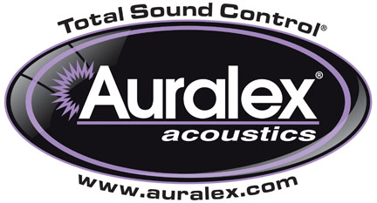

FOR IMMEDIATE RELEASE

Auralex® Appoints Music Veteran Saul Zonana Artist Relations Manager

— Company augments current personnel as part of long-term business strategy —

INDIANAPOLIS, IN, July 10, 2012 – Auralex® Acoustics, Inc., the world’s leading brand of acoustical treatments and soon to celebrate its 35th anniversary, has appointed noted singer-songwriter, producer and multi-instrumentalist Saul Zonana to the position of Artist Relations Manager. In his new capacity, Zonana will spearhead a new artist relations program, with a focus on expanding and maintaining brand equity within the community of accomplished and emerging artists, engineers, producers and musicians. The announcement was made by company founder and president Eric Smith and is part of Auralex’s long-term strategic business plan, which includes providing Auralex dealers and end users additional personnel in the field.

Aside from being the main contact for all Auralex artist and end user activities, Zonana will provide valuable information to Auralex’s marketing department for creating market-driven products and artist-oriented promotional materials. He will also oversee a new artist-centric portion of the Auralex website highlighting key and unique applications of Auralex sound treatment products.

Currently based in the Nashville, Tennessee area, after spending much of his life in New York City and on the road, Zonana has a rich and colorful, decades-long career in the music industry. His past projects include notable 1990s bands No Heroes and Luv Junkies, time spent in KISS guitarist Ace Frehley’s touring band, collaborations with guitar virtuoso Adrian Belew, a stint with Crash Test Dummies and ten solo albums – the latest of which, Fix the Broken, will soon be released on Zonana’s own label.

“Saul’s background in various corners of the music industry makes him a perfect asset for our organization as we reach out to artists who are loyal Auralex users and those who could benefit from our products,” stated Eric Smith. “Aside from his impressive resume, he is a class act, and we are thrilled to have him on our team. As Auralex looks at our long-term business strategies, creative minds like Saul will help us realize our goals.”

For more information, please visit www.auralex.com.

Photo Files: SaulZonana.JPG

About Auralex Acoustics, Inc.
Located in Indianapolis, Auralex Acoustics was founded in 1977 with a mission to provide top-performing acoustical treatment products at the best possible value. Since then, thousands of satisfied Auralex customers have experienced improved acoustics, expert advice and exceptional customer service. Auralex products enjoy widespread use among prominent artists, producers, engineers, corporations, celebrities and government agencies worldwide.

Auralex Acoustics has become the industry leader in innovative sound control solutions and continues to enjoy rapid growth through an international network of authorized dealers. Visit the Auralex Web site at www.auralex.com. Auralex can be reached via email at auralexinfo@auralex.com or by calling 1-800-959-3343.

# # #
PR Contact Info:
Clyne Media, Inc.
615-662-1616
info@clynemedia.com

