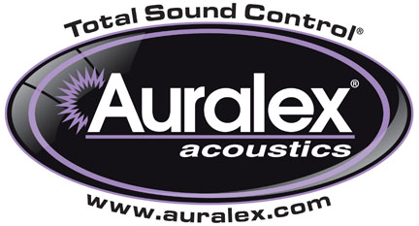

FOR IMMEDIATE RELEASE

Auralex® Expands Its Range of ProPanels™

— New sizes and fabric options offer latest enhancements to Auralex®’s ProPanels™ line of Fabric Wrapped Acoustical Absorption Panels —

INDIANAPOLIS, IN, SEPTEMBER 13, 2012 – As part of their ongoing commitment to providing system integrators with a wide range of sound absorption products, Auralex® Acoustics, Inc., the world’s leading brand of acoustical treatments and soon to celebrate its 35th anniversary, is expanding its line of ProPanels™ Fabric Wrapped Acoustical Absorption Panels. Auralex’s ProPanels are fabric-covered absorbers designed to provide an upscale look with the high-performance absorption qualities that reduce unwanted room reflections (slap and flutter echoes, for instance) to improve the listening environment while affording tasteful aesthetics that complement any décor.

ProPanels meet the Class A fire rating and are available in a choice of 12 standard color/fabric options. ProPanels standard sizes include: 2'x2', 2'x4', 4'x8' and 4'x4' wall panels (with beveled or straight edges) and 2'x4' corner panel (with reverse-mitered edge). The 2'x2' and 2'x4' wall panels are available in 1" and 2" thicknesses; the 4'x8' and 4'x4' wall panels and 2'x4' corner panel are available in 2" thicknesses only. Additionally, Auralex offers a wide variety of installation hardware: flat Impaling Clips (standard with all ProPanels orders); and Z-Clips, Cloud Anchors and Snap-On Anchors (available upon request).

For more specialized needs, Auralex offers its Custom ProPanels, which can be customized with regard to shape, size and thickness, to serve the diverse demands of today’s integrator. Additionally, Custom ProPanels are available in a wide variety of custom fabrics.

For more information, please visit www.auralex.com.

Photo Files: B124_2x4_WallPanel.JPG, B224_2x4_WallPanel.JPG, B244_4x4_WallPanel.JPG, M224_2x4_CornerPanel.JPG

About Auralex Acoustics, Inc.
Located in Indianapolis, Auralex Acoustics was founded in 1977 with a mission to provide top-performing acoustical treatment products at the best possible value. Since then, thousands of satisfied Auralex customers have experienced improved acoustics, expert advice and exceptional customer service. Auralex products enjoy widespread use among prominent artists, producers, engineers, corporations, celebrities and government agencies worldwide.

Auralex Acoustics has become the industry leader in innovative sound control solutions and continues to enjoy rapid growth through an international network of authorized dealers. Visit the Auralex Web site at www.auralex.com. Auralex can be reached via email at auralexinfo@auralex.com or by calling 1-800-959-3343.

# # #
PR Contact Info:
Clyne Media, Inc.
615-662-1616
info@clynemedia.com

