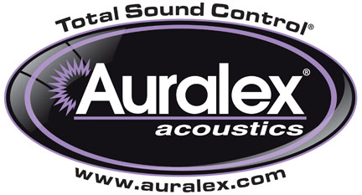

FOR IMMEDIATE RELEASE

Auralex® Now Shipping ProBanners™ and ProBaffles™

INDIANAPOLIS, IN, JULY 1, 2013 – Auralex® Acoustics, Inc., the world’s leading brand of acoustical treatments and currently celebrating its 35th anniversary, offers an extension to its sound absorption product offerings with ProBanners™ and ProBaffles™.

Auralex ProBanners are 2" or 4" thick, custom-produced absorbers that provide an economical way to acoustically treat the ceiling in a large room. Great for reducing reverberation and reflections in gymnasiums, arenas, pools, sanctuaries, restaurants, nightclubs and animal-care facilities, these absorption panels are hung horizontally across the ceiling. ProBanners are available in PVC covering in a variety of colors. ProBanners hold up in harsh environments and install quickly and easily with the supplied hardware, simplifying the installation process and saving time in the field. Perfect for commercial facilities, ProBanners have a fiberglass core and are Class A fire rated per the ASTM E-84 test protocol and are available in sizes from 2' x 4' to 4' x 40'.

Auralex ProBaffles are 2" thick custom-produced absorbers wrapped in lightweight panel fabric or PVC covering and are designed to be hung vertically from the ceilings (and, in some cases, walls) in commercial facilities such as gymnasiums, restaurants, lobbies, and other larger multi-purpose spaces. The absorbers have a fiberglass core and carry a Class A fire rating. The edges and corners are square and either hardened (fabric covering) or non-hardened (PVC covering). Installation of this device is made easy by using the grommets to hang with wire or chain. Size: from 4' x 2' thick to 4' x 10' x 2" thick

Auralex Application Specialists and Engineers can assist contractors and system integrators in finding the optimum custom ProBanner or ProBaffle solution for each job. PVC fabric color options include black, beige, grey, white, red, yellow, blue, green and burgundy.

For more information, please visit www.auralex.com.

Photo Files: ProBanner.JPG, ProBaffles_Photo1.JPG, ProBaffles_Photo2.JPG, ProBaffle_Photo3_Gym.JPG

About Auralex® Acoustics, Inc.
Located in Indianapolis, Auralex® Acoustics was founded in 1977 with a mission to provide top-performing acoustical treatment products at the best possible value. Since then, thousands of satisfied Auralex customers have experienced improved acoustics, expert advice and exceptional customer service. Auralex products enjoy widespread use among prominent artists, producers, engineers, corporations, celebrities and government agencies worldwide.

Auralex Acoustics has become the industry leader in innovative sound control solutions and continues to enjoy rapid growth through an international network of authorized dealers. Visit the Auralex Web site at www.auralex.com. Auralex can be reached via email at auralexinfo@auralex.com or by calling 1-800-959-3343.

# # #
PR Contact Info:
Clyne Media, Inc.
615-662-1616
info@clynemedia.com

