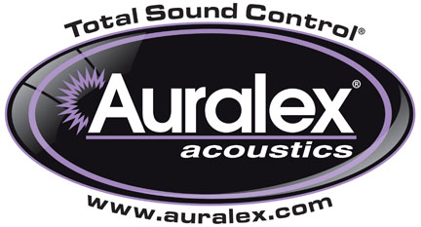

FOR IMMEDIATE RELEASE

Auralex® Announces New Leadership Team

— With Mark Henderson as CEO, David Brune as Director of Sales and Andy Symons as Director of Operations, Auralex® is poised for its next phase of growth —

INDIANAPOLIS, IN, MAY 29, 2013 – Auralex® Acoustics, Inc., the world’s leading brand of acoustical treatments and currently celebrating its 35th anniversary, has announced several recent additions to its leadership team. The announcement was made by Auralex Founder and President Eric Smith and underscores Auralex’s ongoing global expansion.

First, Mark Henderson has been appointed CEO. Prior to joining Auralex Acoustics, Henderson had a successful global career with Dow AgroSciences, and also functioned as Executive Director of the Indiana Soybean Alliance and Indiana Corn Marketing Council, traveling abroad to grow both organizations' market share. Along the way, Henderson acquired experience with Six Sigma and other process and organizational re-engineering job assignments. Henderson received both his MBA and Bachelor degrees from Kansas State University.

Next, Dave Brune has been appointed Director of Sales. Brune brings over two decades of sales management and business development experience with leading global manufacturers including Sony DADC, Maxell Professional Media, Thomson Consumer Electronics, and Ampex Recording Media Corporation. Dave is a graduate of Indiana University with a degree in telecommunications.

Third, Andy Symons has been appointed Director of Operations. Symons brings with him 20 years of experience in operations and management as well as over 30 years of experience in the professional audio and music industries. With a degree in Telecommunications from Butler University, he began his career as a staff engineer (and later Chief Engineer and Vice President) at TRC Recording Studios. He later joined World Media Group as mastering engineer, then Plant Manager and VP of Operations. Starting in 2001, he served as studio manager and marketing director for The Lodge Recording Studios. In the spring of 2011 he decided to return to college to earn an associate degree in IT/Networking, which he completed in late 2012.

“I have known Andy and Dave for several decades, and I can attest to their status as experts in the audio industry, as well as being great friends,” stated Eric Smith. “We are excited to be working with them moving forward. On the same hand, Mark is an experienced business and management professional, and he and I have become close allies since before his appointment. With these three new personnel on our team, we are poised for unprecedented global growth in the coming months and years.”

For more information, please visit www.auralex.com.

Photo File: LeadershipTeam.JPG
Photo Caption: Pictured L-R: Auralex® Acoustics Director of Operations Andy Symons, CEO Mark Henderson, and Director of Sales David Brune.

About Auralex® Acoustics, Inc.
Located in Indianapolis, Auralex Acoustics was founded in 1977 with a mission to provide top-performing acoustical treatment products at the best possible value. Since then, thousands of satisfied Auralex customers have experienced improved acoustics, expert advice and exceptional customer service. Auralex products enjoy widespread use among prominent artists, producers, engineers, corporations, celebrities and government agencies worldwide.

Auralex® Acoustics has become the industry leader in innovative sound control solutions and continues to enjoy rapid growth through an international network of authorized dealers. Visit the Auralex Web site at www.auralex.com. Auralex can be reached via email at auralexinfo@auralex.com or by calling 1-800-959-3343.

# # #
PR Contact Info:
Clyne Media, Inc.
615-662-1616
info@clynemedia.com

