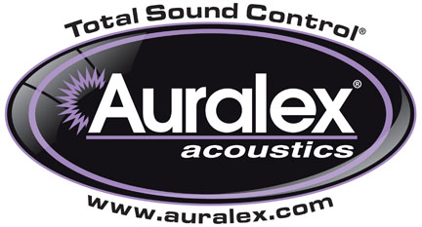

FOR IMMEDIATE RELEASE

Auralex® Now Shipping ISO-Tone™ Turntable Isolation Platform

Indianapolis, IN, April 1, 2015 – Auralex® Acoustics, Inc., the world’s leading brand of acoustical treatments, is now shipping its ISO-Tone™ Turntable Isolation Platform, the newest member of the award-winning ISO Series™ (Instant Sound Optimizers).

Engineered specifically to decouple turntables from the supporting surfaces they rest on, the ISO-Tone diminishes structural vibrations and commonly associated acoustic feedback associated with desktops and DJ cases. Designed for turntablists, mobile DJs, audiophiles, rental houses, and anyone seeking enhanced turntable performance, purity and accuracy, the ISO-Tone features a 0.75" layer of black fabric-wrapped MDF that floats on a layer of Auralex’s proprietary Platfoam that protects turntables from unwanted vibrations. The 17.75" W x 14.25" D x 1.75" H isolation platform accommodates most turntables and the low-profile design enables easy transport.

For more information, please visit www.auralex.com.

Photo Files: ISO-Tone_01.JPG, ISO-Tone_02.JPG, ISO-Tone_03.JPG, ISO-Tone_04.JPG, ISO-Tone_05.JPG, ISO-Tone_06.JPG

About Auralex® Acoustics, Inc.
Located in Indianapolis, Auralex® Acoustics was founded in 1977 with a mission to provide top-performing acoustical treatment products at the best possible value. Since then, thousands of satisfied Auralex customers have experienced improved acoustics, expert advice and exceptional customer service. Auralex products enjoy widespread use among prominent artists, producers, engineers, corporations, celebrities and government agencies worldwide.

Auralex Acoustics has become the industry leader in innovative sound control solutions and continues to enjoy rapid growth through an international network of authorized dealers. Visit the Auralex Web site at www.auralex.com. Auralex can be reached via email at auralexinfo@auralex.com or by calling 1-800-959-3343.

# # #
PR Contact Info:
Clyne Media, Inc.
615-662-1616
info@clynemedia.com

