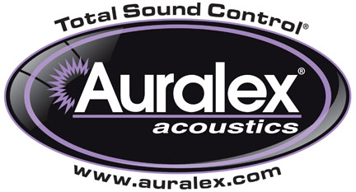

FOR IMMEDIATE RELEASE

Auralex® Now Shipping HoverMat™ Isolation Platform

— The HoverMat™ isolates a drum kit from the floor or a hollow stage, reducing coloration from floor resonance and improving sound isolation —

INDIANAPOLIS, IN, FEBRUARY 4, 2013 – Auralex® Acoustics, Inc., the world’s leading brand of acoustical treatments and currently celebrating its 35th anniversary, is now shipping its HoverMat™ Isolation Platform. The HoverMat is a sturdy, slip-resistant drummers’ mat that improves acoustical isolation and clarifies drum tone. Like Auralex’s critically acclaimed HoverDeck™ Isolation Riser, the HoverMat isolates a drum set from the floor or a hollow stage, reducing coloration from floor resonance by decoupling the drum kit, thereby resulting in a tighter, more pure sound for both studio and live applications. The HoverMat and HoverDeck can also be used in combination for extra isolation.

The HoverMat comes as a 4'x6' section of Auralex’s acclaimed sound-deadening SheetBlok™ sound barrier material, covered with charcoal gray Ozite-type, commercial-grade, road-ready carpet, and is ideal for musicians on the go, worship groups, live performance venues, or anywhere a drum kit needs additional isolation.

The result is a tighter, more focused and pure drum sound night-in and night-out. The HoverMat can be rolled up after any performance or session, and the included heavy-duty cinch sack makes transport a breeze.

Features and Highlights:
- 6’ width x 4’ depth; ¼” thickness
- Non-slip surface holds drums and hardware in place
- Provides acoustical isolation
- Weighs 28 lbs - cinch sack with shoulder strap included
- Great for drummers and keyboard players alike
- Fabricated with industry-leading Auralex SheetBlok™

For more information, please visit www.auralex.com.

Photo Files: HoverMat_with_DrumSet.JPG

About Auralex® Acoustics, Inc.
Located in Indianapolis, Auralex® Acoustics was founded in 1977 with a mission to provide top-performing acoustical treatment products at the best possible value. Since then, thousands of satisfied Auralex customers have experienced improved acoustics, expert advice and exceptional customer service. Auralex products enjoy widespread use among prominent artists, producers, engineers, corporations, celebrities and government agencies worldwide.

Auralex Acoustics has become the industry leader in innovative sound control solutions and continues to enjoy rapid growth through an international network of authorized dealers. Visit the Auralex Web site at www.auralex.com. Auralex can be reached via email at auralexinfo@auralex.com or by calling 1-800-959-3343.

# # #
PR Contact Info:
Clyne Media, Inc.
615-662-1616
info@clynemedia.com

