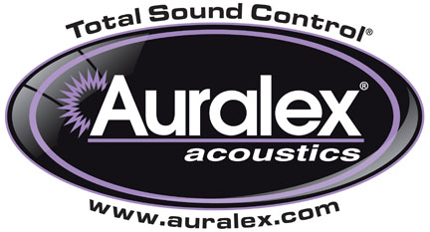

FOR IMMEDIATE RELEASE

Leading Drummers Choose Auralex® HoverMat™ and HoverDeck™

— Products offer superior isolation, reducing coloration from floor resonance and enhancing musicality —

INDIANAPOLIS, IN, FEBRUARY 12, 2013 – Auralex® Acoustics, Inc., the world’s leading brand of acoustical treatments and soon to celebrate its 35th anniversary, is proud to see an increasing number of prominent drummers using the HoverMat™ Isolation Platform and HoverDeck™ Isolation Riser. Used together or separately, these two products isolate a drum set from the floor or a hollow stage, reducing coloration from floor resonance by decoupling the drum kit, thereby resulting in a tighter, more pure sound for both studio and live applications.

Acclaimed drummer Van Romaine, whose credits include Steve Morse Band and Enrique Iglesias, has integrated HoverMat and HoverDeck into his setup for both studio and stage work. He says, “The HoverDeck/HoverMat combo is the perfect addition to my recording studio and my drum riser for touring. The first thing I noticed was the crisp sound of my drums with no extra vibrations from outside sources. The second was how they very easily eliminated any imperfections in the flooring of my studio, enabling me to play with more confidence.”

Another HoverDeck/HoverMat user is Doug Yowell, who has played with such star songwriter/artists as Duncan Sheik, Suzanne Vega, Ari Hest and more. He is currently a key part of Vega’s touring band. He notes, “The HoverDeck in combination with the HoverMat was a game-changer for me. I couldn't believe how resonant the drums were. I didn't have to add any plug-ins to enhance the bottom end. The isolation did everything I could have hoped for and more. I have to say...I can't imagine going back to the sound I had before. These products are really well thought-through and engineered.”

Aaron Comess, founding member of GRAMMY®-nominated, multi-platinum alternative act The Spin Doctors, also has an expansive list of other credits including Edie Brickell, Aaron Neville, Natasha Bedingfield, Joan Osborne, Andrea Bocelli and more. He also enjoys a vibrant career as a solo artist and collaborator in New York City’s jazz, experimental and singer-songwriter scenes. He adds, “The HoverDeck with the HoverMat have really improved the drum sounds we're getting in the studio. It takes the floor out of the equation and cleans up much more than you would think.”

For more information, please visit www.auralex.com.

Photo Files: VanRomaine.JPG, DougYowell.JPG, AaronComess.JPG

About Auralex® Acoustics, Inc.
Located in Indianapolis, Auralex® Acoustics was founded in 1977 with a mission to provide top-performing acoustical treatment products at the best possible value. Since then, thousands of satisfied Auralex customers have experienced improved acoustics, expert advice and exceptional customer service. Auralex products enjoy widespread use among prominent artists, producers, engineers, corporations, celebrities and government agencies worldwide.

Auralex Acoustics has become the industry leader in innovative sound control solutions and continues to enjoy rapid growth through an international network of authorized dealers. Visit the Auralex Web site at www.auralex.com. Auralex can be reached via email at auralexinfo@auralex.com or by calling 1-800-959-3343.

# # #
PR Contact Info:
Clyne Media, Inc.
615-662-1616
info@clynemedia.com

