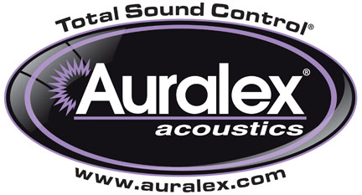

FOR IMMEDIATE RELEASE

Auralex® Now Shipping New Deep6™ Low-Frequency Absorber

INDIANAPOLIS, IN, April 15, 2015 – Auralex® Acoustics, Inc. is now shipping its new Deep6™ Low-Frequency Absorber, a 2’ x 4’ x 6” powder-coated, black steel frame-enclosed absorption device. The Deep6 Low-Frequency Absorber is specifically designed to be installed on a wall or across a vertical corner to improve low-frequency absorption throughout the room and accuracy at the mix position, but without the sonic artifacts of competing products. This solidly constructed acoustical treatment is the perfect choice for rooms where corner-fitted bass traps are not possible due to doors or windows, and provides usable broadband control down to 40Hz.

The Deep6 is Class A fire rated for commercial and residential applications. It complements a wide range of acoustical products & turns mid-high absorbers into a complete broadband system.

Available in Sandstone and Obsidian fabric colors, each Deep6 comes fully assembled and ready to install with the included wall mounting brackets. Additional corner mounting brackets are available.

For more information, please visit www.auralex.com.

Photo Files: Deep6_Photo1.JPG, Deep6_Photo2.JPG, Deep6_Photo3.JPG, Deep6_Photo4.JPG

About Auralex® Acoustics, Inc.
Located in Indianapolis, Auralex® Acoustics was founded in 1977 with a mission to provide top-performing acoustical treatment products at the best possible value. Since then, thousands of satisfied Auralex customers have experienced improved acoustics, expert advice and exceptional customer service. Auralex products enjoy widespread use among prominent artists, producers, engineers, corporations, celebrities and government agencies worldwide.

Auralex Acoustics has become the industry leader in innovative sound control solutions and continues to enjoy rapid growth through an international network of authorized dealers. Visit the Auralex Web site at www.auralex.com. Auralex can be reached via email at auralexinfo@auralex.com or by calling 1-800-959-3343.

# # #
PR Contact Info:
Clyne Media, Inc.
615-662-1616
info@clynemedia.com

