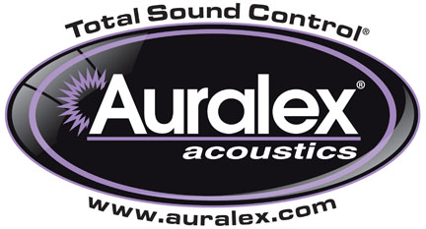

FOR IMMEDIATE RELEASE

Auralex® Is Now Shipping the BigTipper™ Angling Accessory for Its GRAMMA®

Indianapolis, IN, August 24, 2015 – Auralex® Acoustics, Inc., the world’s leading brand of acoustical treatments, is now shipping the BigTipper™ Angling Accessory for its GRAMMA®, the widely used platform designed to isolate bass rigs, guitar amps, monitors and subwoofers on stage and in the studio.

The BigTipper angles an amp or speaker cabinet to redirect speaker projection. This easy-to-install accessory includes all hardware needed to retrofit any GRAMMA or GRAMMA V2 to provide multiple angle options while allowing the true sound of your amp or loudspeaker to come through by negating resonance artifacts that can muddy up the tone of an amp or speaker.

For more information, please visit www.auralex.com.

Photo Files: BigTipper.JPG, BigTipper_withAmp.JPG

About Auralex® Acoustics, Inc.
Located in Indianapolis, Auralex® Acoustics was founded in 1977 with a mission to provide top-performing acoustical treatment products at the best possible value. Since then, thousands of satisfied Auralex customers have experienced improved acoustics, expert advice and exceptional customer service. Auralex products enjoy widespread use among prominent artists, producers, engineers, corporations, celebrities and government agencies worldwide.

Auralex Acoustics has become the industry leader in innovative sound control solutions and continues to enjoy rapid growth through an international network of authorized dealers. Visit the Auralex Web site at www.auralex.com. Auralex can be reached via email at auralexinfo@auralex.com or by calling 1-800-959-3343.

# # #
PR Contact Info:
Clyne Media, Inc.
615-662-1616
info@clynemedia.com

